

2021/2022 MID YEAR PERFORMANCE ASSESSMENT REPORT

(Submitted in terms of Section 72 of the MFMA)

SERVICE DELIVERY AND BUDGET IMPLEMENTATION

PLAN 2021/2022

(QUARTER 2 PERFORMANCE REPORTING)

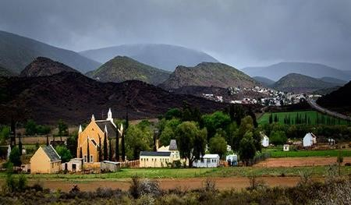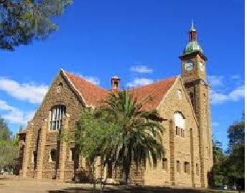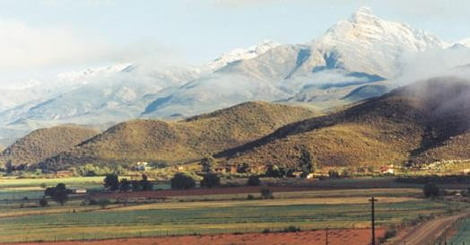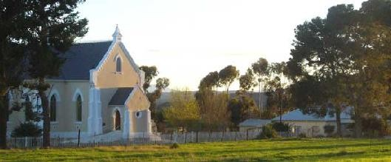

Prepared in terms of the Local Government: Municipal Finance Management Act (56/2003): Municipal Budget and Reporting Regulations, Government Gazette 32141, 17 July 2009

**Contents**

|  |  |  |
| --- | --- | --- |
| **No.** | **Content details** | **Page no** |
| 1. | Acting Municipal Manager’s Quality Certificate | 2 |
| 2. | Executive Mayor’s Certificate of approval | 3 |
| 3. | Introduction | 4 |
| 4. | Legislative Framework | 4 |
| 5. | Performance Policy and monitoring | 5 |
| 6. | Linkage to IDP | 5 |
| 7. | Implementation Monitoring and Review – One year | 9 |
| 8. | Final Revised Top Layer Service Delivery and Budget Implementation Plan (SDBIP) 2021/2022 | 10 |
| 9. | Mid-Year Performance Measured | 10 |
| 5. | **ANNEXURES**   * Detailed capital works programme * Monthly projections of revenue * Monthly projection of expenditure * Service delivery targets and performance indicators (SDBIP quarter 2 performance results) | 12  13  14  15 |

1. **ACTING MUNICIPAL MANAGER’S QUALITY CERTIFICATE**

I, Morne Hoogbaard, the Acting Municipal Manager of the Kannaland Municipality, submits the

Final Revised Top Layer (TL) Service Delivery and Budget Implementation Plan (SDBIP) for

the 2021/22 financial year for approval by the Executive Mayor. This Revised TL SDBIP

2021/22 has been prepared in terms of the stipulated requirements as documented in the

Local Government: Municipal Finance Management Act, 2003 (Act No. 56 of 2003) and

regulations made under this Act.

**…………………………**

**IAN AVONTUUR**

**ACTING MUNICIPAL MANAGER**

Date: **………………………**

1. **EXECUTIVE MAYOR’S CERTIFICATE OF APPROVAL**

I, Nicolaas Valentyn, in my capacity as the Executive Mayor of the Kannaland

Municipality, hereby approves the Final Revised Top Layer (TL) Service Delivery and Budget

Implementation Plan (SDBIP) for the 2021/22 financial year as required in terms of the Local

Government: Municipal Finance Management Act, 2003 (Act No. 56 of 2003) and regulations made under this Act.

……………………………..

**NICOLAAS VALENTYN**

**EXECUTIVE MAYOR**

Date: **………………………**

1. **INTRODUCTION**

This report constitutes the 2021/22 Mid-year Performance Assessment which has been compiled in accordance with Section 72 of the Municipal Finance Management Act, Act 56 of 2003 (MFMA). The report also serves as the quarterly report for the 2nd quarter as required by Section 52(d) of the MFMA.

1. **LEGISLATIVE FRAMEWORK**

Section 72(1) (a) and 52(d) of the Local Government Municipal Finance Management Act No. 56 of 2003 (MFMA) requires the Accounting Officer to by 25 January of each year assess the performance of the municipality during the first half of the financial year. A report on such assessment must be submitted to the Mayor, Provincial Treasury and National Treasury by 25 January in terms of Section 72(1) (b) of the MFMA. Once the Mayor has considered the report, it must be submitted to Council by 31 January in terms of Section 54 (1) (f) of the MFMA. Regulation 34 (1) of the Municipal Budget and Reporting Regulations requires furthermore that the mid-year budget and performance assessment be made public by placing it on the municipal website within 5 working days of 25 January. Section 52(d) of the Municipal Finance Management Act, Act 56 of 2003, requires the Mayor to within 30 days of the end of each quarter; submit a report to Council on the implementation of the budget and the financial state of affairs of the Municipality. MFMA Circular 13 requires the Municipality to report quarterly on its Service Delivery Budget Implementation Plan (SDBIP).

The Municipality’s performance is measured against the Municipality’s Service Delivery Budget Implementation Plan (SDBIP). The SDBIP is “a detailed plan approved by the mayor of a municipality in terms of section 53(1)(c)(ii) for implementing the municipality’s delivery of services and the execution of its annual budget and which must include (as part of the Top Layer) the following:

a) projections for each month of:

(i) revenue to be collected, by source; and

(ii) operational and capital expenditure, by vote;

b) service delivery targets and performance indicators for each quarter”.

c) Budget processes and related matters

The Executive Mayor approved the Top Layer SDBIP for 2021/22 on 5 August 2021. Amendments to the SDBIP will be tabled to Council at the end of January 2022. Any amendments to the Top Layer SDBIP must be approved by Council, and a report in this regard will be submitted in January 2022.

1. **PERFORMANCE POLICY FRAMEWORK AND MONITORING**
2. **Performance Management Framework** Regulation 7(1) of the Local Government: Municipal Planning and Performance Management Regulations, 2001 states that “A Municipality’s Performance Management System entails a framework that describes and represents how the municipality’s cycle and processes of performance planning, monitoring, measurement, review, reporting and improvement will be conducted, organized and managed, including determining the roles of the different role players.” This framework, inter alia, reflects the linkage between the IDP, Budget, SDBIP and individual and service provider performance. The Kannaland Municipality adopted a performance management policy framework that was approved by Council on 31 August 2021 (Council Resolution 50/08/21).
3. **Monitoring Performance**

The Kannaland Municipality does not have an electronic web-based system on which KPI owners update actual performance on a monthly basis. KPI owners report on the results of the KPI by documenting the undermentioned information manually on the performance system spreadsheet:

* The actual result in terms of the target set.
* The output/outcome of achieving the KPI.
* The calculation of the actual performance reported. (If %)
* A performance comment.
* Actions to improve the performance against the target set, if the target was not achieved.
* It is the responsibility of every KPI owner to maintain a portfolio of evidence to support actual performance results updated.

1. **LINKAGE TO THE IDP**

The Council approved the new five - year IDP on 30 May 2017. The SDBIP derives from the IDP which contains the Municipalities vision, mission and strategic goals and objectives, which in turn aligned to the National KPA’s for Local Government. The following table sets out this alignment.

**Kannaland Vision**: “To be the place of Choice”

**Kannaland Mission**:

* Encouraging self-reliance.
* Ensure co-ordination and collaboration of various stakeholders in the delivering of development in a sustainable manner.
* Promote a healthy and vibrant community with high moral standards.
* Unlock the development potential of the area particularly tourism and indigenous knowledge and mobilizing investment.
* Ensure everyone will be active in the economy and utilize technology to the advantage of the municipality.
* Attract and keep a highly skilled work force.

*Horizontal Alignment:*

The table below illustrates the alignment of the strategic objectives of Kannaland Municipality as aligned to the vision and mission statement reflected above with the objectives of the National Development Plan. The aim is to align programmes/projects which the municipality tends to achieve:

| **Kannaland Objectives** | **Garden Route District Objectives** | **PSO** | **NDP Objectives/**  **Outcomes** |
| --- | --- | --- | --- |
| **KPA1: To provide access to reliable infrastructure that will contribute to a higher quality of life for Kannaland citizens** | Conduct regional bulk infrastructure planning & implement projects, roads maintenance and public transport; manage and develop council fixed  assets (3) | Developing integrated and sustainable human settlements (6) | Outcome 6: Efficient, competitive and responsive economic infrastructure network |
| **KPA2: To provide adequate Services and improve our Public relations** |  | Increasing wellness (4)  Integrating service  delivery for maximum impact (10) | Outcome 2: Improve health and life expectancy |
| **KPA3: To strive towards a safe community in Kannaland through the proactive management of traffic, environmental health, fire and disaster risks** | Promote sustainable  environmental management and public safety (4) | Increasing access to safe and efficient transport (3)  Increase safety (5) | Outcome 2: Improve health and life expectancy  Outcome 3: All people in South Africa protected and feel safe  Outcome 7: Vibrant, equitable and sustainable rural communities and food security  Outcome 10: Protection and enhancement of environmental assets and natural resources  Outcome 11: A better South Africa, a better and safer Africa and world |
| **KPA4: To facilitate Economic**  **Growth and Social and Community development** | Grow the district economy  (7)  Healthy and socially stable communities (1) | Creating opportunities  for growth and jobs (1)  Improve education outcomes (2)  Developing integrated and sustainable human settlements (6)  Increasing social cohesion (8)  Reducing poverty (9)  Creating opportunities for growth and development in rural areas (11) | Outcome 1: Improve the quality of Basic Education  Outcome 4: Decent  employment through  inclusive growth  Outcome 6: Efficient,  competitive and responsive economic infrastructure network  Outcome 8: Sustainable human settlements and improved quality of household life.  Outcome 7: Vibrant, equitable and sustainable rural communities and food security |
| **KPA5: To promote efficient and effective Governance with high levels of stakeholder participation** | Promote good governance  (5) | Building the best-run regional government in the world (12) | Outcome 9: A responsive and, accountable, effective and efficient local government system Outcome 12: A development-orientated public service and inclusive  citizenship |
| **KPA 6: To provide an efficient workforce by aligning our institutional arrangements to our overall**  **strategy** | Build a capacitated  Workforce and  communities (2) | Mainstreaming  sustainability and optimizing resource- use efficiency (7) | Outcome 5: A skilled and  capable workforce to support inclusive growth |
| **KPA 7: To strive towards a financially sustainable municipality** | Ensure financial viability of  The Garden Route district municipality (6) | Building the best-run regional government in the world (12) | Outcome 9: A responsive and, accountable, effective and efficient local government system |

1. **IMPLEMENTATION, MONITORING AND REVIEW – ONE YEAR**

The Local Government: Municipal Finance Management, 2003 (Act No. 56 of 2003) (MFMA)

requires that municipalities prepare a Service Delivery and Budget Implementation Plan (SDBIP) as a strategic financial management tool to ensure that budgetary decisions that are adopted by municipalities for the financial year are aligned with their strategic planning tool, the Integrated Development Plan (IDP). The SDBIP is a contract between Council, administration and the community. It gives effect to the IDP and budget of the municipality.

The SDBIP is a one – year detailed implementation plan which gives effect to the IDP and Budget of the Municipality. It is a contract between the administration, Council and community expressing the goals and objectives set by Council as quantifiable outcomes that can be implemented by the administration over the next twelve months. This provides the basis of measuring the performance in service delivery against end year targets and implementing budget.

**The five necessary components are:**

1. Monthly projections of revenue to be collected for each month;

2. Monthly projections of expenditure (operating and capital) and revenue for each vote;

3. Quarterly projections of service delivery targets and performance indicators;

4. Ward information for expenditure and service delivery; and

5. Detailed capital works plan broken down by ward over three years.

1. **FINAL REVISED TOP LAYER 2021/2022 SDBIP**

KPA 1: To Provide access to reliable infrastructure that will contribute to a higher quality of life for Kannaland citizens

KPA 2: To Provide adequate Services and improve our public relations

KPA 3: To strive towards a safe community in Kannaland through the proactive management of traffic, environmental health, fire and disaster risks

KPA 4: To Facilitate Economic Growth and Social and Community development

KPA 5: To Promote efficient and effective Governance with high levels of stakeholder participation

KPA 6: To Provide an efficient workforce by aligning our institutional arrangements to our overall strategy

KPA 7: To Strive towards a financially sustainable municipality

1. **MID-YEAR PERFORMANCE MEASURED AGAINST THE PERFORMANCE INDICATORS ON THE APPROVED TOP LAYER SDBIP FOR 2021/2022**
   1. **OVERALL ACTUAL PERFORMANCE FOR THE PERIOD ENDING 31 DECEMBER**

**2021**

The Municipality has a total of 39 KPI’s on its Top Layer SDBIP and 17 were measurable by mid-year. The remaining 22 KPI’s will be reported on in future quarters when they are due. The Municipality met 7 of its 17 KPI’s which equates to 41%.

|  |  |  |
| --- | --- | --- |
|  | Not yet measured | 22 |
|  | Not met | 9 |
|  | Almost met | 1 |
|  | KPI met | 7 |
|  | KPI met well | 0 |
|  | KPI met extremely well | 0 |
|  | **Total KPI’s measured** | **17** |

**RECOMMENDATION**

1. That the Council note the 2021/2022 Mid-year Performance Assessment Report submitted in terms of Sections 72(1) and 54(1)(f) of the Municipal Finance Management Act, (Act 56 of 2003)
2. That 2021/2022 Mid-year Performance Assessment Report be made public by placing it on the municipal website in terms of Regulation 34 (1) of the Municipal Budget and Reporting Regulations of 2009.
3. That the Top Layer SDBIP be revised and submitted to Council with the approval of the Adjustments Budget.

**Detailed Capital programme 2021-22 Annexure I**

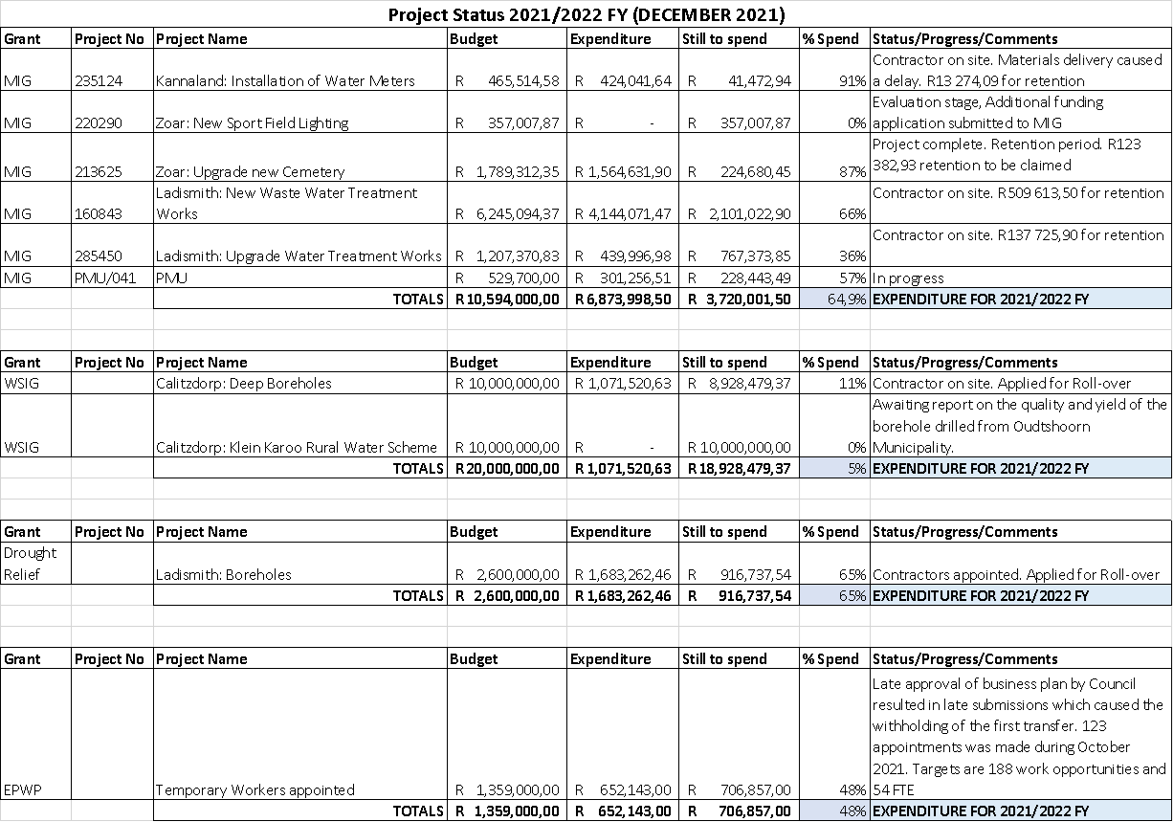

**Total Capital 2021/2022 R23 767 300, 00**

|  |  |  |  |
| --- | --- | --- | --- |
|  | **2021** | **2022** | **2023** |
| **Grant Name** | **Allocation** | **Allocation** | **Allocation** |
| **Municipal Infrastructure Grant** | R10 064 300,00 | R10 529 000,00 | R10 805 000,00 |
| **Water Service Infrastructure Grant** | R10 000 000,00 | R9 552 000,00 | R21 000 000,00 |
| **Integrated National Electrification Programme** | R2 699 000,00 | R2 000 000,00 | R3 000 000,00 |
| **Internal Funding** | R1 004 000,00 |  |  |
|  | R23 767 300,00 | R22 081 000,00 | R34 805 000,00 |

**MONTHLY PROJECTIONS OF REVENUE 2021/2022 ANNEXURE II**



**MONTHLY PROJECTION OF EXPENDITURE ANNEXURE III**

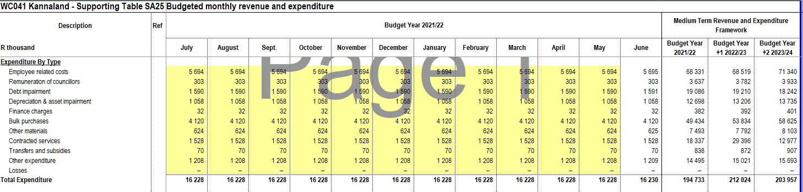

**2021/2022 KANNALAND MUNICIPALITY SERVICE DELIVERY AND BUDGET IMPLEMENTATION PLAN ANNEXURE**

**(PERFORMANCE REPORT FOR QUARTER 1 AND QUARTER 2)**

| ***IDP REF*** | ***IDP KPA*** | ***District***  ***Output*** | ***PSP: VIP (Very Inspired Priorities)*** | ***National***  ***Output*** | ***Department*** | ***Indicator description*** | ***How indicator is measured*** | **Q1**  **TARGET** | **Q1**  **ACTUAL** | **STATUS** | **PORTFOLIO OF EVIDENCE//MANAGEMENT COMMENTS/REMEDIAL ACTION** | **Q2**  **TARGET** | **Q2**  **ACTUAL** | **STATUS** | **PORTFOLIO OF EVIDENCE/MANAGEMENT COMMENTS /REMEDIAL ACTION** |
| --- | --- | --- | --- | --- | --- | --- | --- | --- | --- | --- | --- | --- | --- | --- | --- |
| IDP  Ref | **KPA** | ***District Objective*** | ***Provincial***  ***Outcome (Very inspired priorities)*** | ***National***  ***Output*** | ***Department*** | ***Indicator*** | ***Unit of measurement*** |  |  |  |  |  |  |  |  |
|  | | | | | | | | | |  |  |  |  |  |  |
| KPI.1 | KPA 1: To Provide access to reliable infrastructure that will contribute to a higher quality of life for Kannaland citizens | 3 Bulk Infrastructure Co- ordination | Innovation and Culture | Outcome 6: Efficient, competitive and responsive economic infrastructure network | Infrastructure Services | Spend 98% of allocation for MIG budget within 2020/21 financial year in terms of Provincial DPIP by 30 June 2022 and projects listed in the  approved IDP | % Of Budget spend of MIG funding | **18%** | **18.4%** | **KPI ACHIEVED** | Tender no. Kanna 10/2021: upgrading of Zoar cemetery: completion certificate (project completed on 10 September 2021)and Monthly MIG report submitted. | **40%** | **64.5%** | **KPI ACHIEVED** |  |
| KPI.2 | KPA 1: To Provide access to reliable infrastructure that will contribute to a higher quality of life for Kannaland citizens | 7. An inclusive district economy | Innovation and Culture | Outcome 6: Efficient, competitive and responsive economic infrastructure network | Infrastructure Services | Complete 95% of all infrastructure projects (incl MIG, WSIG, INEP etc.) to the stage where were issued with Practical Completion certificates by  30 June 2022 | % of all Infrastructure projects completed and issued with Practical Completion certificates | Progress  report  to  Mayco | **20%** | **KPI NOT ACHIEVED** | Inept- varkieskloof phase 1 electrification project. 3 months grace period granted. Contractor on site on 18/10/21. Phase 2 – transformer 2 to be discussed after 31/10/21 where 1,5million to be spent by end of nov 21.  Wsig – r2,2million invoice received for payment. All unspent MIG funding will be spent by end of dec 2021.  Library grant – R817 000 unspent of which R304 000 was paid from Kannaland budget and has to be replaced. R500 000 to still be spent.  Drought Disaster – Refurbishment of boreholes in Ladismith to augment water supply. Late in terms of supply chain processes. Contractor is on site. R85 000 available for Fire Services.  Title Deeds – R1million available. | 7 Project Practical Completion certificates | **28.6%** | **KPI NOT ACHIEVED** | MIG total 5 projects, 1 completed  WSIG total 1 project, 0 completed  Drought Relief total 1 project, 1 completed  Total 7 projects 2 completed, therefore 28.6% completed  Attached the 2 projects completion certificates  Submit item to council for KPI target adjustments. |
| KPI.3 | KPA 1: To Provide access to reliable infrastructure that will contribute to a higher quality of life for Kannaland citizens | 7. An inclusive district economy | Innovation and Culture | Outcome 6: Efficient, competitive and responsive economic infrastructure network | Corporate Services | Complete the upgrade of the library in Bergsig, Calitzdorp by end June 2022 | Number of libraries completed (listed if phased project) | - | - | - | KPI not measure in the first quarter. | - | - | KPI not measured in the 2nd quarter |  |
|  | | | | | | | | | |  |  |  |  |  |  |
| KPI.4 | KPA 2: To Provide adequate Services and improve our Public relations | 7 An inclusive district economy | Innovation and culture | Outcome 10: Protection and enhancement of environmental assets and natural resources | Infrastructure Services | Limit total of electricity losses in distribution network to less than 12% accumulative over the financial year  until 30 June 2022 | % of electricity losses in distribution network | 12% | 13.3% | **KPI ALMOST ACHIEVED** | No comment | 12% | 12.35% | **KPI ALMOST ACHIEVED** |  |
| KPI 5 | KPA 2: To Provide adequate Services and improve our Public relations | 7 An inclusive district economy | Innovation and culture | Outcome 10: Protection and enhancement of environmental assets and natural resources | Infrastructure Services | 75% of water samples comply with SANS-241 micro biological indicators  {(Number of water samples that comply with SANS-241 indicators/Number of water samples  tested) x100} | % of water samples that complies with SANS-241 standards | 75% |  | **KPI NOT ACHIEVED** | Non-compliance during July and August. 2021  Complied during September 2021.  Pump station repaired in Zoar. | 75% | 10%  (NON COMPLIANCEWITH SANS 241 CODE) | **KPI NOT ACHIEVED** | Non-compliance with SAN s 241 CODE  Remedial action: Upgrading of water purification works at Zoar. See GRDM Report attached |
| KPI 6 | KPA 2: To Provide adequate Services and improve our public relations | 7 An inclusive district economy | Innovation and culture | Outcome 10: Protection and enhancement of environmental assets and natural resources | Infrastructure Services | Limit accumulated unaccounted for water to less than 30%annually until 30 June 2022 | % of water losses in distribution networks in all of Kannaland towns | 30% | 20% | **KPI ACHIEVED** | No Comment | Less than30% | 18% | **KPI ACHIEVED** |  |
| NKPI 1 | KPA 2: To Provide adequate  Services and improve our public relations | 3 Bulk  Infrastructure Co- ordination | 10. Integrating service  delivery for maximum impact | Outcome 8: Sustainable human  settlements and improved quality of household live. | Financial Services | Number of formal residential properties that receives piped water connected to the municipal water infrastructure network as at 30 June  2022 | Number of residential properties which are billed for water services as at 30 June 2022 | 4635 | 4651 | **KPI ACHIEVED** | No Comment | 4942 | 4671 | **KPI NOT ACHIEVED** | Description of the KPIs refer to formal residential properties only and do not include all consumers in Kannaland area.  Targets has been set for the NKPIs relating to service delivery to ALL consumers in Kannaland. The description of these NKPIs refer to residential properties only and not to ALL consumers in Kannaland area.  Targets are not met due to the reporting being on formal residential properties while the targets are set on all properties within Kannaland.  Submit item to council for approval of adjustment of the target. |
| NKPI 2 | KPA 2: To Provide adequate Services and improve our public relations | 3 Bulk Infrastructure Co- ordination | 10. Integrating service delivery for maximum impact | Outcome 8: Sustainable human settlements and improved quality of household live. | Financial Services | Number of formal residential properties connected to the municipal electrical infrastructure network (excluding Eskom areas) as at 30  June 2022 | Number of residential properties which are billed for electricity (excluding Eskom areas) as at 30 June 2022 | Conventional:  241  Pre-paid:  3003 | Conventional:  239  Pre-paid:  3005 | **KPI ACHIEVED** | No Comment | 3830 | Conventional: 231  Pre-Paid:  3471 | **KPI NOT ACHIEVED** | Description of the KPIs refer to formal residential properties only and do not include all consumers in Kannaland area.  Targets has been set for the NKPIs relating to service delivery to ALL consumers in Kannaland. The description of these NKPIs refer to residential properties only and not to ALL consumers in Kannaland area.  Targets are not met due to the reporting being on formal residential properties while the targets are set on all properties within Kannaland.  Submit item to council for approval of adjustment of the target. |
| NKPI 3 | KPA 2: To Provide adequate Services and improve our public relations | 3 Bulk Infrastructure Co- ordination | 10. Integrating service delivery for maximum impact | Outcome 8: Sustainable human settlements and improved quality of household live. | Financial Services | Number of formal residential properties connected to the municipal waste water sanitation/sewerage network billed for the service as at 30  June 2022 | Number of residential properties which are billed for sewerage services as at 30 June 2022 | 4228 | 4238 | **KPI ACHIEVED** | No Comment | 4470 | 4244 | **KPI NOT ACHIEVED** | Description of the KPIs refer to formal residential properties only and do not include all consumers in Kannaland area.  Targets has been set for the NKPIs relating to service delivery to ALL consumers in Kannaland. The description of these NKPIs refer to residential properties only and not to ALL consumers in Kannaland area.  Targets are not met due to the reporting being on formal residential properties while the targets are set on all properties within Kannaland.  Submit item to council for approval of adjustment of the target. |
| NKPI 4 | KPA 2: To Provide adequate Services and improve our public relations | 3 Bulk Infrastructure Co- ordination | 10. Integrating service delivery for maximum impact | Outcome 8: Sustainable human settlements and improved quality of household live. | Financial Services | Number of formal residential properties for which refuse is removed once per week and billed for the  service as at 30 June 2022 | Number of residential properties which are billed for refuse removal services as at 30 June 2022 | 4537 | 4544 | **KPI ACHIEVED** | No Comment | 4810 | 4546 | **KPI NOT ACHIEVED** | Description of the KPIs refer to formal residential properties only and do not include all consumers in Kannaland area.  Targets has been set for the NKPIs relating to service delivery to ALL consumers in Kannaland. The description of these NKPIs refer to residential properties only and not to ALL consumers in Kannaland area.  Targets are not met due to the reporting being on formal residential properties while the targets are set on all properties within Kannaland.  Submit item to council for approval of adjustment of the target. |
| NKPI 5 | KPA 2: To Provide adequate Services and improve our public relations | 3 Bulk Infrastructure Co- ordination | 10. Integrating service delivery for maximum impact | Outcome 8: Sustainable human settlements and improved quality of household live. | Financial Services | Number of Households with access to free basic services (as per Indigent Register) by 30 June 2022 | Number of Households with access to free basic services (as per Indigent Register) | 2100 | 1995 | **KPI NOT ACHIEVED** | No comment received | 2540 | 2034 | **KPI NOT ACHIEVED** | Not achieved.  Lack of intervention in motivating indigents to apply for the ATTP subsidy. Promote active public participation and engagement on this matter.  Intervention from Ward Councilors to encourage indigents to apply for the indigent subsidy. |
|  | | | | | | | | | |  |  |  |  |  |  |
| KPI.7 | KPA 3: To strive towards a  safe community in Kannaland through the proactive management  of traffic, environmental health, fire and  disaster risks | 4. Environmental management and public safety | 12. Building the best-run regional government in the world | Outcome 9: A responsive and, accountable, effective and efficient local government system | Corporate Services | Review of the disaster management plan by March 2022 | Number of plans reviewed | - | - | - | KPI not measure in the first quarter. | - | - | KPI not measured in the 2nd quarter |  |
|  | | | | | | | | | |  |  |  |  |  |  |
| NKPI.6 | KPA 4: To Facilitate  Economic Growth and Social and Community development | 7. An inclusive district economy | Growth and Jobs | Outcome 5: A skilled and  capable workforce to support inclusive growth | Infrastructure Services | Create job opportunities through the Expanded Public Works Programme (EPWP) | Number of job opportunities created | 80 | 0 | **KPI NOT ACHIEVED** | This is due to the Council not sitting to sign the EPWP contract in time. 123 EPWP workers were appointed on 1 October 2021. | **100** | **123** | **KPI ACHIEVED** |  |
|  | | | | | | | | | |  |  |  |  |  |  |
| KPI.8 | KPA 5: To Promote efficient  and effective Governance with high levels of stakeholder participation | 6. Good Governance | 12. Building the best-run regional government in the world | Outcome 9: A responsive and,  accountable, effective and efficient local government system | Office of the Municipal Manager | Sign performance agreements for all s57/56 managers by end July 2022 | Number of signed performance agreements | 3 | 3 | **KPI ACHIEVED** | Performance Agreements signed by Executive Mayor. | - | - | KPI not measured in the 2nd quarter | Acting CFO appointed for 3 months (10 dec 2021 – 10 march 2022) |
| KPI.9 | KPA 5: To Promote efficient  and effective Governance with high levels of stakeholder participation | 6. Good Governance | 12. Building the best-run regional government in the world | Outcome 9: A responsive and,  accountable, effective and efficient local government system | Corporate Services | Minimum number of General Council meetings to be held per annum | Number of meetings convened | 1 | 1 | **KPI ACHIEVED** | Council meeting minutes | 1 | 1 | **KPI ACHIEVED** | Minutes of a Council meeting attached |
| KPI.10 | KPA 5: To Promote efficient and effective Governance with high levels of stakeholder  participation | 6. Good Governance | 12. Building the best-run regional government in the world | Outcome 9: A responsive and, accountable, effective and efficient local government  system | Corporate Services | Minimum number of Mayoral Committee meetings to be held per annum. | Number of meetings convened | 1 | 1 | **KPI ACHIEVED** | Mayoral Committee Minutes | 1 | 1 | **KPI ACHIEVED** | Minutes of a Mayoral Committee meeting attached |
| KPI.11 | KPA 5: To Promote efficient and effective Governance with high levels of stakeholder participation | 6. Good Governance | 12. Building the best-run regional government in the world | Outcome 9: A responsive and, accountable, effective and efficient local government system | Office of the Municipal Manager | Conduct an Annual Strategic risk assessment | Number of risk assessments conducted | - | - | - | KPI not measure in the first quarter. | - | - | KPI not measured in the 2nd quarter |  |
| KPI.12 | KPA 5: To Promote efficient  and effective Governance with high levels of stakeholder participation | 6. Good Governance | 12. Building the best-run regional government in the world | Outcome 9: A responsive and,  accountable, effective and efficient local government system | Office of the Municipal Manager | Revise the communication strategy by means of approval by the mayor and or council | Number of strategies approved | - | - | - | KPI not measure in the first quarter. | - | - | KPI not measured in the 2nd quarter |  |
| KPI.13 | KPA 5: To Promote efficient  and effective Governance with high levels of stakeholder  participation | 6. Good Governance | 12. Building the best-run regional government in the  world | Outcome 6: Efficient, competitive and responsive  economic infrastructure network | Corporate Services | Number of reviewed policies updated on the Council policy register. | Number of reports generated of updated policies | - | - | - | KPI not measure in the first quarter. | - | - | KPI not measured in the 2nd quarter |  |
| KPI.14 | KPA 5: To Promote efficient  and effective Governance with high levels of stakeholder participation | 6. Good Governance | 10. Integrating service delivery for maximum impact | Outcome 6: Efficient, competitive and responsive economic infrastructure network | Financial Services | ICT governance framework adopted by council by June 2022 | Number of ICT frameworks adopted | - | - | - | KPI not measure in the first quarter. | - | - | KPI not measured in the 2nd quarter |  |
| KPI.15 | KPA 5: To Promote efficient and effective Governance with high levels of stakeholder participation | 6. Good Governance | 12. Building the best-run regional government in the world | Outcome 9: A responsive and, accountable, effective and efficient local government system | Office of the Municipal Manager | Redevelop a led strategy for the Kannaland Municipality by June 2022 | Number of strategies approved | - | - | - | KPI not measure in the first quarter. | - | - | KPI not measured in the 2nd quarter |  |
| KPI.16 | KPA 5: To Promote efficient and effective Governance with high levels of stakeholder  participation | 6 Good Governance | 12. Building the best-run regional government in the world | Outcome 9: A responsive and, accountable, effective and efficient local government  system | Office of the Municipal Manager | Annual review of Performance management policy by September 2022 | Number of policies approved | 1 | 1 | **KPI ACHIEVED** | Council Resolution of Performance Management Policy. Council adopted the PM Policy. | - | - | KPI not measured in the 2nd quarter |  |
| KPI.17 | KPA 5: To Promote efficient  and effective Governance with high levels of stakeholder participation | 6 Good Governance | 12. Building the best-run regional government in the world | Outcome 9: A responsive and,  accountable, effective and efficient local government system | Office of the Municipal Manager | Complete and produce a draft Annual report to council within seven months after the end of the financial year | Number of annual reports completed | - | - | - | KPI not measure in the first quarter. | - | - | KPI not measured in the 2nd quarter |  |
| KPI.18 | KPA 5: To Promote efficient  and effective Governance with high levels of stakeholder participation | 6. Good Governance | 12. Building the best-run regional government in the world | Outcome 9: A responsive and,  accountable, effective and efficient local government system | Office of the Municipal Manager | Produce a final annual report with oversight to council within nine months after the end of the financial  year. | Number of annual reports completed | - | - | - | KPI not measure in the first quarter. | - | - | KPI not measured in the 2nd quarter |  |
| KPI.19 | KPA 5: To Promote efficient  and effective Governance with high levels of stakeholder participation | 6. Good Governance | 12. Building the best-run regional government in the world | Outcome 9: A responsive and,  accountable, effective and efficient local government system | Office of the Municipal Manager | Prepare and submit a draft and final IDP to Council for approval | Number of IDP approved | - | - | - | KPI not measure in the first quarter. | - | - | KPI not measured in the 2nd quarter |  |
| KPI.20 | KPA 5: To Promote efficient  and effective Governance with high levels of stakeholder participation | 6. Good Governance | 12. Building the best-run regional government in the world | Outcome 9: A responsive and,  accountable, effective and efficient local government system | Office of the Municipal Manager | Prepare and submit a section 46 report to the Auditor-General by end August 2020 | Number of section 46 reports submitted | 1 | 1 | **KPI ACHIEVED** | APR Submission to AG by 30 September 2021. Extension granted for awaited financial statements. | - | - | KPI not measured in the 2nd quarter |  |
| KPI.21 | KPA 5: To Promote efficient  and effective Governance  with high levels of stakeholder participation | 6. Good Governance | 12. Building the best-run  regional government in the world | Outcome 9: A responsive and,  accountable, effective and  efficient local government system | Corporate Services | Number of audit and performance committee meetings held | Number of meetings convened | - | - | - | KPI not measure in the first quarter. | 1 | 0 | KPI not achieved | Audit and performance Committee to be appointed. The advert has been placed and applications received for adjudication by Council. |
| KPI.22 | KPA 5: To Promote efficient  and effective Governance with high levels of stakeholder participation | 6. Good Governance | 12. Building the best-run regional government in the world | Outcome 9: A responsive and,  accountable, effective and efficient local government system | Office of the Municipal Manager | Quarterly Ward Committee meetings with consolidated quarterly reports to council until 30 June 2022 | Number of ward committee meetings convened | 4 | 4 | **KPI ACHIEVED** | Attendance registers of ward committee meetings | 4 | 0 | KPI not achieved | The declaration of Local Government elections resulted in disestablishment of ward committees on 1 November 2021.  Submit item to council for adjustment of target. |
| KPI.23 | KPA 5: To Promote efficient  and effective Governance with high levels of stakeholder participation | 6. Good Governance | 12. Building the best-run regional government in the world | Outcome 9: A responsive and,  accountable, effective and efficient local government system | Financial Services | 100% Reporting compliance by submitting s71, s72 and s52d reports within legislated timeframes 30 June 2022. | % of reporting on all compliance documents | 100% | 100% | **KPI ACHIEVED** | All compliance reports loaded onto the website. | 100% | 100% | KPI achieved | All reports placed onto the municipal website. |
|  | | | | | | | | | |  |  |  |  |  |  |
| KPI.24 | KPA 6: To Provide an efficient workforce by aligning our institutional arrangements to our overall strategy | 2 A skilled workforce and communities | 7. Mainstreaming sustainability and optimizing resource-use efficiency | Outcome 5: A skilled and capable workforce to support inclusive growth | Corporate Services | Vacancy rate of the entire approved staff establishment | % of vacancy rate | - | - | - |  | - | - | KPI not measured in the 2nd quarter | N/A |
| KPI.25 | KPA 6: To Provide an efficient workforce by aligning our institutional arrangements to our overall strategy | 2 A skilled workforce and communities | 7. Mainstreaming sustainability and optimizing resource-use efficiency | Outcome 5: A skilled and capable workforce to support inclusive growth | Corporate Services | The number of people from employment equity target groups employed in the three highest levels of management in compliance with a municipality’s approved employment  equity plan | Number of people employed as per employment equity | _ | - | - | KPI not measure in the first quarter. | - | - | KPI not measured in the 2nd quarter | N/A |
| KPI.26 | KPA 6: To Provide an efficient workforce by aligning our institutional arrangements to our overall strategy | 2 A skilled workforce and communities | 12. Building the best-run regional government in the world | Outcome 9: A responsive and, accountable, effective and efficient local government system | Corporate Services | Spend 65% of the municipality’s budget on implementing its workplace skills plan. | % budget spend on wsp | - | - | - | KPI not measure in the first quarter. | - | - | KPI not measured in the 2nd quarter | N/A |
|  | | | | | | | | | |  |  |  |  |  |  |
| KPI.27 | KPA 5: To Promote efficient  and effective Governance with high levels of stakeholder  participation | 6. Good Governance | 10. Integrating service delivery for maximum  impact | Outcome 6: Efficient, competitive and responsive  economic infrastructure network | Financial Services | Budget for 2022/23 financial year approved by Council by 31 May 2022. | Number of budgets approved | - | - | - | KPI not measure in the first quarter. | - | - | KPI not measured in the 2nd quarter | N/A |
| KPI.28 | KPA 7: To Strive towards a financially sustainable municipality | 5. Financial Viability | 10. Integrating service delivery for maximum impact | Outcome 6: Efficient, competitive and responsive economic infrastructure network | Financial Services | Achieve 80% year to date collection rate of revenue billed by 30 June 2022 (Total revenue collected / total  billed) x100 | % on ytd rate of payment rate | - | - | - | KPI not measure in the first quarter. | - | - | KPI not measured in the 2nd quarter | N/A |
| NKPI.7 | KPA 7: To Strive towards a financially sustainable municipality | 5. Financial Viability | 1. Creating opportunities for growth and job | Outcome 4: Decent employment through inclusive growth | Financial Services | Financial Viability measured in terms of Cost coverage ratio for the financial year | ((Cash and Cash Equivalents - Unspent Conditional Grants - Overdraft) + Short Term Investment)  / Monthly Fixed Operational Expenditure excluding (Depreciation, Amortization, and Provision for Bad Debts, Impairment and Loss on  Disposal of Assets)). | - | - | - | KPI not measure in the first quarter. | - | - | KPI not measured in the 2nd quarter | N/A |
| NKPI.8 | KPA 7: To Strive towards a financially sustainable municipality | 5. Financial Viability | 7. Mainstreaming sustainability and optimizing resource-use efficiency | Outcome 5: A skilled and capable workforce to support inclusive growth | Financial Services | Financial Viability measured in terms of debt coverage ratio for the financial year | Debt coverage ratio calculated as follows:  (Total revenue received – Total grants)/debt service payments due within the year) | - | - | - | KPI not measure in the first quarter. | - | - | KPI not measured in the 2nd quarter | N/A |
| KPI.29 | KPA 7: To Strive towards a financially sustainable municipality | 5. Financial Viability | 12. Building the best-run regional government in the world | Outcome 9: A responsive and,  accountable, effective and efficient local government system | Financial Services | Conduct monthly reconciliation of the bank account within 10 working days | Number of reconciliations completed | 3 | 3 | **KPI ACHIEVED** | Reconciliation reports submitted. | 3 | 3 | KPI ACHIEVED |  |
| KPI.30 | KPA 7: To Strive towards a financially sustainable municipality | 5. Financial Viability | 12. Building the best-run regional government in the world | Outcome 9: A responsive and,  accountable, effective and efficient local government system | Financial Services | Financial Statements submitted to the Auditor-General by end of August 2021 | Number of completed annual financial statements to be submitted to the Auditor-General | 1 | 1 | **KPI ACHIEVED** | Annual Financial Statement submission to AG | - | - | KPI not measured during quarter 2 | N/A |
| KPI.31 | KPA 7: To Strive towards a financially sustainable municipality | 5. Financial Viability | 12. Building the best-run regional government in the world | Outcome 9: A responsive and,  accountable, effective and efficient local government system | Financial Services | Submit an adjustment budget to Council for approval by 28 February 2022 | Number of adjustment budget approved | - | - | - | KPI not measure in the first quarter. | - | - | KPI not measured during quarter 2 | N/A |

|  |  |  |
| --- | --- | --- |
|  | Not yet measured | 22 |
|  | Not met | 9 |
|  | Almost met | 1 |
|  | KPI met | 7 |
|  | KPI met well | 0 |
|  | KPI met extremely well | 0 |