
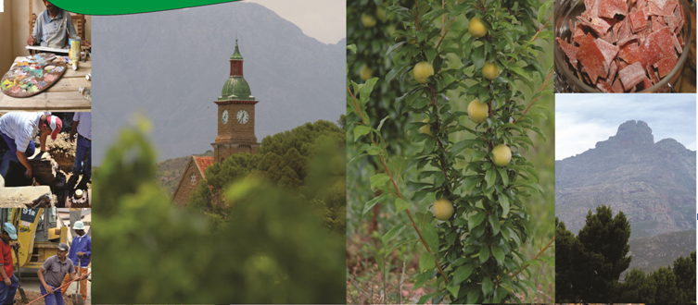

2021/22

INTEGRATED DEVELOPMENT PLAN REVIEW

Contact Details:

Head office:

32 Church Street
Ladismith
6655

Tel Number: 028 551 8000
Fax: 028 551 1766
Email: argiewe@kannaland.co.za
Website: www.kannaland.gov.za

Satellite Offices:
Calitzdorp 044 213 3312
Zoar 028 561 1332
Van Wyksdorp 028 581 2354

Strategic Policy Context

Vision Statement:
The Place of Choice”
To create the ideal environment in which the people of Kannaland would like to live and work.

The mission is to promote: sustainable growth > sustainable human settlements > a healthy community > development and maintenance of infrastructure > increase in opportunities for growth and jobs through:

Our core values are:

Dignity > Respect >Trust > Integrity > Honesty > Diligence

Kannaland at a Glance
The socio economic profile in detail can be read with Chapter 3
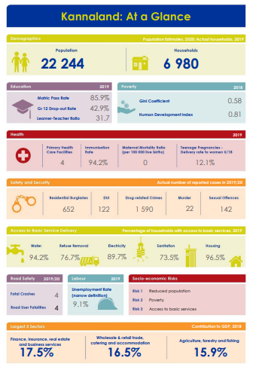

Executive Summary
Introduction

Integrated Development Planning is a process that has become central to local government in driving processes to ensure delivery to residents of a Municipality.

Background
Kannaland Municipality is a Category B Municipality in the Garden Route District. It is the smallest Municipality in the Garden Route District Municipality (the statistics and economical contribution towards the grdm can be viewed in the MERO 2020). The Covid 19 pandemic had a severe impact on the economic growth and state of the financial climate, however the Municipality thrives to deliver services to the community.

Purpose
The purpose of Integrated Development Planning is to facilitate the appropriate delivery of services and provide a framework for economic and social development in a Municipality. The Intergrated Development Planning is guided by legislation, Section 34 of the Municipal Systems Act determines that a municipal council must review its integrated development plan annually under an assessment of its performance measurements and as changing circumstances demand.

Strategic Agenda
The Municipality is the center of development planning. It is at this level of government where people's needs, priorities, and local conditions have to be linked, with national guidelines and sectorial considerations, to specific projects and programs. The Municipality is categorized into seven strategic (key) performance areas. The strategic framework is based on the following (this summary will remain the same as last year’s approved IDP as it must be stressed the importance of the matters that could not be addressed due funding constraints and :hard pandemic we are still facing.)
- Key Performance Area 1: Reliable Infrastructure:
The objective of the Kannaland Municipality is to provide access to reliable infrastructure that will contribute to a higher quality of life for Kannaland citizens. There is an urgent need for the Municipality to upgrade and maintain its infrastructure. Concerning infrastructural planning, the Municipality is in the process of finalizing an Integrated Municipal Infrastructure Plan to eradicate any infrastructural backlogs.

Electricity is the main energy source of households within this municipal area. The electricity infrastructure is outdated and in need of an urgent upgrade. The electricity losses remain a challenge there a need of infrastructure is needed.

The bulk water storage capacity remains a challenge, which emphasise the urgent fast tracking of the construction of dams as indicated later in the document. In order to upgrade water meters, the Municipality obtained funding to install and upgrade water meters in all four wards. The entire Western Cape currently faces a serious drought due to poor rainfall. The demand for water has also steadily increased every year due to the province's rapidly growing population and economy. This, as well as climate change, has added significant pressure on our water supply.

The National Waste Information Regulations requires of municipalities that they must submit actual quantities of waste for the different activities they are registered for on IPWIS from 2018. Kannaland will also be required to obtain funding and make provision for the acquiring of such equipment in their municipal budget.

- Key Performance Area 2: Service Delivery:
The objective of the Municipality is to provide basic services to all its residents and to improve community relationships. The delivery of municipal services in electricity, water, sanitation, refuse, roads and stormwater is a key function of the Kannaland Municipality.

The Municipality faces significant service delivery challenges, including the roll-out of services to rural areas and under-serviced households, ensuring the adequate maintenance of assets occurs, controlling the rising unit costs of service delivery, addressing future bulk supply shortages, and ensuring adequate investment in economic infrastructure.

The Municipality will review the service delivery strategies and service levels and will seek opportunities to service delivery partnerships and the development of a delivery plan and charter for implementation. We urge the community to come and register on a inidigent system to see whether they qualify.

- Key Performance Area 3: Safe Communities:
The objective of the Municipality is to strive towards a safe community in Kannaland through the proactive management of traffic, environmental health, fire, and disaster risks. The function of the traffic service is critical to ensure overall law enforcement and road safety within the Kannaland municipal area. The COVID 19 pandemic has been managed effectively according to new regulations per law, which must be adhered to. The Municipality will focus more on environmental health in terms of alien invasive planning and biodiversity aspects.

The Municipality will review the status of preparedness and contingency plans associated with the prevailing risks identified in the area and to reflect possible risk reduction projects.
With the global disaster, Convid 19 virus, the Municipality, and key stakeholders are in a partnership setting preparedness as well as contingency plans in place. As a Municipality, we adhere to the National Minister's plea of protecting ourselves and fellow South Africans by doing what is expected of us.
- Key Performance Area 4: Socio-Economic Development:
The objective of the Municipality is to facilitate economic growth and social and community development. The Municipality takes cognizance of set priorities of high quality on the improvement of community facilities.
Kannaland's local economy is built on the opportunities created by tourists visiting the area. The tourism industry must be further developed and investment in this industry be promoted to ensure continuous growth. The Municipality will, therefore, engage stakeholders and consider allocations for tourism development, Art and Culture promotion, and SMME development.
The Klein-Karoo has vast developmental potential, especially in terms of agriculture and agro-processing. Agriculture is an important economic sector. The rural character and sensitive natural environment will be protected. The Municipality will identify the cost and source the funding for the development of an Alien Invasive Control Management Plan and assess the influence of climate change.

- Key Performance Area 5: Effective and Efficient Governance
One of the key factors to the success of a Municipality is to be stable, well-managed and efficient. The Municipality promotes efficient and effective governance with high levels of stakeholder participation. The political and administrative leadership of Kannaland Municipality will position itself to manage competing demands for limited resources in a fair equitable and efficient manner.

The Municipality will improve communication of the vision, strategy and plans both internally and externally, to keep staff informed, capacitated and to manage the expectations of the community. In the Agricultural sector, improved processes will be introduced to support inclusive participation in agricultural value-chains and fostering an environment conducive to local and regional private sector investment. Community participation in the structures of local government will be strengthened in all the areas in the Municipality for example an effective functional IDP/Budget Representative forum that meet on a quarterly basis.
- Key Performance Area 6: Efficient Workforce
An Individual Performance Management program for all managers/supervisors up to the third level of reporting will be implemented. The Municipality has developed a Work Place Skills Plan (WSP) of which the main objective is to ensure that there is staff development through training interventions for all levels of staff. A constructive organization renewal process is underway to ensure a well structured municipality.
- Key Performance Area 7: Financial Sustainability
The Municipality will review the budget and expenditure management systems to ensure that efficient and effective service delivery is in line with Municipal priorities. The revenue management systems will be reviewed to maximize revenue generation possibilities and improve revenue performance. The Municipality will introduce measures to enhance levels of customer care, increase responsiveness to consumer billing and other queries. The Municipality will review cash and debt management strategies and practices.
The Municipality will review internal controls and delegations regarding financial management. Funding needs to be sourced to develop an integrated infrastructure and asset management plan.

Foreword Executive Mayor
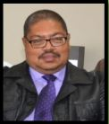
IDP FOREWORD BY
THE ACTING EXECUTIVE MAYOR
The 2021/2022 Integrated Development Plan (IDP) come about through challenging times due to the Covid-19 pandemic and its effects. The pandemic made it highly impossible to call public participating meetings as should be the case to get a thorough indication of our community’s needs.

A further effect of the pandemic was a delay in some projects that should come from the ground but did not happen. Some could not be fully implemented as a result of cost cuts. On the back of it all our IDP co-ordinator left for employment at another municipality.

This IDP Review 2019/2020 will be used as a strategic plan that will guide and inform planning and development in Kannaland Municipality. The IDP is a strategic development plan reviewed annually to guide all development planning in a municipal area and inform municipal budgeting, allocation of resources and performance measurement as prescribed by the Municipal Systems Act.

The National Development Plan calls for the creation of a strong capable developmental state to intervene and transform society as well as grow the economy. Kannaland Municipality has a responsibility to respond to this clarion call and drive fundamental social change in Kannaland. We have to promote the formation and encourage the growth of emerging and small businesses and improve their access to empowerment programmes through soft interventions such as training, mentoring, advice, procurement processes, amongs others. We must empower our local communities to productively make use of the economic development opportunities and resist the triple challenges of poverty, unemployment and inequality.

The Municipality is keenly aware of the fact that we have to redouble our efforts to ensure economic growth and job creation in Kannaland. This will require a collaborative effort to ensure economic growth and job creation in Kannaland. This will require a collaborative effort between the municipality, government, business, labour and civil society. The basis of our vision for the Local economy is the National Development Plan (NDP), which expects that 90% of jobs would have to be created by small and expanding firms by 2030. In pursuit of the objective of the NDP, Kannaland Municipality must formulate plans on how coherent and integrated support services for SMMEs can be rolled out to communities across Kannaland.

As Council, our single most important contribution to a more prosperous Kannaland is to ensure fiscal sustainability. We must strengthen our fiscal resilience and continue with spending reforms across all department in the Municipality. We must pursue, with a greater sense of urgency, the governance and financial reforms aimed at restoring the financial health of Kannaland Municipality.

---------------------
CLLR P ANTONIE
THE ACTING EXECUTIVE MAYOR

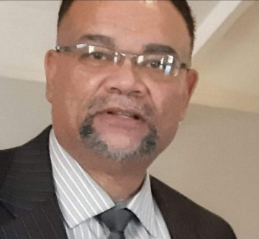
Foreword by the Municipal Manager
IDP FOREWORD BY
THE ACTING MUNICIPAL MANAGER

Introduction

The rural rustic untouched and naturally beautiful Kannaland municipal area, brother to six local municipalities residing in the Garden Route District Municipality is made up of the towns of Calitzdorp, Ladismith, Zoar and Van Wyksdorp. Kannaland was named after the kanna plant (Sceletium tortuosum), named as nature’s Prozac. The kanna plant has been used by South Africans as a mood-altering substance since prehistoric times and it is legal. Evidence of early San and Khoi people in numerous rock paintings, majestic Seweweekspoort, fertile agricultural valleys and the spectacular aerodynamic inter connecting Route 62 traversing this fascinating land is famed as the longest wine route in the world.
Challenges, constraints and solutions:
In search of material prosperity, climate change and desertion.
Material prosperity is always a push factor. Sadly, Kannaland has not expanded to reach its full potential economically. Livelihoods in Calitzdorp and Ladismith are overly dependent on job opportunities presented through the cheese and wine industry.
The effects of climate change has seen regional changes in precipitation, extreme weather events such as heat waves, and expansion of deserts. This threatens to diminish crop yields thereby harming food security leading to desertion of its citizens in search of this notion of material prosperity.
Response:
Kannaland seeks to adopt a policy approach that will not only focus on material prosperity, but also on personal empowerment, social solidarity and human capabilities of co-operation. Economic diversification shall become an economic policy area of focus. Creating an enabling environment for strengthening self-organisation of civil society through community work and member associations. To successfully combat climate change requires action across all economic and societal sectors and at all levels. The principle of the three R’s: Reduce, Re-use Recycle will remain our response to climate change. Interesting is to note that the world is moving towards eating plants, not meat to improve climate change and improve human health. A Green finance agenda - mobilising private capital for greener investments - will seek to access available funds set aside to support climate action and adaptation. This becomes crucial to mitigate the harmful effects caused by industrialised cities surrounding Kannaland thereby ensuring an alignment of climate change to the health and social agenda. A strategic foresight which is consistent with a pathway of transition to a decarbonised society through the introduction of appropriate technology innovation and initiated inter-governmental institutional processes will lead to an infrastructure investment rethink.
In search of jobs and service delivery excellence

Our citizens want jobs and good quality services rendered. Inherited and ongoing aging infrastructure networks are a usage problem and it hampers development. This is as a direct result of a lack of funds for capital projects falling outside areas of MIG preference areas and a lack of political will to divert development to rural areas. The current demand for services from households that are economically part of lower income groups are increasing which exacerbates the current unfunded status of Kannaland which is compounded by its inability to reserve adequate internal funds for smaller capital projects. The over reliance, access to and prioritisation of government grant funding for rural communities is not in line with the principles of good governance and a growing concern. Pressure groups are mostly ignoring the reality and dynamics regarding Kannaland Municipality’s diversity in terms of it’s socio economic profile coupled with its limited resources. People who have moved from farms are now living in informal areas with little or even no infrastructure and facilities whilst ironically wealthy households who have purchased retirement homes demand five star services.

Response:

We will strive towards creating a virtuous cycle of inclusive growth by addressing infrastructural developmental inequalities and realising of a society where all individuals can make use of their full potential, thus breaking cross generational developmental inequalities, as well as the rural and urban divide.
Compliance and statutory matters:

New compliance driven legislation is continuously being drafted in order to respond to the need for alignment and to provide improved legal frameworks for the practical implementation of the municipal IDP and PMS, the most recent being National Treasury Circular 88 and the respective Addendum I and II. Kannaland Local Municipality certainly is not alone when it comes to requisite outdated Master Plans, Strategic plans and business re-engineering transformation frameworks.
Response:
It’s against aforementioned background that the Acting Municipal Manager and his middle management have recruited a highly quantified and experienced IDP and Performance Management expert to assist with the turnaround of the Municipality. From a service delivery point of view, we have further succeeded in recruiting a highly trained young professional as Head of Electrical Engineering Services previously employed through Eskom. The City of George has recently also followed the same strategy by employing a Director from Eskom. It is foreseen that these two highly skilled teammates will work very closely together to share their skills and knowledge thereby promoting excellence and quality services to their respective communities.

Politics and playing the blame game for political aspirations:

Ironically most citizens do understand the dynamics and challenges of Kannaland as one of the poorest Municipality’s in the Western Cape Province with unequal wealth sharing but contrary to this, opportunistic and unrealistic pressure groups are usually pointing fingers to the officials and the Accounting Officer. A very few concerned groups are really showing appreciation for the efforts of labour force irrespective of severe shortcomings and lack of resources.

Way forward: A holistic, credible and responsive IDP.

The Section 139 intervention by the Provincial Government was not serving its intended legitimate and rightful purpose. Personal vendetta’s and a political agenda contrary to the aspirations of the community of Kannaland characterised the Administration intervention. Management is however very optimistic that the latest recruitment of aforementioned specialists together with the existing dedicated staff are willing and geared to work together with both Provincial and National Government to pave the way forward in ensuring an improved state of affairs and further build on the achievements made thus far. I have also learned that several retired technical and administrative experts are willing to assist with in an advisory capacity through our envisioned community associations to be established.

Conclusion
Kannaland Municipality and its inhabitants and stakeholders must realise that the only way forward depends on all of us working together as a collective, in good fellowship and through established partnerships which promote good governance and improved service delivery standards through the effective utilisation of both scarce and available resources optimally and in a cost effective and responsible way. Playing politics and blame games will not solve our problems. Such behaviour will rather contribute to further the harm and destruction of our beautiful towns and rural surroundings.

Commitments
- The IDP will lead the way to the transition to a prosperous clean energy economy.
- We will work together and establish community associations in all municipal sectors.
- We will seize all opportunities for inclusive rural growth.
- We renew our committed towards fighting against corruption and leading by example.
- Access to education is a human right and a strategic policy area for the development of more inclusive, prosperous and peaceful societies.
- Gender equality is crucial for economic growth. We will continue to promote initiatives aimed at ending all forms of discrimination against women and girls and gender based violence, women’s access to leadership and decision making positions, the development of women and girl’s digital skills an increasing their participation in STEM (Science, Technology, Engineering and Mathematics) and high tech sectors and better engage with women entrepreneurs.
- We will engage in public dialogue in order to discard the diffusion of so-called fake news.
R BUTLER
ACTING MUNICIPAL MANAGER

Table of Contents
Contact Details: 1
Strategic Policy Context 2
Kannaland at a Glance 3
Executive Summary 4
Foreword Executive Mayor 8
Table of Contents 10
Glossary of Acronyms 15
Chapter 1 – Introduction: Strategic Planning 17
1.1 Integrated Development Planning 17
1.2 IDP Legislative Framework 18
1.3 Kannaland IDP Process 20
1.3.1 IDP and Budget Process Plan Legislative Requirements 21
1.4 Status quo of critical internal transformation needs and service delivery development challenges: 47
1.5 Inter-Governmental Relations and Policy Alignment 50
` 50
1.5.1 MEDIUM TERM STRATEGIC FRAMEWORK 50
1.5.2 Provincial Government Western Cape - Provincial Strategic Objectives 52
1.5.3 Garden Route District Municipality’s Strategic Goals 52
1.5.4 Kannaland Municipality’s Key Performance Areas (Strategic Objectives) 53
1.5.5 Horizontal Policy Alignment (remain unchanged) 55
1.5.6 Inter-Governmental Cooperation 62
1.5.7 Impact of the COVID 19 Pandemic on participatory processes 63
1.5.8 Public Participation sessions 64
1.5.9 Public Needs Analysis 66
Chapter 2 – Municipal Socio-Economic Profile 77
2.1 Contextualize Analysis 77
2.3 Socio economic Profile 82
2.3.1 Age Cohorts 82
2.3.2 Educational Levels 82
2.3.2.1 Educational facilities 83
2.3.2.2 Education outcomes 84
2.3.3 Employment and Unemployment 84
2.3.4 Health 86
2.3.4.1 Emergency medical services 86
2.3.4.2 HIV/AIDS and Tuberculosis (TB) 87
2.3.5 Safety and Security 87
2.3.6 Basic services provided in Kannaland 89
2.3.6.1 Indigent support 89
2.3.6.2 Access to water 89
2.3.6.3 Access to sanitation 89
2.3.6.4 Access to electricity 90
2.3.6.5 Access to waste removal 90
2.3.6.6 Access to adequate housing 90
2.3.7 Spatial and Environmental Analysis 91
2.3.8 Biodiversity 93
2.3.9 Climate 94
2.3.10 Kannaland Flora 96
2.3.11 Disaster Management 96
2.3.11.1 Hazards / Vulnerabilities Assessments 97
2.3.11.2 Risk Reduction Measures 97
2.3.11.2.1 Risk Preparedness 97
2.3.11.2.2 Risk Prioritisation 97
2.3.11.2.3 Risk Reduction Measures 98
2.3.11.2.4 Response and Recovery Measures 98
2.3.11.2.5 Mitigation measures 100
2.3.12 Tourism 100
2.3.13 Agriculture 105
2.3.13.1 Targeted Commodities 106
2.3.13.2 Land Classes 106
2.3.14 Integrated Rural Development 107
2.3.14.1 Ecosystem Status 109
2.3.14.1.1 Rise of small - medium-scale farmer 109
2.3.14.1.2 Climate Change 109
2.3.15 Spatial Alignment 110
2.3.15.1 Legislation Regulating Municipal Spatial Development Frameworks 110
2.3.15.2 Spatial Planning Categories For Land Use Management 112
2.3.15.3 Major Infrastructure Projects (as per SDF) 114
2.3.16 Major Tourism Destinations 114
2.3.16.1 Land Reform 115
Chapter 3: Governance and Institutional Structures 118
3.1 Political Structure 118
3.1.1 Municipal Council 118
3.1.2 Executive Mayor 118
3.1.3 Ward Committees 118
3.1.4 Political Parties 118
3.1.5 Councilors 119
3.1.6 Mayoral Committee 119
3.1.7 Oversight Structures 119
3.1.7.1 Municipal Public Accounts Committee (MPAC) 119
3.1.7.2 Audit and Performance Committee 119
3.1.7.3 Administrative Structure 120
3.1.7.4 Committee Services 120
Chapter 4: Strategic Thrust 122
122
4.1 High Level SWOT Analysis 122
4.2 Strategic Priorities 124
4.3 Implementation Strategy 125
4.3.1 Key Performance Area 1: Reliable Infrastructure 125
PDO 1: To provide access to reliable infrastructure that will contribute to a higher quality of life for Kannaland citizens: 125
4.3.2 Key Performance Area 2: Service Delivery 145
PDO 2: Provide basic services and improve public relations 145
4.3.3 Key Performance Area 3: Safe Communities: 146
PDO 3: To strive towards a safe community in Kannaland through the proactive management of traffic, environmental health, fire and disaster risks. 146
4.3.4 Key Performance Area 4: Socio-Economic Development 149
PDO 4: To facilitate economic growth and social and community development 149
4.3.5 Key Performance Area 5: Effective and Efficient Governance 151
PDO 5: To promote efficient and effective governance with high levels of stakeholder participation 151
4.3.6 Key Performance Area 6: Efficient Workforce 151
PDO 6: To provide an efficient workforce by aligning our institutional arrangements to our overall strategy 151
4.3.7 Key Performance Area 7: Financial Sustainability 153
PDO 7: To strive towards a financially sustainable Municipality 153
CHAPTER 5: Proposed Organisational Performance 159
5.1 Five Year Performance Scorecard 159
5.4.1 Performance Scorecard Definitions – will be included in the final IDP 163
CHAPTER 6: FINANCIAL PLAN 170
6.1 Financial strategy 170
6.2 Management and governance frameworks 171
6.3 Revenue Framework 172
6.4 Rates charges, tariffs and timing of revenue collections: 173
6.1 Operating expenditure framework 174
6.2 Financial schedules 176
6.3 CASHFLOW 178
7.1 Capital Budget 179
7.2 Budgeted Financial Performance – A2 181
Chapter 7: Sector Planning 184
7.1 Status Quo Master Plans, Operational, Maintenance and other plans 184
7.2 Relationship between sectoral plans: 186
7.3 List of Statutory, Strategic and Operational Plans 188

Tables:
Table 1: institutional challenges and interventions 47
Table 2: KPA – Kannaland Municipality 54
Table 3: Strategic Alignment 61
Table 4: Sector Engagements 62
Table 5: Ward Committee Members 66
Table 6: IDP Priorities 71
Table 7: Source Western Cape DSD 2020 82
Table 8: KSEP: Education Outcome 2020 84
Table 9: Mero 2019 Quantec Research, 2020 84
Table 10: Source Mero 2020 - employment performance per sector 85
Table 11: Source MERO 2019 – Unemployment rate per centage 86
Table 12: health care facilities 86
Table 13: Quantec Research 2018 91
Table 14: Critical Biodiversity Areas - 94
Table 15: Protected land areas: Eden District 95
Table 16: Tourism and culture attraction – refer to figure 3.4.13.1 in SDF Tourism and culture attraction 101
Table 17: Vegetation Types 106
Table 18: Ecosystem Status 109
Table 19: Kannaland SDF – refer to figure 5.3.1.1 in SDF 111
Table 20: SDF alignment with sector plans 111
Table 21: councilors 119
Table 22: MPAC 119
Table 23: audit and performance committee 119
Table 24: SWOT Analysis 123
Table 25: Ladismith WWTW Table 26: Calitzdorp WWTW 126
Table 27: Waste Water Treatment plant – as indicated in SDF figure 3.4.9.1 127
Table 28: Proposed funding for electricity upgrades 132
Table 29: Zoar Internal Road upgrade 134
Table 30: Calitzdorp Bergsig Internal Roads 135
Table 31: infrastructure budget 137
Table 32: SATELLITE IMAGE OF LADISMITH LANDFILL SITE SHOWING PERMITTED BOUNDARY OF THE SITE IN RED (source, google earth satellite imagery, accessed on 15 May 2019 image date 10 April 2019) 138
Table 33: Satellite image of Calitzdorp landfill site showing permitted boundary of the site in red (source, google earth satellite imagery, accessed on 15 May 2019 image date 28 April 2018) 138
Table 34: Satellite image of Zoar landfill site showing permitted boundary of the site in red (source, google earth satellite imagery, accessed on 15 May 2019 image date 10 April 2019) 139
Table 35: Satellite image of Van Wyksdorp landfill site showing permitted boundary of the site in RED (source, google earth satellite imagery, accessed on 15 May 2019 image date 10 April 2019) 140
Table 36: Planned Projects not yet registered 141
Table 37: Infrastructure Budget 142
Table 38: Proposed Housing Projects - Source: ASLA 142
Table 39: Calitzdorp Bergsig Housing Project 143
Table 40: Ladismith Housing Project: Parmalat 143
Table 41: Ladismith Housing Project: Schoongezicht Project 144
Table 42: Housing Project: Van Wyksdorp 144
Table 43: Performance Scorecard 163
Table 44: Cashflow 180
Table 45: Budgeted capital expenditure by vote, functional classification and funding 183
Table 46: A2 188
Table 49: Status Quo Master Plans, Operational, Maintenance and other plans 191
Table 50: Relationship between sector plans 193

Glossary of Acronyms
BBBEE | Broad Based Black Economic Empowerment
CAPEX | Capital Expenditure
CDW | Community Development Worker
CIP | Community Integrated Projects
DBSA | Development Bank of South Africa
DORA | Division of Revenue Act
DWA | Department of Water Affairs
EIA | Environmental Impact Assessment
EPWP | Expanded Public Works Program
IDC | Industrial Development Corporation
HSP | Human Settlements Plan
IDP | Integrated Development Plan
INEP | Integrated National Energy Plan
IRS | Implementation Ready Study
KPA | Key Performance Area
KPI | Key Performance Indicator
LED | Local Economic Development
LGTAS | Local Government Turnaround Strategy
MIG | Municipal Infrastructure Grant
MSIG | Municipal Systems Improvement Grant
MSIG | Municipal systems improvement grant
NDP | National Development Plan
OPEX | Operational Expenditure
PMS | Performance Management System
PSO | Provincial Strategic Objectives
RBIG | Regional Bulk Infrastructure Grant
SALGA | South African Local Government Association
SDBIP | Service Delivery and Budget Implementation Plan
SMME | Small, Micro and Medium Enterprises
WTW | Water Treatment Works
WWTP | Waste Water Treatment Plant
WWTW | Waste Water Treatment Works

CHAPTER 1:
Strategic Planning
Legal framework
IDP process
Institutional challenges
Internal challenges and strategic intervention
Intergovernmental relations and policy alignment
Public Participation Analysis

Chapter 1 – Introduction: Strategic Planning

Integrated Development Planning
This document represents the 4th review of the Kannaland Municipality Integrated Development Plan which is an amendment of the five-year document. The IDP must be read together comprehensive with the five-year IDP and the set of municipal wide sector plans.

The plan will look at economic and social development for the area as a whole. It must set a framework for how land should be used, what infrastructure and services are needed and how the environment should be protected. Integrated Development Planning is the strategic tool of a Local Municipality, designed to bring together and to harmonize individual plans of the Municipality’s departments. The plan guides all future development of the Municipality by setting priorities, allocating resources and defining periods and indicators.

The IDP has a lifespan of 5 years that is directly linked to the council’s elected term of office. After every local government election, the new council has to prepare their IDP in terms of the strategic planning and development. The IDP should be based on long-term spatial, infrastructure and finance plans. The standards of service delivery, financial planning and reporting will therefore be monitored through an effective performance management system.

Municipalities are encouraged and supported by both national and provincial government to develop realistic and credible IDP’s that not only comply with relevant legislation but –
- owned by local leadership, municipal management and community as the single strategic plan to direct resources within the Municipality;
- driven by the management team and systems within the Municipality with implementation regularly monitored during the year through the performance management system;
- contain a long-term development strategy guiding investment across the municipal area;
- provide an investment plan for national, provincial and local government and non-governmental stakeholders to enhance and enable joint planning and resource alignment to improve service delivery to all stakeholders; and
- include local area plans to localise the strategy and implementation of the IDP
This IDP guides all future developments of the Municipality by setting priorities, allocating resources and defining periods and indicators. In preparing the IDP the Municipality has set out to develop an IDP which aims to foster more effective service delivery by providing the framework for economic and social development in terms of the municipal mandate. In doing so, it contributes toward the notion of a developmental local government that fosters a culture of co-operative governance.
Kannaland Municipality strives to continue to develop the IDP as an effective management tool of which the aim is:
- Creating a greater level of focus and thereby improving on the strategic nature of the document;
- Aligning this strategic document with the realities of financial and human resources;
- Alignment of the IDP with the activities of the sector departments
- Alignment of the IDP with the various sector plans

IDP Legislative Framework
The mandate of the Municipality is provided for in section 152 of the Constitution of South Africa that stipulates the objectives for developmental local government, namely:
- to provide democratic and accountable government for local communities;
- To ensure the provision of services to communities in a sustainable manner
- To promote social and economic development;
- To promote a safe and healthy environment; and
- To encourage the involvement of communities and community organisations in matters of local government.
Although the implementation of the IDP is monitored through the performance management system, an annual process is required to check the relevance of the strategic plan within a dynamic environment.
The IDP is given legal status by the following primary and secondary legislation and regulations:
- The Municipal Systems Act 32 of 2000 (referred to as MSA)
- The Municipal Finance Management Act No. 56 of 2003 (referred to as MFMA)
- Municipal Planning and Performance Management Regulations, 2001: Department of Provincial & Local Government
The Municipal Systems Act 32 of 2000 requires that all Municipalities must prepare and adopt an Integrated Development Plan (IDP) and must subject it to an annual review.
In terms of Chapter 5, Section 25, all Municipalities must, within a prescribed period after the start of its elected term, adopt a single, inclusive and strategic plan for the development of the Municipality. Section 34 of the same chapter requires a Municipality to review the IDP annually and, where necessary, to amend the plan in accordance with a prescribed process.
In addition to the requirement for every Municipality to compile such an Integrated Development Plan, the Municipality is also required to monitor and evaluate its performance. Section 34 of the MSA deals with the review and amendment of the IDP:

A Municipal Council must review its Integrated Development Plan annually in accordance with an assessment of its performance measurements in terms of Section 41; and to the extent that changing circumstances so demand; and may amend its Integrated Development Plan in accordance with prescribed processes.

The IDP has to be reviewed annually in order to:
- Ensure its relevance as the Municipality’s strategic plan;
- Inform other components of the Municipal business process including institutional and
- financial planning and budgeting;
- Inform the cyclical inter-governmental planning and budget cycle.

The Local Government: Municipal Planning and Performance Management Regulations, 2001 states in Chapter 2 that the IDP review and amendment process must adhere to the public participation requirements as outlined in Chapter 4 of the MSA.

Section 16(1) of the MSA requires that a Municipality must develop a culture of Municipal
Governance that complements formal representative government with a system of anticipatory governance, and must for this purpose encourage, and create conditions for, the local community to participate in the affairs of the Municipality.

Regulation 2(4) of the Local Government Municipal Planning and Performance Management
Regulations, 2001 requires that:
- only a member or committee of a municipal council may propose an amendment to the IDP;
- the proposal to amend must be accompanied by a reason and be aligned with the district
- IDP;
- the amendment is adopted by a decision of the Municipal Council;
- all the members of the council be given reasonable notice;
- the proposed amendment/s be published for public comment for a period of at least 21 days in a manner which enables the public to make representations in this regard; and the applicable district Municipality be consulted.

In terms of Section 16 and 17, the Mayor must, at a Council meeting not later than the 31st of March each year, table any draft and proposed amendments to the IDP with the draft budget. In terms of Section 24 of the MFMA, the municipal council must at least 30 days before the start of the budget year consider the approval of the annual budget. Both pieces of legislation (Municipal Systems Act and the Municipal Financial Management Act) emphasize the close relationship between the budget processes.

Kannaland IDP Process
The IDP was developed in terms of an IDP process plan developed to ensure that the IDP process complies with certain minimum quality standards, to ensure that proper coordination between and within the spheres of government is established and engaged during the preparation of the IDP.

Council approved the process plan for 2021/22 on 30 Augustus 2020, which sets out the methods and approached according to which the IDP planning process to be conducted.

The process plan enhances integration and alignment between the IDP and Budget, thereby ensuring the development of an IDP-based budget. It fulfils the role of a business plan or an operational framework for the IDP process outlining the manner in which the IDP process will be undertaken. In addition, it identifies the activities in the processes around the key statutory annual operational processes of the budget and IDP compilation, performance management implementation and the adoption of the Municipality’s annual report.

The IDP and Budget processes are two distinct but integrally linked processes which must be coordinated to ensure that the IDP and budget related policies and the final budget are mutually consistent and credible. Credibility refers to the Municipality’s ability and capacity to spend and deliver services in accordance with its approved budget. The process creates its own dynamics since it encompasses the involvement of external role-players and vested interest groups, therefore
it requires accurate logistical planning and arrangements of engagement sessions to ensure that the process is implemented in accordance with the approved schedule.

IDP and Budget Process Plan Legislative Requirements
According to Section 28(1) of the Municipal System Act, No 32 of 2000 a municipal council must adopt a process set out in writing to guide the planning, drafting and review of its integrated development plan. This Process Plan outlines the programme to be followed and provides detail on the issues specified in the Act. A process plan must include the following:
- A programme specifying time-frames for the different steps;
- Outline mechanisms, processes and procedures for consultation of the community, organs of state, traditional authorities and role-players;
- Identify all plans and planning requirements binding on the Municipality;
- Be consistent with any other matters prescribed by legislation.
Section 21(1) of the Municipal Finance Management Act (Act 56 of 2003) further prescribes that the Mayor of a Municipality must co-ordinate the processes of preparing the annual budget and for reviewing the Municipality’s IDP. It is therefore imperative that a time schedule outlining the key activities in the process with deadlines for attainment be tabled to Council for approval ten (10) months prior to the final approval of the IDP and Budget.
In order to ensure certain minimum quality standards of the IDP process and a proper coordination between and within the spheres of government, the preparation of the planning process is regulated by the Municipal Systems Act, No 32 of 2000. Section 28 of the Systems Act stipulates that:
- Each Municipal Council must adopt a process set out in writing to guide the planning, drafting, adoption and review of the IDP.
- The Municipality must through appropriate mechanisms, processes and procedures established in terms of Chapter 4, consult the local community before adopting the process.
- A Municipality must give notice to the local community of particulars of the process it intends to follow.
In terms of Section 29(1) of the Municipal Systems Act the process must:
- be in accordance with a predetermined programme specifying timeframes for the different steps;
- through appropriate mechanisms, processes and procedures allow for the local community to be consulted on its development needs and priorities, allow the local community to
- participate in the drafting of the IDP, and allow organs of state, including traditional authorities, and other role players to be identified and consulted on the drafting of the IDP;
- provide for the identification of all plans and planning requirements binding on the Municipality in terms of national and provincial legislation.

Roles and responsibility:
ROLE PLAYERS | ROLES AND RESPONSIBILITIES
Council | - Approve and adopt the process and framework plans as well as IDP and budget  - Monitor the implementation and approve any amendments of the plan when necessary.
Executive Mayor and Mayoral Committee | - Consider the IDP and Budget timetable and Process Plan and submit to Council for approval.  - Overall management, coordination and monitoring of the IDP process.  - Assign and delegate responsibilities in this regard to the Municipal Manager.  - Submit the draft IDP to Council for approval.  - Submit final IDP and Budget to Council for adoption.  - Provide political guidance in IDP and Budget (in terms of section 53(a) of the MFMA Act 56 of 2003.  - Co-ordinate plans and Timetables for the Budget.  - Exercise close oversight on Budget Preparation Process.
Speaker | - Overall monitoring of the public participation process.  - Exercise oversight of the ward committee system.
Ward Councillors / Ward Committees | - Form a link between the Municipality and residents.  - Link the IDP process to their respective Wards.  - Assist in the organising of public consultation and participation.  - Monitor the implementation of the IDP with respect to their particular wards  - Encourage residents to take part in the IDP process.

Municipal Manager | - Managing and coordinate the entire IDP process as assigned by the Executive Mayor.  - Fulfil the duties of Accounting Officer as set out in Sections 68 and 69 of the MFMA, Act 56 of 2003.
IDP Co-ordinator | - Prepare IDP process plan and monitor the timeously implementation thereof.  - Day to day management and coordination of the IDP process.  - Ensure stakeholder engagement in IDP process by organising and setting up meetings for engagement.  - Ensure that the IDP process is participatory and that planning is ward-based oriented.  - Respond to public and MEC comments on Draft IDP.  - Compilation of comprehensive, neat and presentable IDP document that complies with all legislative requirements.  - Amend the IDP document in accordance with the comments of the ME
Executive Managers and Head of Departments | - Provide relevant technical, sector and financial information for analysis for determining priority issues.  - Provide technical expertise in consideration and finalisation of strategies and identification of projects.  - Provide departmental, operational and capital budgetary information.  - Preparation of project proposals, integration of projects and sector programmes.  - Give input during the IDP review process
IDP-Steering Committee | - Refinement and Quality check of IDP document to ensure compliance with legislation.  - Consist of Municipal Manager, Senior Management, IDP Co-ordinator, Speaker.  - Provide an organisational mechanism for discussion, negotiation and decision making between stakeholders.  - Represents the interest of their functions in the IDP process.  - Monitors the performance of the planning and implementation process and update of the performance system  - Comprises of the Mayor, Councillors, Ward Committees, Municipal Manager, Directors, representatives of various sectors, NGO’s, Government Departments and specialised community members.
Budget-Steering Committee (GRAP) | - To provide technical assistance to the mayor in discharging the responsibilities set out in Section 53 of the MFMA.  - Consist of portfolio Councillor for Financial matters, the Municipal Manager, the Chief Financial Officer, Senior Managers and Head of Departments to give technical advice if necessary.

The approved detailed process plan is depicted as follows
INTEGRATED DEVELOPMENT PLAN (IDP) AND BUDGET TIME-SCHEDULE FOR COMPILATION AND APPROVAL OF THE 2021/22 IDP REVIEW AND MEDIUM TERM EXPENDITURE FRAMEWORK
REF | ACTIVITY | LEGISLATIVE REQUIREMENTS | TARGET DATES |  |  | RESPONSIBLE PERSON
REF | ACTIVITY | LEGISLATIVE REQUIREMENTS | IDP | BUDGET | PMS
JULY
1 | The Accounting officer must no later than ten working days after the end of each month, submit a report on the budget to the mayor, provincial treasury and national treasury - | MFMA 71 | 14/07/2020 |  |  | Accountant: Financial Reporting
2 | Publish the section 71 on the website | MFMA 75 |  | 15/07/2020 |  | LED/Communication Coordinator  Accountant: Financial Reporting
3 | Make public the projections, targets and indicators as set out in the SDBIP (no later than 14 days after the approval of the SDBIP) | MFMA - Sec 53(3)(a)  MBRR - Reg 20(2)(b) |  |  | 02/07/2020 | IDP/PM Coordinator
4 | Commence with the preparation of Capital Adjustments Budget for the 2020/21 Financial year | MFMA - Sec 28(2)(e)  MBRR - Reg 23(5) |  | 15/07/2020 |  | CFO  BTO Manager
5 | Submit 2019/20 Fourth Quarter Financial and Performance Report to Council/Mayco for approval | MFMA - Sec 52(d) MFMA - Sec 71(1) MBRR - Reg 29 |  | 30/07/2020 |  | CFO  Accountant: Financial Reporting
6 | Submit the fourth quarter of 2019/20, section 52 report, to Provincial and National Treasury | MBRR Sec 31 |  | 31/07/2020 |  | CFO  Accountant: Financial Reporting
7 | Drafting and signing of new performance contracts for Section 57 Managers for 2021/22 financial year | MPPMR Section 13 |  |  | 31/07/2020 | MM  CFO  Direc Infrastructure
AUGUST 2020
8 | The Accounting officer must no later than ten working days after the end of each month, submit a report on the budget to the mayor, provincial treasury and national treasury - | MFMA 71 |  | 14/08/2020 |  | Accountant: Financial Reporting
9 | Place 2019/20 Fourth Quarter Performance Report and the section 71 of 2020/21 financial year on website | MFMA - Section 75 (2) MSA 21(b) |  | 14/08/2020 |  | LED/Communication Coordinator  Accountant: Financial Reporting
10 | Submit 4th Quarter (2019/20) Performance Reports - SDBIP Performance Reports to National and Provincial Treasuries | MPPMR - Reg 13 |  | 04/08/2020 |  | Accountant: Financial Reporting
11 | Budget Steering Committee considers 2020/21 Adjustments Budget | MFMA - Sec 28 MBRR - Part 4 |  | 25/08/2020 |  | CFO  BTO
12 | Tabling of 1st 2020/21 Adjustment Budget to Council to incorporate Rollovers, Changes on SDBIP and KPI’s as per adjustment budget. | MFMA - Sec 28(2)(e)  MBRR - Reg 23(5) |  | 27/08/2020 |  | CFO  BTO
13 | Management considers self-assessment report identifying gaps/challenges in the IDP Process and proposed measures to improve on the process including a review on external mechanisms | Not applicable | 31/08/2020 |  |  | Executive Management
14 | Management start process to review current budget related policies and compile newly needed budget related policies | MFMA - Sec 21 MBRR - Part 3 |  | 31/08/2020 |  | CFO  BTO
15 | Commence with the annual performance assessment (subject to change of date) | MPPMR Section 13 |  | 31/08/2020 |  | IDP/PM Coordinator
16 | Request information regarding tariffs for input in tariff book. | MFMA - Chapter 4 MBRR - Part 3 |  | 31/08/2020 |  | CFO  BTO
17 | Executive Mayor and Mayoral Committee recommend that Budget / IDP / PM Time Schedule (at least 10 months before the start of the budget year) and IDP Public Participation Roadshow Schedule be approved by Council | MSA S28 | 27/08/2020 |  |  | IDP/PM Coordinator
18 | Identification of mandatory projects prioritised for implementation for 2021/22 and two years by Internal Sector Departments. | Internal Management Procedure | 31/08/2020 |  |  | Executive Management
19 | Attend Quarterly District IDP Meeting (Virtual) to give effect to alignment planning and development with regards to IDP, Budget and PMS. | Not applicable | 06/08/2020 |  |  | IDP/PM Coordinator
20 | Operating Budget: Salaries and Wages schedules to Directors for scrutiny and corrections. | Internal Management Procedure |  | 31/08/2020 |  | CFO  BTO
21 | Publication of approved adjustments budget on website and submit to National & Provincial Treasuries both printed and electronic formats. | MFMA S75 |  | 31/08/2020 |  | LED/Communication Coordinator  Accountant: Financial Reporting
22 | Drafting the AFS (as per Government notice No 43582, exemption has been granted by the Minister of Finance) | Internal Management Procedure |  | TBC |  | TBC
23 | Submit unaudited 2018/19 Annual Report to Auditor-General as required by legislation (Due to exemption the APR and draft AR will be submitted concurrently with the AFS to AG) | MFMA S126  MFMA Cirular |  | TBC |  | TBC
24 | Gather performance information (POE’S) that substantiate actual performance reported on 2019/20 Top level SDBIP and Management Scorecard. | Internal Management Procedure |  |  | Ongoing | IDP/PM Coordinator
SEPTEMBER
25 | The Accounting officer must no later than ten working days after the end of each month, submit a report on the budget to the mayor, provincial treasury and national treasury - | MFMA Sec 71 |  | 14/09/2020 |  | Accountant: Financial Reporting
26 | Place the section 71 on the website | MFMA Sec 75 |  | 15/09/2020 |  | LED/Communication Coordinator  Accountant: Financial Reporting
27 | Submit the approved Budget / IDP / PM Time Schedule to the MEC for Local Government and Provincial Treasury | MSA - Sec 21, 21A, 28(3) | 01/09/2020 |  |  | IDP/PM Coordinator
28 | Place advertisement to notify the public of the approved Budget / IDP / PM Time Schedule on website, local newspapers and notice boards | MSA - Sec 21, 21A, 28(3) | 01/09/2020 |  |  | LED/Communication Coordinator  IDP/PM Coordinator
29 | Attend IDP Provincial Coordinating Forum | MSA Section 24 | 03/09/2020 |  |  | IDP/PM Coordinator
30 | Assess and identify information from adopted Sector Plans for integration into the IDP Review document if possible | MSA Section 34 | 24/09/2020 |  |  | Municipal Manager  IDP/PM Coordinator
31 | Convene high level strategic planning session to review municipal high level strategies (short and long term) development objectives | Internal Management Procedure | 30/09/2020 |  |  | Executive Management
32 | Set up public participation schedule with councilors for project and financial projections in terms of the IDP and Budget 2021/22 | Internal Management Procedure | 30/09/2020 |  |  | Councilors  IDP/Pm Coordinator
OCTOBER
33 | The Accounting officer must no later than ten working days after the end of each month, submit a report on the budget to the mayor, provincial treasury and national treasury - | MFMA Sec 71 |  | 14/10/2020 |  | Accountant: Financial Reporting
34 | Place the section 71 on the website | MFMA Sec 75 |  | 15/10/2020 |  | LED/Communication Coordinator  Accountant: Financial Reporting
34 | Public participation meetings | MFMA - Sec 22(a) MSA - Sec 21A MPPMR - Reg 15(3) | TBC | TBC | TBC | TBC
35 | Departmental IDP/Budget Work sessions to review projects, key initiatives and programmes from Community IDP Needs List and identified actions emanating from the sector plan analysis | Internal Management Procedure | 29/10/2020 |  |  | Executive Management  IDP/PM Coordinator
36 | First Quarter 2020/21 Performance Report to senior management for revision (informal) | MPPMR - Reg 13 |  |  | 27/10/2020 | Executive Management  IDP/PM Coordinator
37 | Submit AFS and related documents to AG | MFMA S126, 127, 129, 133  MFMA S177 (1)(b) |  | 30/10/2020 |  | CFO  BTO
38 | Submit first section 52 report to council | MFMA - Sec 52(d) MFMA - Sec 71(1) MBRR - Reg 29 |  | 29/10/2020 |  | CFO  BTO  Accountant: Financial Reporting
39 | Place first quarter section 52 report on website after approval | MFMA S75  MBRR S31 |  | 30/10/2020 |  | Accountant: Financial Reporting  LED/Communication Coordinator
40 | Submit first quarterly section 52 report to Provincial Treasury | MFMA 75  MBRR S133 |  | 30/10/2020 |  | Accountant: Financial Reporting  LED/Communication Coordinator
NOVEMBER
41 | The Accounting officer must no later than ten working days after the end of each month, submit a report on the budget to the mayor, provincial treasury and national treasury - | MFMA 71 |  | 12/11/2020 |  | Accountant: Financial Reporting
42 | Place the section 71 on the website | MFMA 75 |  | 12/11/2020 |  | Accountant: Financial Reporting  LED/Communication Coordinator
43 | Prepare the draft salary budget for 2021/22. | Internal Management Process |  | 25/11/2020 |  | CFO  BTO
44 | Directors submit capital budget projections for the outer financial year. | Internal Management Procedure |  | 25/11/2020 |  | CFO  BTO
45 | Directors submit operating expenditure / income budget and current year final projections to BTO | Internal Management Procedure |  | 25/11/2020 |  | CFO  BTO
46 | Finalise preliminary projections on OEPX 2021/22 | Internal Management Procedure |  | 25/11/2020 |  | CFO  BTO
47 | Provide tariff list structure to departments for further inputs | Internal Management Procedure |  | 25/11/2020 |  | CFO  BTO
48 | Discuss capital budget inputs with Senior Management | Internal Management Procedure |  | 25/11/2020 |  | CFO  BTO
49 | BS Committee discuss the draft capital budget emanating from departments | Internal Management Procedure |  | 30/11/2020 |  | CFO  BTO
50 | Draft Initial changes to IDP (summary): Reconcile community, administrative and political priorities | Internal Management Procedure | 30/11/2020 |  |  | IDP/PM Coordinator
DECEMBER
51 | The Accounting officer must no later than ten working days after the end of each month, submit a report on the budget to the mayor, provincial treasury and national treasury - | MFMA 71 |  | 14/12/2020 |  | Accountant: Financial Reporting
52 | Place the section 71 on the website | MFMA 75 |  | 15/12/2020 |  | Accountant: Financial Reporting  LED/Communication Coordinator
53 | Attend the quarterly Provincial IDP Managers Forum | Not applicable | 03/12/2020 |  |  | IDP/PM Coordinator
JANUARY
54 | The Accounting officer must no later than ten working days after the end of each month, submit a report on the budget to the mayor, provincial treasury and national treasury - | MFMA 71 |  | 14/01/2021 |  | Accountant: Financial Reporting
55 | Place the section 71 on the website | MFMA 75 |  | 15/01/2021 |  | Accountant: Financial Reporting  LED/Communication Coordinator
56 | Submit the mid-year financial performance report for 2020/21 to Council | MFMA S72 |  | 25/01/2021 |  | MM  CFO  Accountant: Financial Reporting  IDP/PM Coordinator
57 | Submit Mid-year Budget and Performance Report to Provincial Treasury, National Treasury and Department of Local Government by 25/01/2019 | MFMA - Section 72(1)(b) MBRR - Reg 35 |  | 26/01/2021 |  | Accountant: Financial Reporting
58 | Place mid-year performance report on the website | MFMA Sec 75 |  | 26/01/2021 |  | LED/Communication Coordinator
59 | Table draft Annual Report 2019/20 to Council | MFMA Sec 121 |  |  | 28/01/2021 | IDP/PM Coordinator
60 | Publish the draft annual report for public inspection in newspaper and or website | MFMA Sec 75 |  |  | 29/01/2021 | IDP/PM Coordinator  LED/Communication Coordinator
61 | Bi Annual performance assessment of the section 57 managers for the 2020/21 financial year | MPPMR - Reg 13 GN 21- 17/01/2014 |  |  | 21/01/2021 | IDP/PM Coordinator
62 | Finalise draft capital and operating budget projections for further discussion before approval of draft budget for 2021/22 | Internal Management Procedure |  | 28/01/2021 |  | CFO  BTO
63 | Review final tariffs and charges which will determine the tariffs to balance in relation to the draft budget | Internal Management Procedure |  | 28/01/2021 |  | CFO  BTO
FEBRUARY
64 | The Accounting officer must no later than ten working days after the end of each month, submit a report on the budget to the mayor, provincial treasury and national treasury - | MFMA Sec 71 |  | 12/02/2021 |  | Accountant: Financial Reporting
65 | Place the section 71 on the website | MFMA Sec 75 |  | 15/02/2021 |  | Accountant: Financial Reporting  LED/Communication Coordinator
66 | BS Committee to table and capital budget 2021/22 as well the second adjustment budget 2020/21 | Internal Management Procedure |  | 22/02/2021 |  | MM  CFO  BTO
67 | Table the adjustment budget 2020/21 to council for approval (possible amendment of IDP and SDBIP) | MFMA - Sec 28 MBRR - Part 4 |  | 25/02/2021 |  | MM  CFO  BTO
68 | Publishing the adjustment budget on the website | MFMA Sec 75 |  | 26/02/2021 |  | LED/Communication Coordinator
69 | Submit the approved adjustment budget to Provincial and National Treasury | MFMA - Sec 28(7) MSA - Sec 21A MBRR - Part 4 |  | 26/02/2021 |  | LED/Communication Coordinator  Accountant: Financial Reporting
70 | Attend the Strategic Integrated Management Engagement | Not applicable |  | 17/02/2021 |  | Executive Management
71 | Submit draft Budget and IDP to Executive Management for comments (final overview, inclusiveness and quality check) | Internal Management Procedure |  | 23/02/2021 |  | Executive Management
72 | Workshop IDP and Budget to the Mayor before Council approval | Internal Management Procedure |  | 25/02/2020 |  | Executive Management  Executive Mayor
MARCH
73 | The Accounting officer must no later than ten working days after the end of each month, submit a report on the budget to the mayor, provincial treasury and national treasury - | MFMA Sec 71 |  | 12/03/2021 |  | Accountant: Financial Reporting
74 | Place the section 71 on the website | MFMA Sec 75 |  | 15/03/2021 |  | Accountant: Financial Reporting  LED/Communication Coordinator
75 | Submit draft Annual Report to MPAC for discussion and approval of oversight report | MFMA - Sec 129 |  |  | 24/03/2021 | MM  CFO  IDP/PM Coordinator  Manager: Admin  MPAC
76 | Council consider the annual report and adopts the oversight report as per legislative requirements | MFMA - Sec 129 |  |  | 31/03/2021 | Council  MM  CFO  IDP/PM Coordinator  Manager: Admin
77 | Table draft IDP and Budget to council | MFMA - Sec 16(2) MSA - Sec 25 MBRR - Part 3 | 31/03/2021 |  |  | Council  MM  CFO  IDP/PM Coordinator
APRIL
78 | Publish the draft IDP and Budget, oversight report on the website for public inspection | MFMA Sec 75 | 01/04/2021 |  |  | LED/ Communication Coordinator
79 | The Accounting officer must no later than ten working days after the end of each month, submit a report on the budget to the mayor, provincial treasury and national treasury - | MFMA Sec 71 |  | 14/04/2021 |  | Accountant: Financial Reporting
80 | Place the section 71 on the website | MFMA Sec 75 |  | 15/04/2021 |  | Accountant: Financial Reporting  LED/Communication Coordinator
81 | Submit draft IDP and Budget to provincial and national government departments in both printed and electronic formats | MFMA Sec 22  MBRR 15 (1) and (3)(b) | 01/04/2021 |  |  | IDP/PM Coordinator
82 | Consult the public wrt the draft IDP and Budget inputs to be included in final documents.  (If the national state of disaster has been placed under normal business ease, public participation will continue)  Please note that social distancing will remain in place, therefore stakeholders must be encourage to submit inputs via virtual meetings, emails, whatsapp, the municipal facebook page and or written inputs to be submitted at municipal offices) | MFMA - Sec 22(a) MSA - Sec 21A MPPMR - Reg 15(3) | TBC | TBC | TBC | MM  CFO  Councillors  IDP/PM Coordinator
83 | LG MTEC 3 IDP and Budget Assessments by Provincial Treasury and Department of Local Government | MSA Chapter 5 |  | 28/04/2021 |  | Executive Management
84 | Prepare and submit the third quarter section 52 report to council | MFMA Sec 52 |  | 29/04/2021 |  | Accountant: Financial Reporting
85 | Submit the approved section 52 report to Provincial and National Treasury | MSA 21  MBRR Sec 31 |  | 30/04/2021 |  | Accountant: Financial Reporting
86 | Workshop final inputs received from stakeholders with Council for inclusion in the final IDP and Budget | Nternal Management Procedure | 30/04/2021 |  |  | CFO  MM  BTO  IDP/PM Coordinator
MAY
87 | The Accounting officer must no later than ten working days after the end of each month, submit a report on the budget to the mayor, provincial treasury and national treasury - | MFMA Sec 71 |  | 14/05/2021 |  | Accountant: Financial Reporting
88 | Place the section 71 and section 52 on the website | MFMA Sec 75 |  | 15/05/2021 |  | Accountant: Financial Reporting  LED/Communication Coordinator
89 | Submit the Final IDP to the GRDM | MSA Sec 29 | 19/05/2021 |  |  | IDP/PM Coordinator
90 | Submit final IDP and Budget to Council for approval | MFMA Sec 24 | 28/05/2021 |  |  | CFO  MM  BTO  IDP/PM Coordinator
91 | Submit the approved IDP and Budget to both Provincial and National government departments | MFMA Sec 24  MBRR REG 20 | 29/05/2021 |  |  | CFO  MM  BTO  IDP/PM Coordinator
92 | Publish the IDP and Budget on the website | MFMA Sec 75 | 29/05/2021 |  |  | LED/Communication Coordinator
JUNE
93 | The Accounting officer must no later than ten working days after the end of each month, submit a report on the budget to the mayor, provincial treasury and national treasury - | MFMA Sec 71 |  | 12/06/2021 |  | Accountant: Financial Reporting
94 | Place the section 71 and section 52 on the website | MFMA Sec 75 |  | 15/06/2021 |  | Accountant: Financial Reporting  LED/Communication Coordinator
95 | Submit the draft top layer sdbip to the mayor for discussion (14 days after approval of Budget and IDP) | MFMA - Sec 69(3)(a) |  |  | 11/06/2021 | MM  IDP/Pm Coordinator  Executive Mayor
96 | The mayor approves the top layer sdbip 28 days after approval of final budget | MFMA - Sec 53(1)(c) (ii) |  |  | 25/06/2021 | MM  IDP/PM Coordinator  Executive Mayor
95 | Publish the approved top layer sdbip on the website | MFMA Sec 75 |  |  | 29/06/2021 | IDP/PM Coordinator
96 | Submit the approved sdbip to the Provincial Government department | MFMA Section 53(3)(a MBRR Reg 19 |  |  | 29/06/2021 | IDP/PM Coordinator

TAble 60: IDP Process

Status quo of critical internal transformation needs and service delivery development challenges:
The Municipality has identified several challenges within the need of transformation, hence positive outcomes derived from intermediate changes. Below is the identified challenges and status quo thereof.

Challenges | Intervention
Organisational Redesign | - Continuous implementation of the Batho Pele  - Developing and implementation of a Customer Care Policy / Framework- in progress  - Implementation of customer care electronic system  - Organizational restructuring and implementation of job descriptions  - Training for staff (currently busy with financial staff training)
Financial constraints in terms of service delivery | - Submit business plans to fund critical projects  - Eradication of backlogs  - Short and medium planning to deliver services in all four wards
Financial sustainability | - The financial policies needs revision for implementation;  - PT assist the municipality with a financial plan;  - Debt collection control needs to be implemented;  - Economic projects (identified in the IDP needs to be unlocked)  - Develop and implementation of an credible LED strategy in terms of improving and enhancing the economic profile of Kannaland
Systems and Controls | - Standing operating procedures – in progress  - Electronic systems (pms and collaborator)
Table 1: institutional challenges and interventions

Funding still is required to obtain electronic systems.
The Kannaland Municipality identified the following development challenges measured towards the Key performance areas:

Key performance areas | Strategic Intervention
Reliable Infrastructure and service delivery | - Addressing the Limited bulk water storage capacity in the municipal area in partnership with Department f Water and Sanitation.  - Addressing service delivery backlogs around electricity and bulk water infrastructure by applying for grant funding.  - Addressing lagging infrastructural backlogs around roads, water and housing by applying for grant funding.  - Developing ward-based profiles, which include social infrastructure backlogs in order to improve the quality of information available.  - Securing water for the entire Kannaland.  - Apply for a Dam in Ladismith – in process
Service Delivery | - Providing access to basic services  - Reviewing of the indigent policy  - Indigent awareness campaigns in all four wards  - Attend to public priorities – Lead departments support
Safe Communities | - Secure funding for the K53 center  - Development of an alien invasive management plan  - Support from DEADP and relevant departments to introduce environmental programmes  - Roll out of fire services projects  - Actively coordinating the JOC activities in terms of disaster management (covid 19)  - Assist with the community safety plan

Socio economic development | - Reviewing the LED strategy and SDF  - Utilizing opportunities posed by Local Economic Development and tourism development.  - Creating partnerships with local business and emerging business to promote revenue enhancement and collaboration around projects that can stimulate the local economy.  - Harness municipal spending to promote local economic development.  - Alcohol and Drug Abuse information sessions to communities to inform communities of the negative effect of these practices on development issues
Effective and efficient governance | - Communicating frequently, and more effectively, with the residents of the Kannaland Municipality through communication channels identified in the Communication Strategy.  - Ensuring functioning of ward committees by giving effective administrative support.  - Create a participative culture with the community through public participation processes and establishing relevant forums.  - Ensure compliance with MFMA and statutory requirements in terms of committees
Efficient workforce | - Creating a sound environment in the HR department  - Implementing a cost effective organizational structure  - Adhere to compliance  - Implementing individual performance management  - Reviewing the job descriptions
Financial sustainability | - Securing government grants and other funding sources to attend to the mandate of effective service delivery.  - Ensure the financial viability of the Municipality through sound fiscal management, revenue enhancement and improvement on audit opinions expressed by the Auditor General.  - Increase the payment rate of service accounts.

Inter-Governmental Relations and Policy Alignment

`
Government’s targets for 2030 are as follows:
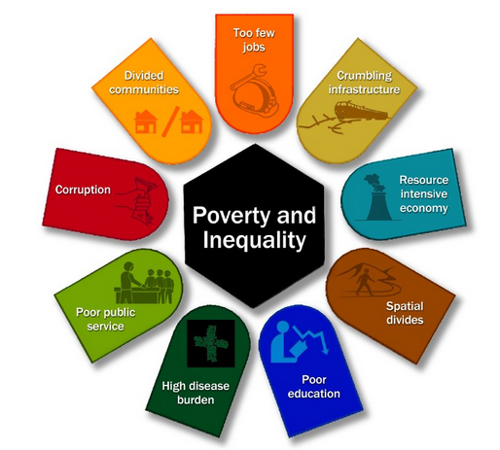
1. Create 11 million more jobs by 2030.
2. Expand Infrastructure.
3. Transition to a low-carbon.
4. Transform urban and rural spaces.
5. Education and Training.
6. Provide Quality Health Care.
7. Build Capable State.
8. Fight Corruption.
9. Transformation and Unity.

MEDIUM TERM STRATEGIC FRAMEWORK
This MTSF 2019-2024 outlines the priorities to be implemented in the sixth administration. It also outlines the priorities and interventions across South Africa’s national development pillars. The purpose of the MTSF is to outline the Government strategic intent in implementing the electoral mandate and NDP Vision 2030 as our lodestar.

Priority 1: A capable, ethical and developmental state
Priority 2: Economic transformation and job creation
Priority 3: Education, skills and health
Priority 4: Consolidating the social wage through reliable and quality basic services
Priority 5: Spatial integration, human settlements and local government
Priority 6: Social cohesion and safe communities
Priority 7: A better Africa and world

According to the executive summary of the MTSF, the short- to medium-term strategic direction, development priorities and proposed implementation plan are clearly stipulated. It marks a transition from the focus on establishing the constitutional democracy, building institutions of government, creating a safety social net and broadening access to basic services, to focus on undoing the structural pillars of apartheid that produced multi-generational impoverishment of the African majority. The framework prioritises the need to address the triple challenge of poverty, inequality and unemployment. Therefore it is imparitave for all stakeholders to participate in implementing this framework as it focuses government development planning on implementation at a strategic and operational level and provides for strategic focus on resourcing, partnerships, coordination
of all state entities, social compacts with social partners including defining clear commitments for labour and private sector investment.

Provincial Government Western Cape - Provincial Strategic Objectives
The Provincial Government of the Western Cape (PGWC) published the Draft Strategic Plan with the title “A safe Western Cape, where everyone can prosper”. The 2019-2024 Provincial Strategic Plan provides the strategic framework for the provincial medium-term budget policy priorities, which in turn are aligned to the NDP strategic outcomes.

In order for the Western Cape government to achieve prosperity and safety for all, five Vision inspired priorities have been identified. This IDP can be read together with the draft PSP 2019-2024.

This Plan puts forward the following 5 Strategic Objectives:
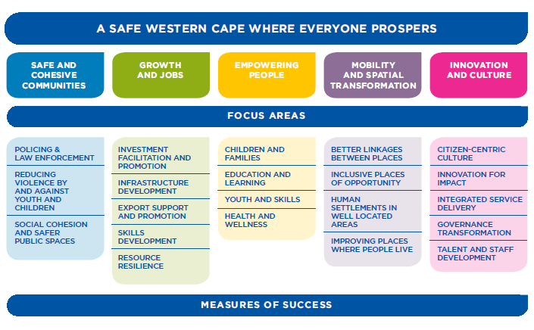
- Safe and cohesive communities
- Growth and Jobs
- Empowering people
- Mobility and spatial transformation
- Innovartion and culture

Garden Route District Municipality’s Strategic Goals
GRDM has identified seven (7) strategic goals that are essential for realising their vision and mission and which contribute to the achievement of their long term vision beyond this 5 year IDP. Each of the goals below is supported by several more specific and measurable objectives.
- Healthy and socially stable communities
- A skilled workforce and communities
- Bulk Infrastructure Co- ordination
- Environmental management and public safety
- Financial Viability
- Good Governance
- An inclusive district economy

Kannaland Municipality’s Key Performance Areas (Strategic Objectives)
Kannaland Municipality developed goals, objectives and strategies that are aligned with some of these outcomes however, achieving the outcomes remain a challenge. Effective intergovernmental relations stand in the way of achieving the challenge posed by historical mediocre performance of government departments to achieve outcomes developed on paper. National outcome 9 in particular provides the space for local government to improve its functioning so as to ensure an accountable, responsive, effective and efficient local government system. Achieving outcome 9 will restore the confidence of citizens in the local government sphere as well as improve performance and professionalism and strengthen partnerships between local government, communities and civil society.

Taking into consideration political, national, and provincial and district policies, Kannaland Municipality adopted the following seven (7) Key Performance Area’s:

Table 2: KPA – Kannaland Municipality

Horizontal Policy Alignment (remain unchanged)
The table below illustrates the alignment of Kannaland Municipality and the strategic directives. The aim is to align programmes/projects which the Municipality tends to achieve:
Kannaland Objectives | GRDM Objectives | WC Strategic Plan (2019-2024)  Vision Inspired Priorities | NDP Objectives / Outcomes | Kannaland Strategies
KPA1: To provide access to reliable infrastructure that will contribute to a higher quality of life for Kannaland citizens | SO 3: Coordinate Bulk Infrastructure service delivery | VIP 2 – Growth and Jobs  VIP 3 - Empowering people  VIP 4 – Mobility and Spatial Transformation  VIP 5 – Innovation and Culture | Outcome 6: Efficient, competitive and responsive economic infrastructure network | - Implement all infrastructure projects as per approved (IDP)  - Landfill site construction and operations (dependent on available budget)  - Develop and or review master plans  - Develop maintenance plans

Kannaland Objectives | GRDM Objectives | WC Strategic Plan (2019-2024)  Vision Inspired Priorities | NDP Objectives / Outcomes | Kannaland Strategies
KPA2: To provide adequate Services and improve our Public relations | SO 3: Coordinate Bulk Infrastructure service delivery | VIP 2 – Growth and Jobs  VIP 3 - Empowering people  VIP 4 – Mobility and Spatial Transformation  VIP 5 – Innovation and Culture | Outcome 8: Sustainable human settlements and improved quality of household life. | - Implement a sound customer care system  - Increase the indigent register database
KPA3: To strive towards a safe community in Kannaland through the proactive management of traffic, environmental health, fire and disaster risks | SO 4: Environmental management and public safety | VIP 1: Safe and cohesive communities | Outcome 3: All people in South Africa protected and feel safe  Outcome 10: Protection and enhancement of environmental assets and natural resources  Outcome 11: A better South Africa, a better and safer Africa and world | - Protect and enhance the natural assets in the municipal area through planning, disaster management and fire services, waste management and air quality control. (District to assist as on requests);  - Develop and implement community safety plan;  - Seek assistance with the development of environmental management plans to be implemented;  - Mitigate potential disasters by implementing ward based disaster risk reduction mechanisms and programmes (review the disaster management plan and assessment);  - Climate change resilience;  - Develop and implement a traffic management safety plan;
KPA4: To facilitate Economic Growth and Social and Community development | SO7: An inclusive district economy | VIP 2: Growth and Jobs  VIP 3: Empowering people  VIP 4: Mobility and Spatial transformation  VIP 5: Innovation and Culture | Outcome 1: Improve the quality of basic education.  Outcome 4: Decent employment through inclusive growth  Outcome 6: Efficient, competitive and responsive economic infrastructure network  Outcome 8: Sustainable human settlements and improved quality of household life.  Outcome 7: Vibrant, equitable and sustainable rural communities and food security  Outcome 12: A development-orientated public service and inclusive citizenship. | - Re-develop and implement the Led strategy;  - Support the lto by facilitating tourism marketing and development through the tourism strategy;  - Coordinate and implementation of the EPWP in Kannaland;  - Improve the communication and community partnering between internal and external stakeholders (economic growth solutions)  - Enhance community development through offering educational assistance (libraries);  - Identify and implement community development projects (identified per ward);  - Engaging with lead sector departments (DSD, Health, WCED, Rural Development and Land Reform and agriculture to assist with areas such as:  - Early childhood development;  - Gender mainstreaming;  - TB/HIV/Aids/Covid 19 awareness;  - Disabled and elderly persons;  - General youth development.  - Agricultural programs and projects
KPA5: To promote efficient and effective Governance with high levels of stakeholder participation | SO 6: Good Governance | VIP 5: Innovation and Culture | Outcome 9: A responsive and, accountable, effective and efficient local government system  Outcome 12: A development-orientated public service and inclusive citizenship | - Provide strategic support to achieve strategic objectives (ito pms and the frp);  - ICT integration and governance;  - Implementing the branding of the new corporate identity;  - Ensure compliance withing the organization;  - Establish a participatory, developmental, inclusive, active and responsible citizenship through ward committee involvement and stakeholder partnering;  - Development and implementation of action plans for section 80 committees;  - Update and monitoring of policies and by laws;
KPA 6: To provide an efficient workforce by aligning our institutional arrangements to our overall strategy | SO 2: A skilled workforce and communities | VIP 3: Empowering People  VIP 5: Innovation and Culture | Outcome 4: Decent employment through inclusive growth  Outcome 5: A skilled and capable workforce to support inclusive growth | - Implement all processes wrt the organisational structure review;  - Implement the workplace skills plan;  - Review all HR related policies;  - Review and implement the Employment equity plan;  - Implement induction training to all new employees;  - Establish individual performance management system;  - Provide training to all staff on strategic documents (IDP, Budget, EAP);  - Implement all OHS measures;  - Enhance employee health and wellness
KPA 7: To strive towards a financially sustainable Municipality | SO 5: Financial Viability | VIP 5: Innovation and Culture | Outcome 9: A responsive and, accountable, effective and efficient local government system | - Implement mScoa (constant training where necessary to stay abreast with the trending);  - Submit business plan for funding to secure the ICT infrastructure;  - Implement cost saving measures  - Implement accurate and detailed accounting and financial reporting as per legislator requirements  - Implement the MFMA compliance calendar.
Table 3: Strategic Alignment

Inter-Governmental Cooperation
The Municipality fosters relations with other spheres of government and participates in various intergovernmental activities to promote a closer working relationship between the various spheres of government which will certainly act as a catalyst in advancing the agenda to create a stable governance structure, promote financial sustainability and service delivery through infrastructure, housing and other services.
An external IDP/Budget representative forum needs to be established to ensure a further robust manner of communicating during the planning stage. The communication strategy needs to be updated with more ways to strengthen the communication especially now during the pandemic period.
ENGAGEMENTS
Council Meetings which is open to the public | On schedule
IDP Indaba 1 | Annually
MinMay | Quarterly
MinMay Tech | Quarterly
District Coordinating Forum | Quarterly
TIME 1 & 2 | Annually
Back to Basics Engagements | Quarterly
Human Settlement Engagements | Quarterly
Water and Sanitation Forum | Quarterly
Kannaland Municipality public participation meetings | Quarterly
Provincial and District IDP forums | Quarterly
ICT Managers Forum | Quarterly
SMME Forum | Quarterly
Premiers Coordinating Forum | Quarterly
Council feedback meetings | Quarterly
Zoar Community Integrated platform | As per scheduled by project leaders
JOC meetings | Regular
Table 4: Sector Engagements
The municipality aims to enhance intergovernmental relations by mobilizing resources and strategic partnerships which will ensure co-ordination of service delivery by all departments to the citizens to gain a better and healthy quality of life.
The desired outcome of inter-governmental cooperation as previously mentioned is to:
- strengthen good governance;
- addressing the needs of the poor by introducing programs to the community which will boost entrepreneurship skills eg. Food gardening ect.
- coordinate and managing all municipal relationships with other spheres of government;
- ensure that there is a strong link between departments internally and the two spheres of government (National and Provincial);
- facilitate information and knowledge sharing through inter-municipal cooperation (steering committees);
- To build managerial and technical capacity (through study tours, exchange programmes, seminars and conferences);
- To develop project partnerships with other government departments for mutual benefit;
- To create employment through the public works programmes;
- To focus on supporting the successful implementation of the strategic priorities;
- To ensure that there is monitoring and alignment of municipal budgets and IDP implementation with provincial and national government departments;
- Coordinating and aligning all events that involve other spheres of government – e.g. national days, Imbizo’s, etc.
- Promoting efficient lines of communication and between the Municipality and other spheres of government;

Impact of the COVID 19 Pandemic on participatory processes
The lower of levels opportune industries to operate more frequently in other word the economy was relieved and to be operational. The Covid 19 pandemic has affected many programmes such as the participatory processes of the IDP and budget, however measures were communicated to municipalities on measures to obtain inputs. This has also impacted the budget for 2020/21 and calls for adjustments as the disaster had taken a strong financial effect on the municipality.

Despite the financial distress this pandemic caused, the municipality still delivers its services to the community of Kannaland. To stay abreast with local governments strategic agenda, numerous virtual meetings were held to report on projects, financial and non-financial aspects. The municipality participate in Intergovernmental engagements to give feedback on the current status of the covid 19 within the municipal area. The platforms used are engagements with the District Mayors, top management and all Municipal Managers, to discuss the impact of the virus and challenges in providing service delivery.

We empathise with our local economic partners whom is affected by this lockdown which result in close downs, lay off workers and loss of income. The Garden Route District Municipality has several clusters that obtain data to be submitted to the relevant stakeholders in order for assisting those partners. The cluster for economic is the Business, Economic and Tourism Cluster within the recently activated District Command Council (DCC).

The purpose of the clusters is to develop a recovery strategy for the district which will assist b municipalities, addressing issues of business rescue, support and building of business resilience.
Together we can make Kannaland a safer environment if we all adhere to the measures that needs to be taken into account – social distancing – sanitise – wearing masks – attend fo medical assistance if feeling sick.

Public Participation sessions
The process was informed by the prior year’s assessments, the mid year budget assessment to improve this planning process, complaints system, ward committees and ward councillors in identifying the needs of the community; an analysis of the current status of service delivery and the environment; and various stakeholder engagements. It must be noted that the municipality could not held the first round due to the National Declaration made by the President of RSA to indicate the impact of COVID 19 pandemic and its measures that needs to be taken to combat the spread of the virus.

The Municipality has clearly demonstrated its effort to promote participative democracy in the developing of its by-laws, planning applications as well as other planning processes

The socio-economic conditions and character of the four towns of Kannaland and settlements are distinctly different, resulting in their expectations from the budget and service delivery priorities being diverse. This variety and service delivery backlogs in some areas were duly considered in the IDP Review. The public participation process was characterized by active participation by all sectors of society and again highlighted the fact that the expectations from communities are very high in terms of service delivery, infrastructure development and other development challenges considering the limited resources available to the Municipality.

Effective partnerships with communities, other spheres of government and the private sector are essential to deliver on this expectation adequately. The inputs received from the various stakeholders during the IDP review process, were refined and duly incorporated into this document with the sole intention to inform the budget and other development priorities of the Municipality. Some of the participants got the opportunity to identify solutions for the challenges to ensure that they take responsibility of their own development.
Furthermor a great portion of the community also raised a number of issues that were not necessarily competencies of local government and those will be referred to the respective government departments via the IDP Indaba and other relevant IGR structures.

Representatives from sectors which are not necessarily represented on the ward comittees are also invited to the prioritization workshops to ensure that the interest of their sectors is duly considered.

The main functions of ward committees are:

The Kannaland Municipality has established a ward committee system which will be actively involved in the mobilising process as well the IDP and budget related processes for the next reviews.

Ward 1 Ladismith: Nissenville | Ward 2: Calitzdorp
Ms. Elizabeth Jacobs | Ms. Emilene Hess
Ms. Carol Hendricks | Ms. Fransiena Quantini
Past. Melanie Ayslie | Mr Mike Neebe
Past. Hendrik Rademeyer | Vacant
Mr Johannes Ruiters | Mr Monolito Pieterse
Ms. Gloria Douwries | Mrs Bettie Mcolillon
Ms. Brumilda Januarie | Mrs. Quinta Valentyn
Mrs. Hilda van Eick | Mr. Horn
Mr. Dawid Rooi | Mrs Sophia Roman
Mr. J Cedras | Mr Gert Uithaler
Ward 3: Zoar | Ward 4: Ladismith / Van Wyksdorp
Mr. Tsodinyane Jacob Nkokou | Aletta
Vacant | Mr Jonathan Jantjies
Vacant | Mrs Regina Carolus
Ms Manoline Willemse | Mrs Nerina Lochner
Ms. Leslene De Jongh | Mrs Maria Herdien
Mr. Dennis Jacobs | Vacant
Ms. Elize Booysen | Mr Edward Adcock
Ms. Carol Hess | Vacant
Ms. Rina Hector | Vacant
Mrs. Diane Hardien | Mr Ivan Januarie
Table 5: Ward Committee Members

Public Needs Analysis
Throughout the stakeholder meetings, public hearings and other interactions, various needs were identified and will be clustered below in the form of the Key performance areas. The needs are similar to prior years, and must be stressed of the financial constraints we are doing our utmost best in prioritiseing the needs below. It must also be noted that most of the issues are sector related and request that all relevant sectors participate where applicable in presenting projects and programmes as per listed below:

KPA | REQUESTS | WARD
Infrastructure and Basic Service Delivery | Repairs & Maintenance included requests for the upgrades of roads, rehabilitation of community facilities like halls and parks, fixing of potholes, building of speed humps, attending to sewage blockages, repairing of burst water pipes, repairs to RDP houses where roofs are leaking | 1,2,3,4
Infrastructure and Basic Service Delivery | Requests for roads predominantly centred around the building of new roads, link roads, access roads, and tarred roads where there have never been roads constructed before | 1,2,3,4
Infrastructure and Basic Service Delivery | Renewable energy supplies needs to be considered, including but not limited to: solar, wind, and hydro power | 1,2,3,4
Infrastructure and Basic Service Delivery | Request for halls and community centres focussed on the construction of new halls and community centres, which are multi-purpose in nature, in order to enhance community development through social cohesion. | 1,2,3,4
Infrastructure and Basic Service Delivery | Housing requests include the request for RDP houses and houses in general. | 1,2,3,4
Infrastructure and Basic Service Delivery | Upgrading or new construction of old infrastructure (water, sanitation and electricity) | 1,2,3,4
Infrastructure and Basic Service Delivery | Ensuring proper lighting be placed in order to reduce crime | 1,2,3,4
Infrastructure and Basic Service Delivery | Current and new establishment of sport fields – netball, rugby, hockey and soccer fields | 1,2,3,4
Infrastructure and Basic Service Delivery | Ensuring all informal settlement areas be equipped with basic services | 1,2,3,4
Infrastructure and Basic Service Delivery | Multi-Purpose Centre in Zoar and Calitzdorp | 2,3
Infrastructure and Basic Service Delivery | Early development centres | 2
Infrastructure and Basic Service Delivery | Implementation of Advanced Waste Management Systems that reflect community values around waste minimisation. | 1,4
Infrastructure and Basic Service Delivery | Recovery, re-use and recycling of waste is maximised. The volume of waste disposed to landfill is minimised. Life spans of landfill sites are extended. | 1,4
Local Economic Development | Seamless movement of people, goods, and services in and around the town | 1,2,3,4
Local Economic Development | Community must be supported with programs for self-empowerment and job creation projects. | 1,2,3,4
Local Economic Development | Identify land for small scale farmers | 1
Local Economic Development | Economic growth leading to the creation of decent jobs. | 1,2,3,4
Local Economic Development | People connect virtually through high-speed information and communication technology.  Reliable telecommunications networks provide access to learning and information opportunities in homes, schools, and workplaces.  Business and industry embrace high-speed broadband networks to become more productive and innovative. Energy efficiency is promoted by telecommuting. | 1,2,3,4
 | An Indaba be arranged to invite all stakeholders with the aim of identifying, projecting new investments for future | 1,2,3,4
Good Governance | Communities to be informed about the IDP process, to be involved in the budget process, for the Municipality to strengthen relationships between communities and their councillors.  It also included the issue of youth development, job creation, training and skills development, small business establishment, building of libraries, & other aspects in order to strengthen the economy.  Communication be improved | 1,2,3,4
Safe environment | Foot bridge in Zoar – Current sports field | 3
Safe environment | Establishment of speed cameras in all four towns | 1,2,3,4
Safe environment | Three way stop at the entrance of Calitzdorp | 2
Safe environment | Law enforcement be strengthen in all four towns | 2
Safe environment | Taxi rank with toilets in Calitzdorp | 2
Safe environment | Medical centre for Van Wyksdorp and Zoar  - Current medical facility in Calitzdorp be expanded  - Current clinic in Ladismith be expanded and a new clinic be built in central Ladismith | 3,4
Safe environment | Social infrastructure supports healthy lifestyles, learning opportunities, and community unity and social cohesion. Health infrastructure is readily available and meets community needs.  Major recreational infrastructure (eg. sports stadium, cultural facilities, etc.) | 1,2,3,4
Safe environment | Urban renewal and greening is recognised by communities and the business group as contributing to environmental and ecological sustainability, as well as supporting future residential, commercial, and industrial development | 4
Safe environment | Tree planting and paving of street blocks | 1,2,3,4
 | Upgrading of the swimming pools | 1,2
Financial Viability | Training or replacement programme for incumbent to do the municipal accounts and enquiries | 1,2,3,4
Financial Viability | Re-look the tariffs on the current budget | 1,2,3,4
Financial Viability | Needs to budget for repairs and maintenance more  and not on sportsfields (that can be done once the basics is covered)

Below is the main key issues which were communicated to us at the public meetings, relevant stakeholder meetings per ward:

WARDS | CONCERNS
Ward 1 | There is a shortage of proper traffic calming measure motoring
Ward 1 | Lightning at the entrance of Sakkies Baai and dark areas – High mass lights
Ward 1 | The need for recreational facilities for tourists and the community of Kannaland
Ward 1 | Promote our small business to establish tourism activities in Ward 1 – home stays, guest houses and back packers, resident routing
Ward 1 | Opportune the youth and informal business owners to register as a proper business and to transfer skills to others
Ward 1 | Investigate the housing (GAP) to be finalized as per the HSP
Ward 1 | Paving of the internal roads of Nissenville and informal areas with storm water services as well planting trees.
Ward 1 | The CWP must be managed better. All the workers cannot just pick up garbage.
Ward 1 | Establishment of youth centre in Nissenville
Ward 1 | Opportunities by providing land for small scale farmers
Ward 1 | The need for proper lightning in informal areas.
Ward 1 | Establishment of more recreational parks in Nissenville – Identified open land
Ward 2 | Paving of the Bergsig area roads
Ward 2 | Promoting the youth through development programmes – youth cafes
Ward 2 | Promote tourism in the area – Assisting the tourism offices with needs as per requested
Ward 2 | Helping the tourism bureau with financial support – festivals and campaigns
Ward 2 | Ensure that law enforcement be implemented in Calitzdorp
Ward 2 | The current medical facility needs to be expanded and clustered into groups (health)
Ward 2 | A big tourism board needs to be placed at the entrance and exit of Calitzdorp to indicate all the activities and attractions.
Ward 2 | Mobile medical care needs to be mobilise to rural areas (farms) more efficiently
Ward 2 | The DOH needs to consider to place more medical staff at the current facility.
Ward 2 | Roll out of ECD centres
Ward 2 | Identifying land for open spaces and parks
Ward 3 | There is a critical shortage of land for small farming initiatives (crops and livestock),
Ward 3 | The future use of under-utilized commonages and the need for an Agricultural Strategy,
Ward 3 | The leadership must lead responsibly, be certain that enough is being done and that development is in fact taking place,
Ward 3 | The transformation of Amalienstein farm and surrounding Zoar needs to be fast tracked
Ward 3 | Assets being acquired for the Ward,
Ward 3 | Fast tracking of the building of a Model C school (centralized)
Ward 3 | Strengthen the partnership with SAPS to create a more safe and clean town – Neighbourhood watch needs to be placed in Zoar
Ward 3 | Establishing a FAS centre in Zoar
Ward 3 | Establishing a tourism hub in Zoar – To promote the area
Ward 3 | The community of Zoar needs to more technological connected – By establishing youth café’s
Ward 3 | Skilling and capacitating the Youth, as opposed to the use of Consultants,
Ward 3 | Critical intervention is required for the Ward’s cemeteries – it must be clearly indicated where the cemetery is located and road signs be placed at the entrance of the area.
Ward 3 | Stringent measures to curb the illegal littering and dumping were required,
Ward 3 | A new Clinic with extended health services was a critical need,
Ward 3 | Ablution and other facilities had to be provided at the new sports field, Abandoned and vandalized buildings are a serious health and safety hazard, as are the overgrown open spaces – harbouring criminal elements and allegedly used for satanic rituals; the Municipality must obtain an order to have them demolished and overgrown areas must be cleared to improve safety of pedestrians,
 | Recreational activities needs to be introduced
 | Housing and water quality needs to be re-looked urgently
 | The water storage capacity problem needs to be attended to by building a dam (drinking and irrigation water)
Paving of internal roads:
- Bruintjieshoogte
- Karoolande
- Protea Park – A paved circle needs to be placed at 5th avenue where it links to 9th avenue
- Paving of the entire Protea Park and the part of Braklaagte with the following streets:
  - Malva Street
  - Gousblom Avenue
  - Daisy Avenue
  - Vygie Avenue
  - Bloekomlaan
Ward 4 | Indigent support be provided to residents in Van Wyksdorp
Ward 4 | Proper lighting throughout the entire town  - Entrance from the R62 needs to be equipped with lighting as accidents volume is high on the road
Ward 4 | Entrance from the R62 up an till VWD needs to be tarred/ reseal
Ward 4 | SDF needs to be refined as VWD has a vast area for tourism and business expansion which create job opportunities
Ward 4 | Municipal accounts needs to be re-looked and investigated and properly communicated to the community
Ward 4 | Lightning in surrounded farms is inadequate as well the road conditions
Ward 4 | The Municipality needs to do an assessment which included the owners of the land on the R62, wine vineyards ect to consider attraction points for tourists as well enhancement of income and job opportunities
Ward 4 | The tourism master plan/strategy needs to be in place
Ward 4 | Roads needs to be upgraded and proper management and maintenance be put in place  - High volume as well low volume needs to be identified where to pave and tarred and the trucks needs to be informed where to drive or not (via weighbridge)
Ward 4 | Air quality management needs to be managed more frequently with regards to pollution
Ward 4 | The hiking trials: Die liggie, towerkop and waterkloof area needs to be cleaned up and properly managed
Ward 4 | The caravan park and swimming pool needs to be re-developed in a housing complex or tourist attraction and be management more strictly.
 | Consider to sell or lease old buildings (In die Bos area) for the development of an auto motor business
 | The Municipality needs to partner with the community in a clean our town campaign
 | The waterkloof route needs be kept clean as well the maintenance of the “Die Liggie”hiking trial.
 | Land to be identified for Recreational parks in Town. The caravan park needs to be upgraded and better managed.
Table 6: IDP Priorities
Generic needs for all four wards were:
- Maintenance of infrastructure and proper supervision of workers and the quality of their work had to be stepped up,
- It was suggested that the Municipality utilize the EPWP for starting a campaign throughout Kannaland – Keep our Town clean,
- Sport & Recreation Facilities could also be linked to EPWP, or applications for Lotto funding – specifically for the purpose of Youth Development,
- The EPWP and CWP should be re-launched so that the general public could have a clearer understanding of the concept and process; these programmes should also be linked to the Integrated Waste Management of the Municipality,
- Liaise with DEADP for environmental projects or programmes to eradicate the alien invasive species,
- More regular meetings must be held in the Ward and communication to be improved,
- Response time to complaints required improvement; the prepaid electricity vending station issue must be resolved,
- Some public toilets in town were not being managed properly (this was problematic for pension and grant beneficiaries, who have to spend long hours on pay-days),
- Local Economic Development (LED) and Special Programmes needs to be stepped up,
- Food Security projects should be supported; land and water to be provided for this purpose,
- The Ward Development Priorities be reprioritized, with regards to Roads & Storm water, upgrading of ageing and failing Infrastructure, and then Waste Management (including the implementation of more stringent measures to address the illegal dumping and littering).

Future ward based programmes / projects:
Ward | Programme / project
1 | SMME awareness - procurement processes, registering on wcsd, business proposals
1 | Agriculture workshop with small scale farmers
1 | Career planning “summit at schools”
1 | Food security project
1 | Invasive alien plant clearing
1 | Klowe clearing: Gabian Project – open space / parks
1 | Ward based cleaing of streets (ward committees)
1 | Developing community-based maintenance teams (as part of the Expanded Public Works Programme); in order to allow infrastructure maintenance to be done in a way that supports poverty eradication and socio-economic upliftment of poorer communities.
1 | Community survey – Indigent database
1 | Community survey – informal settlement database
1 | Community Survey – Unemployed youth (skill level)
1 | Community Survey – Informal Traders, plumbers, electricians, Spaza shops)
1 | Traffic patrole for scolars
1 | Road safety: Pothole repair, speedhumps
1 | Cleaning of council halls – Community Hall
1 | Re-establish the old library in Nissenville with sustainable programs e.g. food gardening
1 | Open space for art and craft, fresh produce market ect – to attract tourists and other residents to the Nissenville area
1 | Identify space for soccer field
1 | Utilize the community hall for multi purpose sports
2 | Community survey – Indigent database
2 | Community survey – informal settlement database
2 | Community Survey – Unemployed youth (skill level)
2 | Community Survey – Informal Traders, plumbers, electricians, Spaza shops)
2 | Traffic patrole for scolars
2 | Road safety: Pothole repair, speedhumps
2 | Cleaning of council halls – Community hall
2 | Ward based cleaing of streets (ward committees)
2 | Developing community-based maintenance teams (as part of the Expanded Public Works Programme); in order to allow infrastructure maintenance to be done in a way that supports poverty eradication and socio-economic upliftment of poorer communities.
2 | ECD
2 | Art studio – youth café (multi purpose)
2 | Spekboom planting in town and Bergsig
2 | Cleaning of entrance and exit of town
2 | SMME awareness - procurement processes, registering on wcsd, business proposals
3 | Community survey – Indigent database
 | Community survey – informal settlement database
 | Community Survey – Unemployed youth (skill level)
 | Community Survey – Informal Traders, plumbers, electricians, Spaza shops)
 | Traffic patrole for scolars
 | Road safety: Pothole repair, speedhumps
 | Cleaning of council halls – Maxis Hall
 | Ward based cleaing of streets (ward committees)
 | Developing community-based maintenance teams (as part of the Expanded Public Works Programme); in order to allow infrastructure maintenance to be done in a way that supports poverty eradication and socio-economic upliftment of poorer communities.
 | Youth café
 | Obtaing needs from schools
 | Working with DSD, SAPS for programmes with youth
 | Open day – Awareness (general)
4 | Community survey – Indigent database
 | Community survey – informal settlement database
 | Community Survey – Unemployed youth (skill level)
 | Community Survey – Informal Traders, plumbers, electricians, Spaza shops)
 | Traffic patrole for scolars
 | Road safety: Pothole repair, speedhumps
 | Cleaning of council halls – Town Hall
 | Ward based cleaing of streets (ward committees)
 | Developing community-based maintenance teams (as part of the Expanded Public Works Programme); in order to allow infrastructure maintenance to be done in a way that supports poverty eradication and socio-economic upliftment of poorer communities.
 | Signage board – entrance of town
 | Promote tourism in Kannaland (more accessible building as information centre)
 | Established a business chamber to discuss economic aspects
 | Business Breakfast

Special events to be implemented (subject to budget)
- Women day
- Mandela day
- Reconciliation day
- Heritage Day
- Youth Day
- Mayoral Golf Day
- Open Day Supply Chain
- Wellness Programmes
- Refresher: Ward committees- NOMINATION AND INDUCTION PROCESSES

CHAPTER 2:
Municipal socio-economic profile

Chapter 2 – Municipal Socio-Economic Profile

2.1 Contextualize Analysis

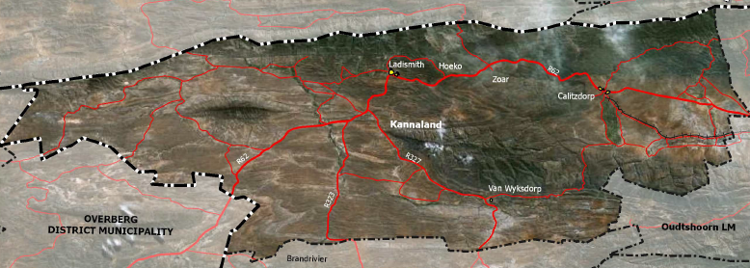
Kannaland Local Municipality is a Category B Municipality situated in the Western Cape Province, 325 kilometres from Cape Town. The Municipality covers an area of 4, 758 square kilometres in the Little Karoo, stretching from the Swartberg in the north to the Langeberg in the south, and from the Anysberg in the west to the Gamkaberg in the east. It is drained by the Groot River and the Gourits River. It borders on the Kannaland and Prince Albert municipalities to the north, the Oudtshoorn Municipality to the east, the Hessequa Municipality to the south and the Swellendam and Langeberg Municipalities to the west.

The Kannaland Local Municipality is situated within the Garden Route District Municipality which lies in the Western Cape Province. The main urban areas within the Kannaland Municipality are clustered in the following ward with their characteristics and analysis of contraints and opportunities:

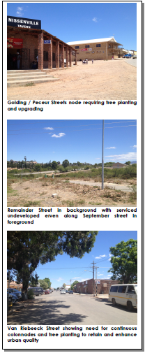
Ward 1 – Ladismith Nissenville

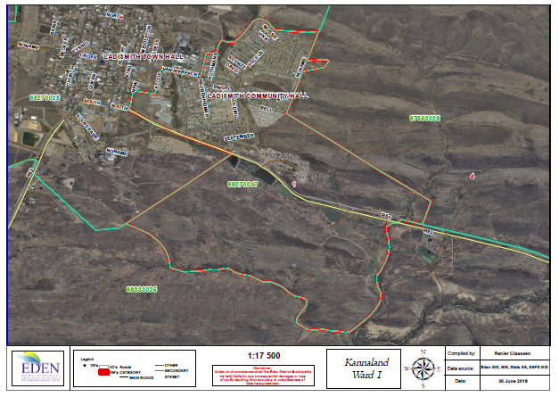
The town is the main urban centre of the Municipality. The town serves as an agricultural service centre for the surrounding agricultural areas. Ladismith Cheese and Parmalat, two diary factories, are amongst the most prominent industries in the town. The town is located below the Swartberg Mountains in the central Northern parts of the Kannaland Municipality along the R62. Nissenville forms part of the main town.

Constraints | Opportunities
Road infrastructure is poorly developed and unsurfaced. | - A fresh water ecologist should determine the river corridor set-back lines for urban development and intensive agriculture opportunities  - Open land for housing opportunities  - Maintain existing tree lines and extend road side tree planting along major routes in Nissenville including Van Riebeeck Road east, Remainder Street to R62, and September, Golding, David and Peceur Streets.  - Open parks can be established through the spatial planning process
Poorly LED opportunities for smme’s
The relatively under-developed area of bulk infrastructure.
Lack of tourism and economic interventions

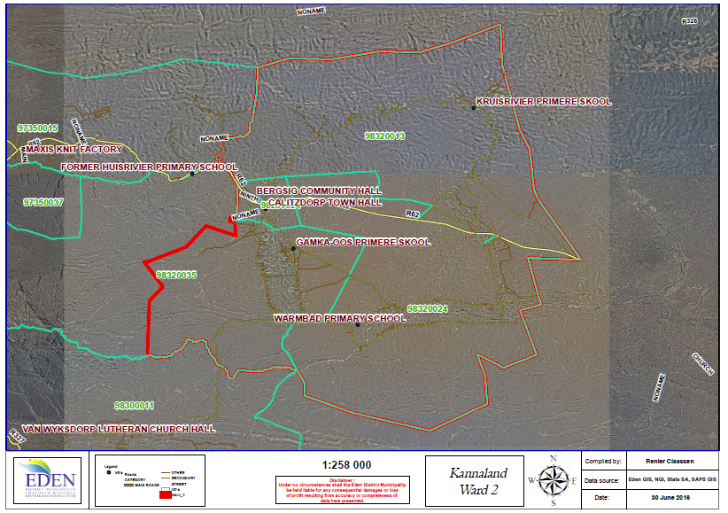

Ward 2 - Calitzdorp:

Calitzdorp is an agricultural service centre serving the needs of the surrounding agricultural areas. The town is known as the “Port wine capital” of South Africa. Tourism plays a significant role mainly due to the town’s location on the R62 tourism route. The town is located in the central eastern parts of the Municipality.

Constraints | Opportunities
Poorly internal roads | Historical and heritage resources;  Well-developed tourism business corridor  Exposure to the R62 tourism route
Tourism to be better implemented
Funding to secure aging infrastructure
Lack of job opportunities

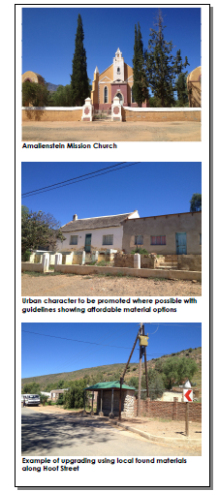
Ward 3 - Zoar:

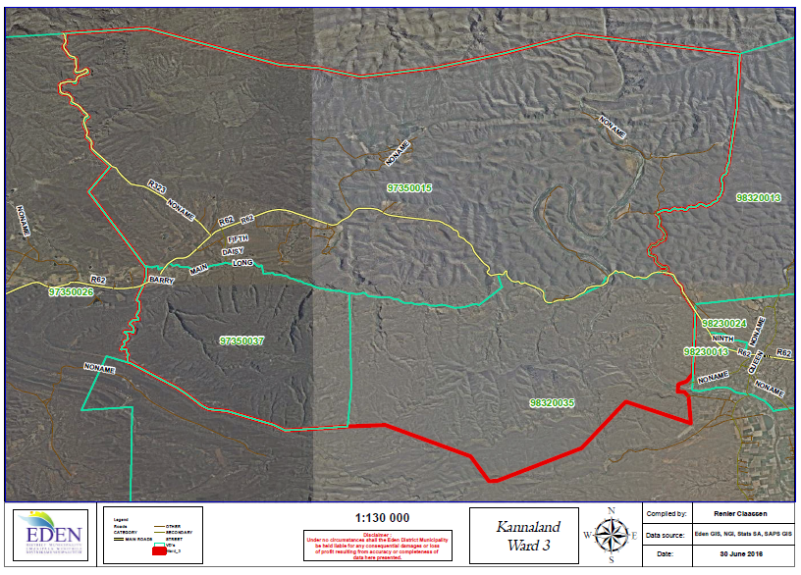
Zoar, originally a mission station, is a dispersed rural settlement. The town is located between Ladismith and Calitzdorp on the R62. Large sections of land are proclaimed in terms of The Rural Areas Act (Act 9 of 1987) and have remained undeveloped. Amalienstein forms part of Zoar and established as a Lutheran Mission Station. Development here comprises of a restored church building, historical graveyard and farm buildings.

Constraints | Opportunities
Water security | - Scenic routes for self-drive and guided tours, especially Seweweekspoort,  - R62, R327 and district road from Ladismith to Calitzdorp via Van Wyksdorp;  - Potential mission route and cultural tourism opportunities including  - Lutheran mission complex and church in Ladismith, SA Mission society church in Zoar and Berlin Mission Society church in Amalienstein;  - Zoar as potential cultural tourism centre along Hoof Street with B&Bs and cafes and Amalienstein mission as termination of Seweweekspoort pass;  - Existing agri-industrial activities provides job opportunities for the local community;  - Rural character and setting of the settlement;  - Valuable agricultural resources.
Lack of proper housing
Led opportunities
Dispersed location of the various agri industrial sites
The topography, river corridor and agricultural resources are limit to development opportunities

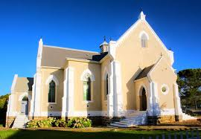
Ward 4

Ladismith (main) is widely well known for its cheese factories and vibrant wine vinyards. This is an economic driver for export of goods and creating jobs. Ladismith has numerous characterical faces that lurr people into our history (Towerkop Pick, Stanly se Liggie). This is also known for hiking trails for locacl residents and tourists.

Van Wyksdorp is a small and isolated rural village situated along the R327 in the south of the Kannaland Municipality. The town is popular among residents for its rural character.

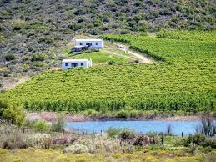
Hoeko: Hoeko is situated approximately 15km east of Ladismith and is a rural settlement. CJ Langenhoven, a famous South Africa writer, most famous for composing the South African Anthem “Die Stem”, was born here in 1873. The town has some tourism significance (i.e. a water monument) and is known for the production of apricots.

Constraints | Opportunities
Lack of water storage capacity | Scenic routes for self-drive and guided tours
More houses to be constructed | Well-developed tourism business corridor
Lack of maintanence of roads | Building of dams

2.3 Socio economic Profile

The population of Kannaland consists of 22 224 people in 2020, making it the least populated municipal area in the Garden Route District (GRD). This total is expected to decrease further to 20 563 by 2024, equating to an average annual growth rate of -1.9 per cent. The declining population appears to be also within the working age population and is a sign of out migration for work opportunities.
While a declining population limits strain on municipal resources, losing workers and reducing demand can have a negative impact on the economy.

Age Cohorts
Between 2020 and 2026, the largest decline in the population occurred within the +65 aged cohort
which declined at an annual average rate of 2.6 per cent, compared to a decline of 2.4 per cent in the
children and 1.4 per cent in the working aged population. With the decline in the aged and child
population, the dependency ratio is expected to drop significantly towards 2026. Note however that at
59.2 per cent in 2020, Kannaland still has the second highest dependency ratio in the District.

Kannaland: Age Cohorts, 2019 – 2025
Year | Children 0 – 14 Years | Working Age 16 – 65 Years | Aged  65+ | Dependency Ratio  %
2020 | 6473 | 13974 | 1797 | 59.2
2023 | 5993 | 13337 | 1650 | 57.3
2026 | 5609 | 12837 | 1535 | 55.7
Growth | -2,4% | -1,4% | -2.6% | -
Table 7: Source Western Cape DSD 2020

Educational Levels
Educational facilities are largely clustered around the settlements of Ladismith, Calitzdorp, Van Wyksdorp and Zoar. No educational facilities are available in Anysberg and Plathuis in the West and in Kraaldorings, Badshoogte and Vleirivier in the Eastern parts of the Municipality.

According to the Western Cape Education Department (WCED) Learner enrolment in Kannaland increased by 0.4 per cent annually from 4 679 in 2017 to 4 718 in 2019. This annual average increase is significantly lower than the District annual average growth rate of 1.4 per cent. The learner teacher ratio is the second highest in the District at 31.7 in 2019, increasing from 28.4 in 2017. Learner retention is a challenge in Kannaland. The learner retention rate is on a downward trend, declining significantly from 67.2 per cent in 2018 to 57.1 in 2019.


In an effort to alleviate some of the funding challenges the Western Cape Department of Education (WCED) offered certain fee-paying schools an opportunity to become no-fee schools. The proportion of no-fee schools are high in Kannaland as 13 of the 14 public schools are registered as no-fee schools with the Department of Education.

Educational facilities
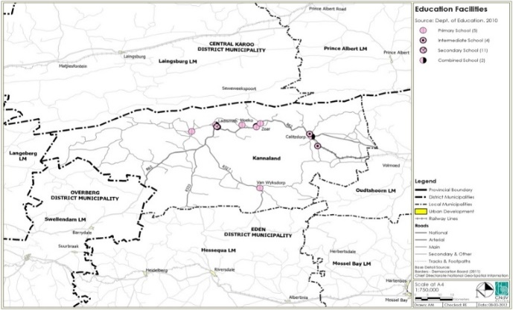
The availability of adequate education facilities such as schools, FET colleges and schools equipped with libraries and media centres could affect academic outcomes positively.
Figure 18: Education facilities – as indicated in SDF figure 3.3.3.1

Education outcomes
Education remains one of the key avenues through which the state is involved in the economy. In preparing individuals for future engagement in the labour market, policy choices and decisions in the sphere of education play a critical role in determining the extent to which future economic and poverty reduction plans can be realised. Kannaland’s matric outcomes are slightly higher than the District average although it is on a downward trend, from 89.2 per cent in 2017 to 85.9 per cent in 2019.
Area | 2017 | 2018 | 2019
Kannaland | 89.2 | 85.6 | 85.9
Table 8: KSEP: Education Outcome 2020

Employment and Unemployment
The Kannaland municipal area’s GDPR was worth R1.3 billion in 2018 and is estimated to have decreased by 1.1 per cent (in real terms) in 2019. It is estimated that 114 jobs were shed in the municipal area in 2019, bringing the total number of employed people in the region to 10 116 in 2019

Owing to lockdown regulations implemented as a result of the COVID-19 pandemic, the Kannaland municipal area is expected to experience a further contraction of 4.4 per cent in 2020 before recovering marginally by 3.7 per cent in 2021.

The table below indicate the employment growth as per statistical year of the MERO, 2020:

Municiaplity | Number of jobs | Trend 2014-2018 | Employment (Net Change) 2019
Kannaland | 10 230 | 145 | -114
Table 9: Mero 2019 Quantec Research, 2020

According the Mero 2020, the economic contraction from 2019 is not forecast to abate in 2020, with the 2020 GDPR set to decline by 4.4 per cent. Apart from COVID-19, the effects of the drought are set to continue negatively impacting the local economy.

A GDPR growth of 2.8 per cent in 2021 will be supported by planned projects such as the construction of the R1.2 billion renewable energy PPP between Kannaland Municipality, National Treasury and other partners. New developments and business expansions in the Kannaland municipal area will contribute to employment creation.

The table below indicates the employment performance per sector:
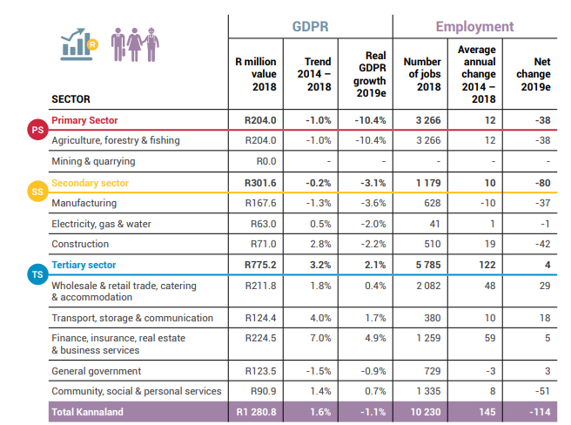
Table 10: Source Mero 2020 - employment performance per sector

UNEMPLOYMENT RATE DATA:
Kannaland municipal area has been one of the two municipalities which registered the lowest unemployment rate in the Garden Route District.

The diagram below provides an overview of the employment dynamics in the GRD by depicting the unemployment rate, labour absorption rate and labour force participation rate for each of the municipal areas.

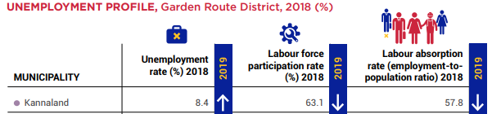
Table 11: Source MERO 2019 – Unemployment rate per centage

Health
There are four clinics, five satellite clinics, with mobile health routes and one district hospital servicing the municipal area. The clinic in Ladismith will be relocated to a more central location in Van Riebeeck Street opposite Parmalat.

Good health is vital to achieving and maintaining a high quality of life to the citizens of Kannaland. A diverse range of factors play a role in ensuring the good health of communities and that disease, especially preventable and contagious/communicable ones, are kept at bay. Some of the factors include lifestyle features that depend on the provision of high quality municipal services, such as clean water, sanitation and the removal of solid waste. Access to healthcare facilities is directly dependent on the number and spread of facilities within a geographic space. During numerous community consultations is has occurred that there is a strong need for a centralised clinic in Zoar as well permanent doctors in Zoar and Calitzdorp. The current medical facility in Calitzdorp needs to be expanded.
Area | PHC Clinics |  | Community Health Centres | Community Day Centres | Hospitals |  | Treatment Sites
Area | Fixed | Non-fixed | Community Health Centres | Community Day Centres | District | Regional | ART Clinics | TB Clinics
Kannaland | 4 | 5 | 0 | 0 | 1 | 0 | 5 | 7
Table 12: health care facilities

Emergency medical services
Only two operational ambulances are in Kannaland. The relevant low number of operational ambulances in Kannaland makes it difficult in some medical cases on rural areas with regards to saving lives and attending to urgent medical care.

HIV/AIDS and Tuberculosis (TB)
Kannaland’s total registered patients receiving anti retroviral treatment (ART) increased by 78 patients between 2018 and 2019. A total of 25 738 registered patients received ART in the Garden Route District in 2019. Kannaland, at 712 patients, represents only 2.8 per cent of the patients receiving ART in the Garden Route District.

The Kannaland municipal area experienced a decline in Tuberculosis (TB) cases from 2017 to 2019. A total of 223 TB patients were registered in 2019 compared to 254 in 2017.

Safety and Security
The extent of crime in South Africa does however not only have a significant impact on the livelihood of citizens, but also affects the general economy. Crime hampers growth and discourages investment and capital accumulation. If not addressed with seriousness, it has the potential to derail both social and economic prosperity.
The diagram below outlines the statistics of Kannaland and the Garden Route District Municipality:
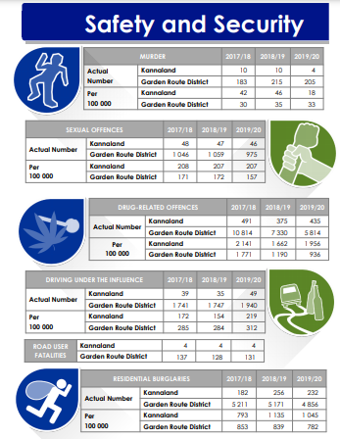
Note: The IDP can be read together with the Western Cape Local Government Socio Economic Profile of 2020

Basic services provided in Kannaland

Indigent support
Municipalities offer additional support through its indigent policy. The indigent policy provides free or discounted rates on basic services such as water, electricity, sanitation, refuse removal and also on property rates.

Access to water
With a total of 6 980 households in the Kannaland municipal area, 96.5 per cent had access to formal housing. This is significantly higher than the district average of 82.9 per cent. Despite the relatively high proportion of households living in formal dwellings, service access levels within the municipal area were lower. Access to piped water inside/within 200m of the dwelling was highest at 94.2 per cent.

Access to sanitation

Kannaland have access to flush toilets (connected to sewerage/septic tank), which is below the district average of 73.5 per cent. There is however a concern that the backlogs still need to be addressed.

Sewerage is predominantly of domestic origin and flows to the works under gravity. The Ladismith waste water works was originally completed and has a nominal capacity of 1.2 MI/d. The works is classified as a Class C Works (Infrastructure Grading).

The existing treatment works is a conventional biological works that comprises of a primary settling tank, biological filter, humus tank, anaerobic digester, sludge drying beds and four maturation ponds. In Ladismith a small part of the town is serviced by a pump station with the rest feeding to the works via gravitation. The Municipality has commissioned Aurecon to prepare a report on the upgrading and expansion of the Kannaland Waste Water Treatment Works. A scoping report has been finalised which will result in a (1) technical feasibility, (2) preliminary design and (3) Implementation Ready Study Report.

A significant portion of the older sections of Calitzdorp is serviced by means of conservancy and septic tanks that are regularly emptied by vacuum tankers. The western side of Calitzdorp has a waterborne wastewater reticulation system, with gravity mains and associated pump stations that deliver the wastewater to the WWTW. The low-cost housing in this town is serviced with waterborne sanitation and is pumped to the WWTW. The waste water treatment works is a simple pond system, and has a capacity of 0.32 MI/d. Currently no flow measurement devices are installed at Calitzdorp WWTW and estimates of present and future flow are based on population and water usage estimates.
In Zoar the existing works is a class E facility, which makes use of oxidation ponds. The WWTW has a tank that is used to settle solids in the effluent perform an anaerobic digestion function and act as a balancing tank for peak flows. No chemical disinfection currently takes place. A preliminary estimate of the component capacities and overall capacity of the works has been estimated as 0.25Ml/d.

Access to electricity
According to the socio-economic profile 2020, 89.7% per cent of households in Kannaland had access to electricity for lighting purposes.

Access to waste removal
The data indicates that within Kannaland, 66.7 per cent of households have their refuse removed at least once a week. This is the lowest level in the district and it is also lower than both the Province and the District in terms of the levels of access to refuse removal by the local authority at least once a week.
Challenges in terms of waste management may include limited land availability for waste management facilities. The Municipality has identified and prioritised the landfill sites as a priority. It was also identified by the community that waste containers be placed at strategic points to be collected by the Municipality.

Access to adequate housing
Decent housing with the relevant basic services is essential for human security, dignity and well-being.
Dwelling Type | Kannaland | %
House or brick structure on a separate stand or yard | 6 797 | 94.9
Traditional dwelling/hut/structure made of traditional materials | 28 | 0.3
Flat in a block of flats | 48 | 0.6
Town/cluster/semi-detached house (simplex, duplex or triplex) | 32 | 0.4
House/flat/room, in backyard | 25 | 0.3
Informal dwelling/shack | 170 | 2.3
Room/flatlet not in backyard but on a shared property | 7 | 0.0
Other/unspecified/NA | 51 | 0.7
TOTAL | 7 159 | 100
Table 13: Quantec Research 2018
Planning applications have been submitted to the Department of Human Settlement for future housing planning as per the HSP.

Spatial and Environmental Analysis
This component includes: pollution control; biodiversity and landscape; and costal protection. Urban expansion and farming in marginal areas to meet the demand of an increasing population, are leading to a loss of land and productivity. Secondary pressures, such as climate change, desertification and alien plant invasion, are further contributing factors.

Humans influence land degradation in three principle ways:
- The use of land resources for productive purposes: for agriculture, the collection of wood for fuel and building materials, as well as water abstraction and mineral extraction.
- The use of land resources for space needs, for example, settlement, infrastructure and recreational purposes.
- A tertiary set of influences comprises the incidental and often remote impacts of economic activity on land resources: for example, pollution of (sub) surface and atmospheric water resources by industry, alien plant invasion and climate change.
Agriculture has transformed much of Kannaland’s natural landscape to cultivated lands. The Little Karoo, in general, which is under extensive agriculture, game farming and conservation land uses, falls within the category “Succulent Karoo /Spekboom/ Fynbos”.

Land degradation manifests itself in the soil and in the veld. Sheet erosion is the most common form of soil degradation, with some rill and gully erosion in Kannaland. The Combined Land Degradation Index (CDI) indicates that the most degraded areas within Kannaland are situated around Ladismith and Calitzdorp because of overgrazing. The rest of Eden is only lightly affected by soil and veld degradation issues.

To monitor land degradation in Kannaland, the following indicators need to be identified:
- Area of land under formal conservation protection;
- Landscape change;
- Number of agricultural subdivisions; and
- Combined Land Degradation Index.
Six impact groups associated with land degradation drivers in Kannaland are:
- Farming in marginal areas, which leads to loss of ecosystem integrity, loss of natural habitats and which exerts stresses on the natural resource base, for instance on water through irrigation of crops.
- Subdivision of agricultural land into uneconomically viable units and urban sprawl leads to diminishing agricultural returns.
- Urban expansion triggered by population growth and a better standard of living leads to the loss of agriculturally productive land and other land conflicts (e.g. conservation vs. urban development).
- Alien plant invasions cause veld degradation, a reduction on the quality and quantity of water and hence the loss of biodiversity resources.
- Climate change (global warming) brings an increase in the frequency of extreme weather events (droughts/ flooding), change in rainfall patterns and in extreme cases desertification. Loss of biodiversity is strongly associated with these phenomena.
Kannaland falls largely within the Gouritz Water Management Area, a grouping of primary water catchments, which are diverse in nature, evaporation exceeds rainfall in the northern catchments meaning that these are water stressed areas. In contrast, rainfall generally matches evaporation in the southern catchments meaning that these are generally moister environments. In the Gouritz River catchment the development of surface water resources has reached its full potential and all the water is fully utilised.

The inland water resources are under severe pressure through urban population increased. In concert with population growth Kannaland has experienced expansion in the provision of water services. In addition, low-cost housing projects emerging from the National Reconstruction and Development Programme (RDP), together with the National Water and Sanitation Programme which has contributed to water demand. A further pressure on the water resource is the influx of tourism over the holiday season, introducing a spike in water demand. Economic growth and consumer and export demand has led to an increase in agricultural production, which in turn has placed greater pressure on water resources through greatest abstraction for irrigation.

Alien invasive plant and animal species, introduced by human actions either accidentally or for commercial purposes, are proving a major threat to the quality and quantity water, as well as to the biodiversity of freshwater systems. Climate change is expected to lead to slightly reduced rainfall over the Kannaland region, increased variability of rainfall, fewer but heavier precipitation events and increased temperatures and evaporation. These effects could work together to increase flooding, but could also reduce base-flow (long term low flow).

Biodiversity
Owing to its broad range of climatic conditions, geology, soils and landscapes, Kannaland has a very substantial share of global biodiversity within its borders. Kannaland’s biological heritage is important in many ways – providing ecosystem services like clean water, contributing directly to the economy through industries like fishing and tourism, supporting livelihoods by providing food, medicines and building materials and generally improving health and well-being. Through habitat destruction and ill-conceived developments biodiversity is under threat world-wide. To counteract this threat Kannaland should protect representatives of as many types of community and ecosystem as possible. By conserving suitable habitat, we are also improving the survival chances of the species and populations contained therein. Living landscapes preserve the option value of biodiversity – the potential to provide benefits in the future.

Important driving forces putting pressure on the biodiversity resources of Kannaland are:
- Population growth;
- The demand for economic growth to provide wealth and job creation;
- Demand for housing and associated services for historically disadvantaged people;
- Unsustainable extraction of natural resources as a result of poverty or greed;
- Poor land use practices promoting soil erosion and infestation by invasive alien plants;
- Poor waste and pollution management;
- Climate change; and
- Lack of understanding
In terms of appropriate responses, the mainstreaming biodiversity consideration into socio-economic agendas holds most promise to turn the situation around. It is necessary to:
- Integrate the protection and management of biodiversity resources with all human development by means of regional and national conservation initiatives;
- Build capacity in the areas of conservation assessment, taxonomy, green technology and knowledge transfer;
- Increase capacity in environmental law enforcement, management and education;
- Strengthen existing biodiversity conservation programmes to identify ecosystems, species and genetic resources that are at imminent risk of extinction;
- Implement strong counter measures to slow down the speed with which the loss of biodiversity occurs; and
- Link biodiversity protection and economic stimulation, as biodiversity protection provides an opportunity for less formal, nature-based community initiatives to act as economic engines and job creators.
Table 14: Critical Biodiversity Areas -

Climate
There is general scientific agreement that the world is now warmer than at any time in the last 1000 years, and that the cause for this warming is due to human activities. Kannaland is at risk from projected changes in rainfall pattern and warming induced by changes in the global energy balance and atmospheric water balance.

Trends in climate over a five-year period can easily be meaningless or insignificant in a statistical sense. However, the average for the five-year reporting period may be useful for simple comparative purposes against the long term average. Once a continuous ambient air quality sampling programme is in place, quarterly air quality reports which will provide useful state of environment data.

Increased drying and changes to the seasonal nature of precipitation will bring an increase in irrigation requirements which are likely to desiccate wetlands and threaten seasonal ecosystem interactions within the wetland. Such impacts are likely to further threaten the biodiversity of freshwater resources, which in turn will impair the environmental services they provide. The impact caused by climate change in terrestrial ecosystems include the detrimental effects associated with wildfires due to increased berg-wind conditions, and the possibility of changes in the distribution of alien invasive species, apart from changes in indigenous species distribution and interactions.

Numerous economic sectors could be affected by changes in temperature and precipitation patterns. The impact is likely to be felt in agriculture, fisheries, forestry, the manufacturing industry, tourism, finance and investment, transport, communication and trade, and construction. Climate change is likely to impact water services in terms of diminishing reserves on the one hand, and damage to infrastructure due to heavier precipitation events on the other.

The climate in Kannaland is known for its hot and dry summer days. The average annual rainfall is about 270 mm, with rainfall occurring throughout the year. The average midday temperatures range from 16.6°C in July to 29.6°C in January and the mercury does drop to 3.2°C during winter nights. The municipal area is very popular amongst domestic and foreign tourists for its rural rustic Karoo scenery. Our unique offerings in the heart of the Klein Karoo, the local top-class brandy and top-class cheese industries, is an attractive tourist destination for local and foreign tourist who will and can enjoy trying new delicacies.

An important role and function of the Municipality is to balance the need for development with the need to reserve the fauna and flora which are an important leverage within the agriculture and tourism industry. The area is very popular amongst artists, cyclists and off-road enthusiasts who come here for untouched natural beauty. The Municipality has a difficult task to balance the interest in the natural environment with the need to promote development which will address the socio under development, infrastructural backlogs and the need to promote investment inflows to the area. The Spatial Development Framework (which is reflected in the IDP) will be one of the key strategic tools with which the Municipality will balance these competing interests.

Table 15: Protected land areas: Eden District

Kannaland Flora
The Cape Floral Kingdom is characterized by its exceptional richness in plant species. More than 8 700 species are known to exist, with more than 68% of these being endemic. The Cape Floral Kingdom, thus, compares with some of the richest floras worldwide. It is the smallest of the Floral Kingdoms and covers a mere 0.06% of the earth's surface, and is the only Floral Kingdom contained in its entirety within a single country.

Kannaland is a region of extensive plains, arid foothills and rugged rocky ridges and includes a wide range of microhabitats with extreme seasonal and diurnal temperature fluctuations. There are 1325 plant species in this area, including 182 Succulent Karoo endemics and 92 Red List species (www.skep.org.za). While unique and rare species are found throughout the landscape, many of the endemics are concentrated along veins of weathered quartz, where patches of white pebbles provide camouflage and moderate the temperature for “stone plants”

Disaster Management
The Disaster Management Act (57 of 2002 as amended) states that a Disaster Management Plan:
- “Forms an integral part of the Municipality’s Integrated Development Plan”;
- “Must conduct Risk Assessments for its municipal area”; and
- “Provide measures and indicate how it will invest in disaster risk reduction”.
The purpose of Contingency Plans is to forecast, prepare for incidents and to identify roles and responsibilities of the departments within the Municipality. It enhances the Municipality’s capabilities to effectively and efficiently manage and mitigate any situation that could pose a threat to life, property and the environment.

The limitations in capacity is of a high nature and roles with specific primary and secondary roles/functions is set out to guide the sections within the Municipality to work collectively for all to participate and plan for before / during and after disasters within the area. As defined in the prescriptions of the Act, the Municipal Manager is the Head of Disaster Management with the delegation of assistance through to the Director of Corporate Services.
A review and update of the disaster risk assessment of the Garden Route District Municipality was completed by Disaster Risk Management (Pty) Ltd (DMS). The planned review will be communicated with all stakeholders.

The Municipality has a Disaster Management Plan and the establishment of a Disaster Management Centre has been successfully established, namely the joint operation centre. However more resources still are required but operateds effectively with the expertise of other joint stakeholders.

Not only are we facing the nightmare of drought due to low rainfall, but also the outbreaks of an epidemic. The committee operates proactively and update the community of current situations and preparedness mechanisms to adhere to.

As throughout this IDP is identified that water storage capacity is the main problem and has therefor prioritized the water and sanitation needs as a high and urgent matter to be attend to.

The procedures in general for disasters or major incidents are to activate a Joint Operation Centre, which is currently in operation from the municipal offices.

Hazards / Vulnerabilities Assessments
The impact prioritization for the most important risks (in order of priority) is as follows:
- Drought
- Floods
- Plantation and vegetation fires
- Agricultural and human epidemics
- Hazardous materials transport

Risk Reduction Measures

Risk Preparedness
Risk Management (ito sec 62 of the Municipal Finance Management Act (MFMA)) is a systematic process to identify, evaluate and address risks on a continuous basis in order to introduce preventative measures. Risk management is integrated with the IDP and linked to the strategic outcomes.
The Disaster Risk Plan of the Municipality contains preventative as well as prepared responses towards the risks that have been identified.

The indicative risk profile is dynamic and can change depending on many variables, e.g. crowd profile, weather conditions, time of day, traffic conditions, spectator behaviour and the safety and security threat analysis.

Risk Prioritisation
The impact prioritisation for the most important risks (in order of priority) is as follows:
- Drought
- Floods
- Plantation and vegetation fires
- Agricultural and human epidemics
- Hazardous materials transport
- Social Cohesion Risks

Risk Reduction Measures
No other risk reduction measures are in place other than proactive measures during early warnings and forecasts or progression of incidents. Preventive measures are relocating or evacuating members of communities and providing support at a local level or as assisted through the district. The Municipality does not have a functional disaster management ICT, GIS and early warning system.
- Disaster Management Advisory Forum has been established.
- Meetings/ forums / workshops (newly established Disaster Management Forum).
- Service Level Agreement/ Memorandum of Understanding with Garden Route District Municipality.
- Facility for Fire Services in process.
- Kannaland local disaster management committee in place and engage on regular basis.
- Identification and Installation of water tanks at strategic distribution points
- Water will be shut down to regulate water flows
- 80 litre drinking water per person per household per day will be supplied at distribution points.
- Transport of water
- Stock pile water at distribution points
- Communication – radio broadcasting, pamphleteering and load hailing (Regularly)
- Activation of contingency plans from Emergency services, SAPS, Ambulance Service and hospital and Clinics for outbreaks of any diseases

Response and Recovery Measures
Kannaland’s Disaster Management function is supported by the Garden Route District Municipality and the Provincial Disaster Management Centre. The main Risks which may have a potential disaster-risk impact: -
- Natural Risks
- Drought;
- Extreme Weather (heat wave / cold snap);
- Floods
- Snowfalls
- Windstorms
- Earthquake
- Desertification / Soil erosion / Loss of biodiversity
- Thunderstorms and lighting
- Predators
- Service Risks
- Disruption of Electricity Supply / Power Failure (sustained);
- Disruption of Telecommunications & IT Services or Public Address;
- Solid and sewerage waste disposal management
- Disruption of Water Supply
- Disruption of Sanitation & Storm water Systems
- Disruption of Solid Waste Removal Services
- Civil Unrest
- Bomb Threat / Hostage-taking/ Bomb explosion
- Hooliganism / Civil Unrest / Rioting / Public Disorder
- Disruption of Commercial or Governmental Activities, incl. Strike action by personnel
- Accidents
- Road Traffic Incidents, including Road Transportation Disruption/Blockades/Traffic Congestion;
- Structural Collapse;
- Hazmat Incident or Chemical or Biological Agents’ or Radio-active Materials’ (CBR) Release
- Fire – Veld / Structural / Effects of Pyrotechnics
- Rail Incident
- Aircraft Incidents
- Health Risks
- Epidemic / Major Infectious Disease Outbreak, incl. Food Safety issues
- Human Disease
- Animal Disease
- Environmental Pollution – Ground / Air / Water
- Shale gas drilling and Uranium mining and extraction
- Ground water pollution
No other risk reduction measures are in place other than proactive measures during early warnings and forecasts or progression of incidents. Preventive measures are relocating or evacuating members of communities and providing support at a local level or as assisted through the district.

Mitigation measures
- Water restrictions in place – notify the public through strict water restriction notices
- Drilling of boreholes
- Cleansing of storm water drainage systems
- Disaster Management Advisory Forum has been established.
- Meetings/ forums / workshops (newly established Disaster Management Forum)
- SLA/MOU with Eden District Municipality
- Constant communication and awareness to community on outbreaks and disasters

Tourism
This modest allocation by the Municipality for tourism should be seen against the context of the broader package of municipal programs (e.g. keeping local towns clean, enhancing the aesthetic appeal of the built and natural environment and its planning framework).
Kannaland LM is in dire need of a Tourism Masterplan that could amongst others unlock local economic opportunities through:
- Proper Spatial Planning – e.g. promoting economic growth along the R62, agri-tourism, adventure tourism, etc;
- Development of an Art, Culture and Heritage Plan; which will identify sites of architectural, heritage significant areas and resources which will be able to contribute to the unique selling proposition of the area and attract people to the Kannaland region through cultural tourism;
- Leveraging assets such as the caravan park, through either alienation or public private partnership which could stimulate economic activity.
Kannaland’s local economy is built on the opportunities created by tourists visiting the area. It is essential that the tourism industry be further developed and investment into this industry be promoted to ensure continuous growth. The aim is that each town to have a tourism satellite office which will reside under the Kannaland Tourism umbrella. Each town has its unique economical setup and programs.

The 2 local tourism bureau offices currently maintain and operate two websites:
- Ladismith: http://www.ladismith.org.za
- Calitzdorp: http://www.calitzdorp.org.za
The figure below (SDF - Figure 3.4.13.1) illustrates the main tourism and cultural attractions in the Municipality (ENPAT, 2003). These are made up of various cultural tourism sites (grave/burial sites, monuments, etc) and 2 local hiking trails:
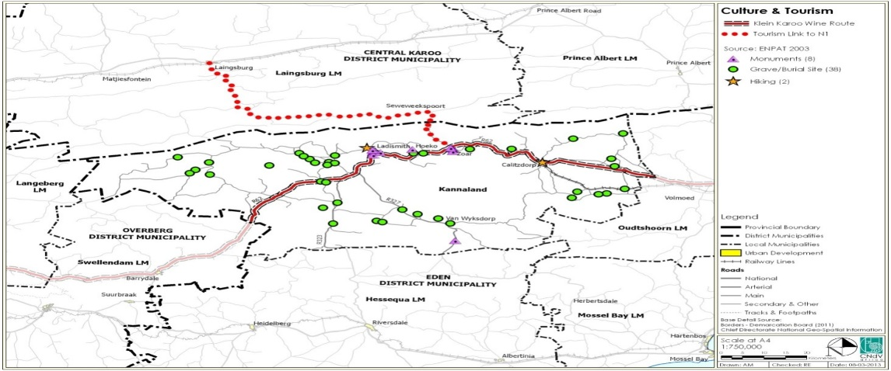
Table 16: Tourism and culture attraction – refer to figure 3.4.13.1 in SDF Tourism and culture attraction
Tourism is one of the key economic sectors in the Municipality, calling for the development of a tourism master plan or a municipal wide tourism strategy. The local tourism offices need urgent support from the government department to assist in either funding of programs or the development of each town – as mentioned a masterplan is needed. The tourism sector can contribute significantly to the reduction of unemployment. The urban areas along the R62 tourism route should maximize their exposure on this route as a means of enhancing economic growth.

Each town has its unique economical set-up and programs. Given the above, Garden Route District Municipal Council has passed a resolution to support Kannaland Municipality with the development of a tourism strategy; this tourism strategy aims to transform Kannaland into a viable tourist destination to improve local economy. The Garden Route District Municipality IDP of 2017/2018 - 2022 identified tourism marketing and development & Film industry (film location catalogue) as key developmental priorities.
Kannaland is an area of outstanding natural beauty and bio-diversity significance with great appeal to the wilderness and adventure tourism market. These include amongst others:
The key tourist attractions in Kannaland include:

Kannaland has its own individual building style, which makes it unique. For example, the so-called Ladismith Style is a simplified Georgian design and dates from the 1830's. Several other architectural styles, i.e. NeoGothic, Georgian, Victorian, Regency and Rural (Karoo) style, can also be found throughout Kannaland.
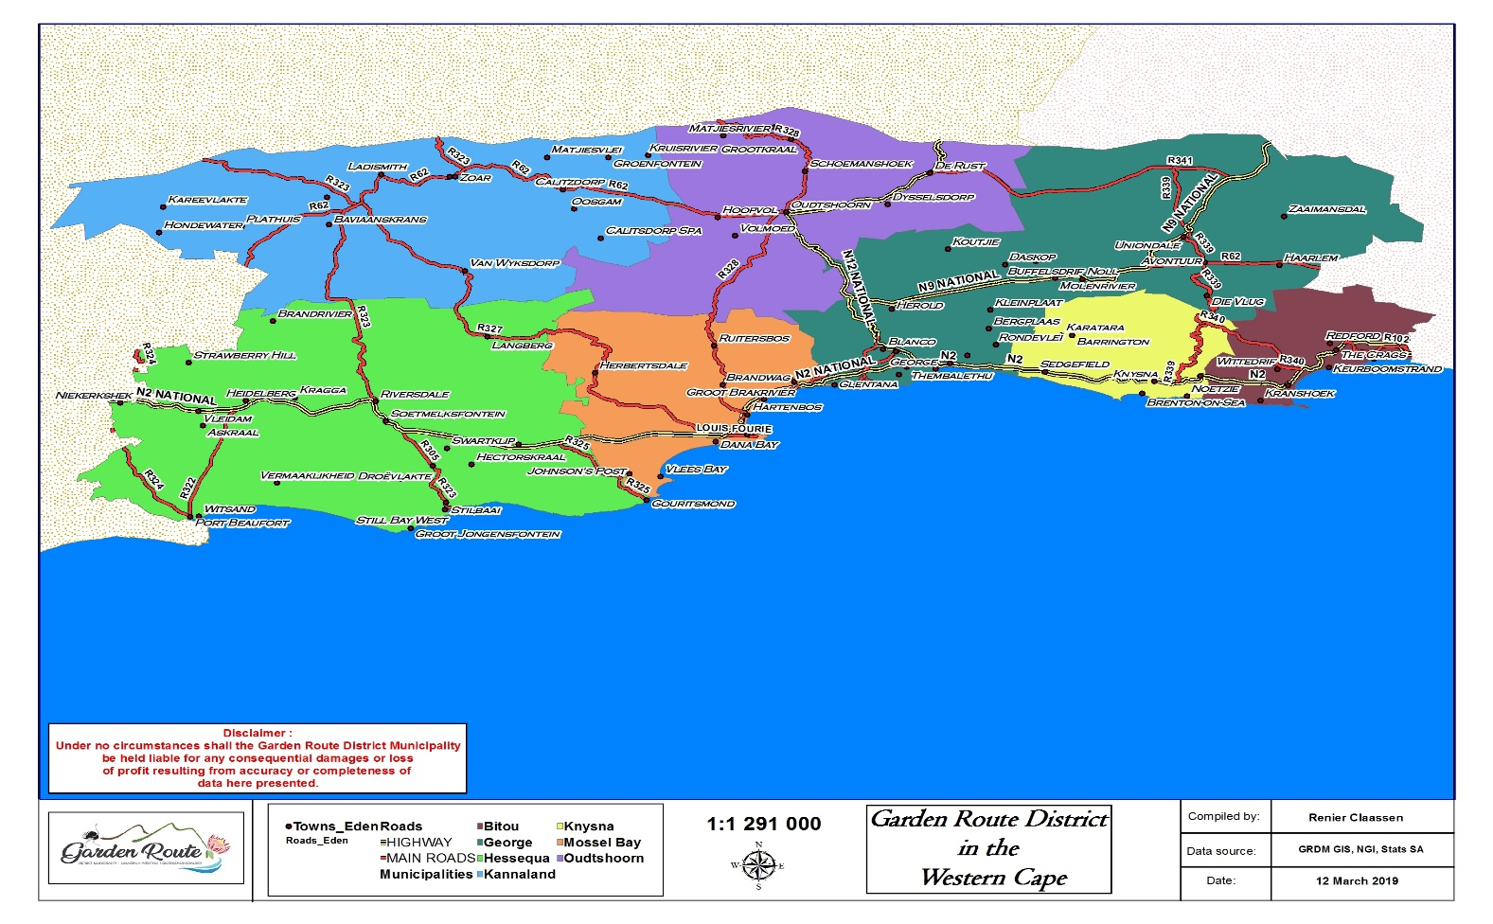
Figure 1: Map of Kannaland Municipal area
Kannaland is an integral part of the Garden Route District, along with six other local municipalities, namely Hessequa, Mossel Bay, George, Oudtshoorn, Knysna and Bitou. The Kannaland Municipal area shares its borders with the Central Karoo District Municipality to the North, and Cape Winelands District in the west.
The municipal area is very popular amongst domestic and foreign tourists for its rural rustic Karoo scenery. An important role and function of the Municipality is to balance the need for development with the need to reserve the fauna and flora, which is an important advantage within the agriculture and tourism industry. The area is very popular amongst artists, cyclists and off-road enthusiasts who visit for the untouched natural beauty.

Herewith a brief introduction of the existing tourism sectors:
Accommodation  Accommodation ranges from:  - 1 to 5 star backpackers,  - Self-catering houses,  - Luxury guesthouses,  - Caravan parks & camping grounds  - Home stays | Heritage  - Lutheran mission complex and church  - SA Mission society church  - Berlin Mission Society  - Church festival (Amalienstein & Zoar)  - Harvest festival (Ladismith)  - Heritage festival (Calitzdorp)  - Full moon festival (Amalienstein & Zoar)  - Winter festivals (Calitzdorp)
Nature-based  - Mountain biking  - Bird watching  - Hiking  - Horse riding  - Quad biking  - Fishing  - Self-drive and motorcycle touring  - Public and Private nature reserves  - Eco-resorts | Entertainment  - Restaurants and cafes
Points of interest  - Cheese factory shops  - Port style Wine Cellars  - Zoar Tourism  - Restuarants | Other attractions/activities  - Seweweeks Poort  - Hot springs
Major conference and special event venues  - Municipal auditorium/Civic centre  - Camping  - Private game farms | Infrastructure and facilities  - Sports grounds  - Public toilets  - Several schools  - Government hospitals/ Clinics
Services  - Information offices (Calitzdorp and Ladismith)  - Tourism service providers  - Tourism forum (Van Wyksdorp)  - Tow trucking | Retail/Shopping  - Ladismith town (antiques, art galleries, etc)  - Calitzdorp town (antiques, art galleries, etc)  - The gallery (Van Wyksdorp)  - Van Wyksdorp mall

The Calitzdorp tourism office successfully held the port (wine) and winter festival which bring out the culture of the town to the tourist as well neighboring municipal places. Through various community engagements it was requested that a tourism satellite be established in Zoar as well.

Agriculture
The Kannaland Municipal area is dependent on the agriculture sector. Economic pressures in the agricultural sector over the past few years forced farm workers to migrate to towns where, in most cases, these families became indigents who must be given free basic services, placing huge financial strain on the resources of Kannaland.

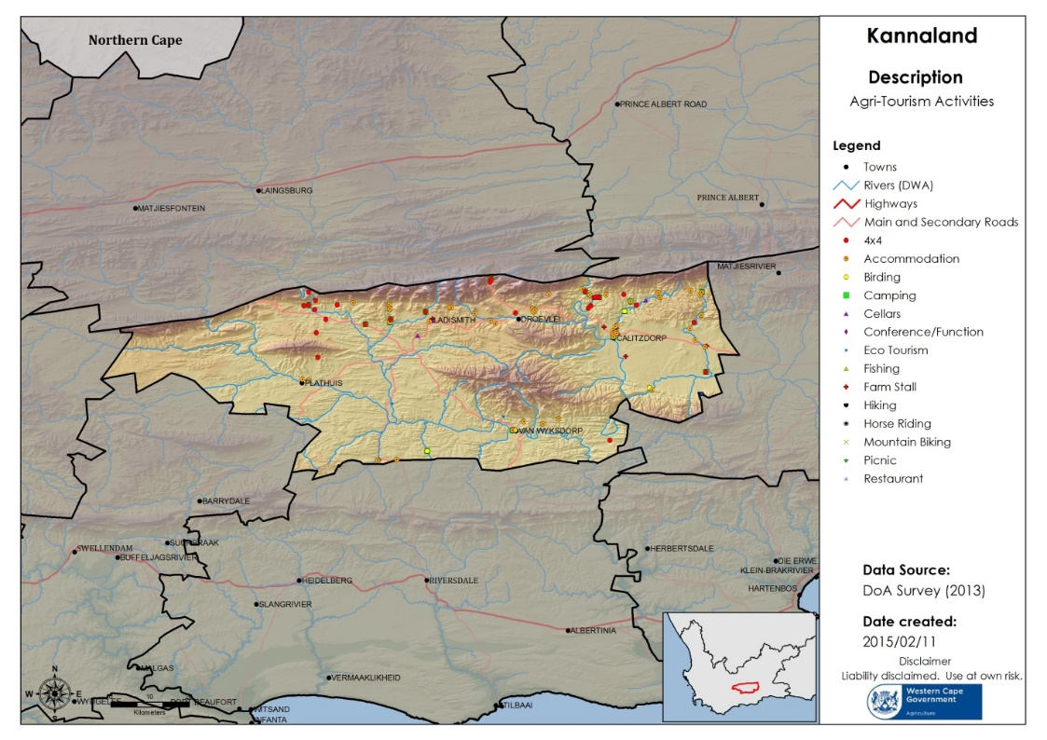

The following proposed needs that were raised in terms of promoting agro tourism in Kannaland will be explained in detail with the final IDP:
- Establish a small-scale community-based vegetable tunnel farming project in Calitzdorp
- Compilation of a wild honeybush harvesting feasibility report (where strong harvesting occurs and possible infrastructure needed)
- Compilation of an invasive alien plant monitoring, control and eradication report
- Compilation of an Environmental Management Framework report
- Compilation of an Integrated Water Strategy report
- Compilation of an Integrated Municipal Property Management Strategy report

Targeted Commodities
Proposed Agri-park commodities have been identified with inputs from the District and Local Municipalities and DAMC using the following criteria:

The presence of an existing sustainable production advantage (both currently and into the future); and Commodities produced by small and emerging farmers which could help them achieve economic independence and sustainability, contribute to GDP growth for the district and where they require support in order for this to happen.
The impact and possible future impact of the commodity (ies) on the local economy by way of contribution to the GDP and job creation. Commodities with high potential growth and high potential of job creation.

Land Classes
Table 17: Vegetation Types

Integrated Rural Development
According to the Integrated Rural Development Strategy of National Government, rural areas throughout the world tend to have similar characteristics. The Kannaland Municipality is no different and is also characterised by the following: -
- Populations which are spatially dispersed.
- Agriculture which is the dominant, and sometimes the exclusive economic sector,
- Opportunities for resource mobilisation which are limited.
- Infrastructure backlogs.
- These characteristics mean that people living in rural areas face a set of factors that pose major challenges to development.
- The spatial dispersion of rural populations often increases the cost and difficulty of providing rural goods and services effectively.
- The specific economic conditions in rural areas result in fewer opportunities than in non-rural locations.
- Consequently, the tax base is limited, so rural areas are rarely able to mobilise sufficient resources to finance their own development programmes, leaving them dependent on transfers from the centre.
- Factor markets in rural areas often operate imperfectly, rendering the search for efficient outcomes an extremely challenging one.
- Furthermore, rural areas are often politically marginalised, leaving little opportunity for the rural poor to influence government policies.
- Policies have also consistently discriminated against agriculture through high levels of taxation and other macro-economic policies that have adversely affected agricultural performance and the rural tax base.
In defining itself as a rural Municipality, the Kannaland Municipality seeks to understanding the multitude, complexities and challenges that rural communities face. In doing so the Municipality is able to partner with developmental agencies around access to developmental programs that are aimed at improving the quality of life of rural households. This will also identify the economic potential of each area. The rationale of declaring Kannaland Municipal area a rural development node, is to access resources to:
- Promote the implementation of land reform policies of national government through its Spatial Development Framework, Integrated Development Plan and leverage existing council resources such as property and operational budget to promote investment and co-funding.
- Promote the stimulation of agricultural production with a view to contributing to food security through its LED strategy.
- Promote the enhancement of rural livelihoods and rural food security through the LED Strategy;
- Improve service delivery to ensure quality of life – increased investment in the delivery of services to rural areas, including housing, water, sanitation and energy – using, where appropriate, alternative technologies to overcome physical and other impediments by working with provincial and national government through the Housing and Infrastructure program and policies;
- Implement a development program for rural transport – the formulation of a Rural Transport Program that will aim at promoting rural transport infrastructure and services through coordinated rural nodes and linkages by working with provincial and national government through its Rural Transport Strategy.
- Partnering with the provincial and national government to promote skills development and accessing financial resources elsewhere.
- Revitalization of rural towns by accessing spatially targeted grants for the revitalization and development of rural towns to serve as service centres for rural economies. This will involve the development of hard and soft infrastructure, including institutional networks for marketing, storage, advisory services, finance and improved agro-logistics;
- Through the Kannaland Local Economic Development Strategy explore and support non-farming economic activities through initiatives which need to be devised to support other forms of rural potential, including tourism, light manufacturing and cultural work;
- Through the IDP, create a platform through which agencies, working towards better focus of energies, integration of efforts, optimal utilisation of resources and initiatives to promote rural development.

Ecosystem Status
Table 18: Ecosystem Status

Rise of small - medium-scale farmer
The demand for agricultural land in Africa has risen dramatically since the surge in global food prices starting in 2007. This demand has been accelerated by agricultural subsidies and land policies in many countries. By investing in land at an unprecedented rate leading to the rapid rise of medium-scale farmers in Africa. The small – medium scale farmers raise the need of open land to expand their productive capacity. Not only will it enable them to be sustainable farmers but it has an inclusive pattern of economic growth with the effect on employment creation and poverty reduction.

Climate Change
Given the vast variation in climatic zones on the continent, the impacts of climate change on country-specific farming systems will vary and is difficult to predict. However, there is consensus on two general predictions of climate change; these include greater variability in agricultural production and a decline in crop productivity. The alternative, ecological intensification of agriculture would require minimizing the constraints to appropriate technology adoption; focusing on sustainable water use through irrigation; and implementing best farming practices. Given the rising competition for water it will be imperative that agriculture focus on developing irrigation technology that improves water use efficiency and enhances our ability to adapt to climate change.

Spatial Alignment
A Municipal Spatial Development Framework (MSDF) is a long-term development strategy required in terms of the Municipal Systems Act 32 of 2000 and forms part of the Integrated Development Plan (IDP). The main aim of the MSDF is to clearly outline the spatial status quo of the Municipality, identify the opportunities and threats and then set out the local authority’s goal, strategies and supporting policies in achieving medium - and long-term growth. The document will give spatial expression on the Municipality’s service delivery and development agenda. Furthermore, it will clarify and directs development and management activities in urban and rural areas in alignment with National and Provincial spatial planning legislation. The Municipality is in collaboration with the Provincial Department of Environmental Affairs to finalise the draft MSDF. Proper consultation with the stakeholders of Kannaland will be conducted to ensure all concerns and proposals are obtained for consideration.

Legislation Regulating Municipal Spatial Development Frameworks
The Spatial Development Framework (SDF) is the 20-year Development Plan for Kannaland Municipality was reviewed and adopted by the Kannaland Council (during the 2013/2014 financial year). As the Municipality does not have an in-house spatial planner and was unable to obtain budget resources to procure a service provider, the review and updating of the SDF has not been completed. The Municipality is engaging with the Garden Route District Municipality and the Provincial government to obtain resources to review and update the SDF during the outer financial year. For the purpose of this IDP, the approved SDF will be used as a basis for alignment even though the projects identified in the SDF may be misaligned with the IDP and the Budget.
The Kannaland SDF makes specific recommendations concerning the following elements:
- Bio–regions;
- Spatial Planning Categories (SPCs) for Land Use Management;
- Sustaining the economy;
- Major infrastructure projects;
- Major Tourism Destinations;
- Land Reform;
- Urban Related Development;
- Climate change;
- Urban design guidelines;
- Potential rural nodes and periodic rural markets; and
- Settlement hierarchy and structure.
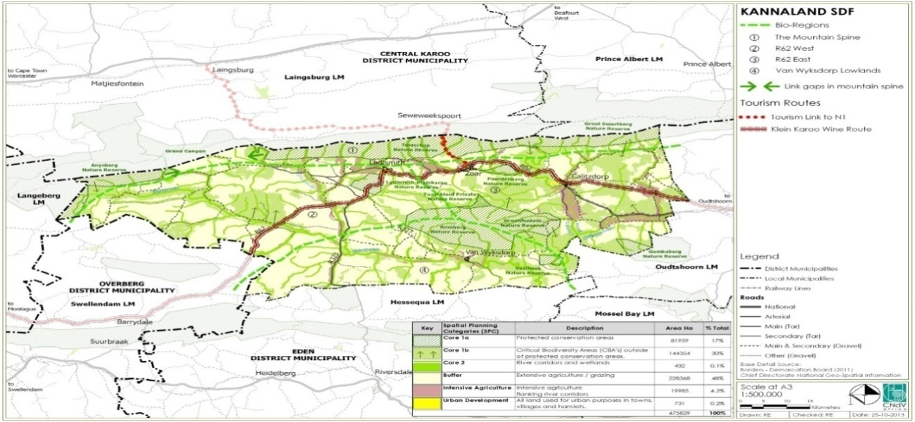
Table 19: Kannaland SDF – refer to figure 5.3.1.1 in SDF
The following diagram illustrates the alignment of the sector plans with the Municipal Spatial Development Framework (MSDF). The ultimate objective of this one holistic planning approach which commences with development of an SDF (that is inclusive of all current and future developments) is to inform and align operational plans ensuring planning is streamlined across sector departments.

Table 20: SDF alignment with sector plans

The current SDF outlines various catalytic projects for Kannaland spatially as well as future economic initiatives. The SDF is attached to this IDP (It should be noted that the SDF will be updated and reviewed as soon as the resources for doing so has been obtained). Throughout this IDP projects are being promoted which will be initiated as per listed financial years.
The SDF put forward spatial proposals for:
- Rural Areas (natural environment, agricultural areas and land reform)
- Tourism
- Urban related development
The SDF identified that the rural areas of the Kannaland Municipality should be classified per Spatial Planning Categories (SPC’s). These include:
- Indicate areas like corridors on zoning maps and other planning maps to ensure their preservation and protect these areas from undesirable land uses.
- Overgrazing should be discouraged and the eradication of alien plant species promoted.
- Environmental management plans need to be formulated as apriority.
- The Kannaland Municipality should market the proposed ecological corridors and accordingly implement land use control over these areas.
- In terms of tourism the following goals are provided:
- Develop tourism in a sustainable manner for the benefit of all in the Municipality.
- Promote tourism in order to create jobs.
- Increase disposable income levels of community members through increased tourism opportunities.
The review will aim to ensure compliance with the procedural as well as content requirements in terms of all the applicable legislation. Tender specifications are current will rolled out for the appointment of a specialist team of consultants to head the review, consisting of town planners, engineers, environmental practitioners, economists and GIS professionals.

The current status of the MSDF illustrates a misalignment of the objectives in the IDP as well the proposed projects for the outer financial years. However below is a diagram where the MSDF’s objectives is linked to the current IDP Objectives (2017-2022).

Spatial Planning Categories for Land Use Management
The Spatial Planning Categories provide the basis for managing rural land uses. The general conditions guiding what activities may occur within each category are generally in accordance with
- Core 1a Formally protected conservation areas
- Core 1b Critical Biodiversity Areas
- Core 2 River corridors and wetlands

Urban Areas
This includes the areas that are or will be used for urban related activities. All these areas should be included in a defined Urban Edge. These include the settlements of:
- Ladismith;
- Calitzdorp;
- Zoar; and,
- Van Wyksdorp
Rural Nodes
- Hoeko
- Voorwaart;
- Warmbad; and,
- Dankoord.
Wind and Solar Energy Generation
These include all wind and solar energy generation facilities. These facilities should be promoted to support the supply of electricity in the Municipality and the provision of basic services to those in need. These projects are to be sensitively placed to not negatively impact on the surrounding urban, agricultural or natural environment

Sustaining the Economy
Although Kannaland faces major poverty and employment challenges it is a well-resourced Municipality compared to many other including in the Western Cape. Almost all of the Municipality can be considered to be an area of outstanding natural beauty and bio-diversity significance with great appeal to the wilderness and adventure tourism market:
- Eco-resorts and getaways;
- Hiking;
- Bird-watching;
- Organised and informal mountain biking; and
- Self-drive and motorcycle touring;
- Agriculture and its associated industries including wine and dairy represent another tourism market;

Major Infrastructure Projects (as per SDF)
The following projects should be considered:
- Implement a multi-pronged water management strategy;
- Rainwater harvesting;
- Grey water recycling;
- Reducing unaccounted for water;
- Extension of regional water service delivery; and,
- Water demand management for large users.
- Promote domestic and large-scale solar energy usage and projects such as wind and solar farms subject to appropriate guidelines and siting principles.

Tree Planting and Paving
Tree planting is one of the cheapest forms of urban upgrading with the greatest positive visual impact. This can be done together with upgrading of roads per town as identified through this document. The ideal is to make our towns greener and will result in attracting visitors and possible investment.

The tree planting and paving projects can initially form part of the Extended Public Works Program (EPWP). They are labour intensive and cost effective. For example, broken bricks can be used for paving or pavers can be made on site. Planting trees helps prevent soil erosion, stabilizes coastlines and increases land fertility. Trees also serve a role in water regulation: They can help stave off damage during flooding as well as conserve water during droughts.

Major Tourism Destinations
Ladismith, Calitzdorp and van Wyksdorp B&Bs, guesthouses, restaurants and places of interest;
- Cheese factory shops;
- Public and Private nature reserves and eco-resorts for hiking and MTB;
- Port and Wine Cellars;
- Scenic routes for self-drive and guided tours, especially Seweweeks Poort, R62, R327 and district road from Ladismith to Calitzdorp via Van Wyksdorp;
- Potential mission route and cultural tourism opportunities including Lutheran mission complex and church in Ladismith, SA Mission society church in Zoar and Berlin Mission Society church in Amalienstein;
- Zoar as potential cultural tourism centre along Hoof Street with B&Bs and cafes and Amalienstein mission as termination of Seweweeks Poort pass;
- Ensure that new development responds positively to the layout of historic settlements; and,
- There are no cultural landscapes with the Eden district which have any formal protection status. Various examples of representative cultural landscapes were identified in the Heritage and Scenic Resources:

Land Reform
- Land reform opportunities should not be targeted only at agricultural operations although this will always be the major activity;
- Bio-diversity conservation and eco and agri-tourism operations should also be considered; and,
- Future land reform projects should carefully consider the context in which they are located and then seek to take advantage of that area’s opportunities, not only in agriculture.
Potential Rural Nodes and Periodic Rural Markets
The potential of rural nodes is derived from the rural economic opportunities that are generated by their location and “attracting force”. However, in some nodes these forces are so small that permanent infrastructure or services cannot justify permanent buildings or staff. Initially, these nodes, can be supported through periodic markets at which mobile services, for instance, home affairs, pension pay outs, clinics, libraries can be dispensed.

This approach could be applied at settlements with low threshold populations to ensure that the necessary services can be provided. Where such facilities do not exist, periodic service centres should be established for coordinated use by a wide variety of government, nongovernment and private organisations.

These periodic service centres should be located at points of highest access according to the same principles. The services of various government departments and private sector organisations should be co-ordinated into a mobile caravan of dedicated buses and vans which travels from periodic service centre to periodic service centre stopping for morning or afternoon sessions as appropriate.

Local arts and crafts people and business people should be encouraged to trade in the stop-over periods of the mobile service caravans at the periodic service centre. The location of shops and abattoirs should also be encouraged here. This strategy should be considered for Zoar, Amalienstein and Van Wyksdorp.
- There is potential for fruit processing and manufacturing
- Agri tourism needs to be promoted
- We are ashamed of the town because it is dirty.
- A money problem cannot be solved with money. What you have needs to be managed correctly.
- There is no culture of transparency in the Municipality. We do not see how the money the Municipality receives is spent.

CHAPTER 3:
Governance and Institutional Structures

Chapter 3: Governance and Institutional Structures

Political Structure

Municipal Council
The Council is the ultimate decision-making authority. Decisions to approve or amend the Municipality's integrated development plan (IDP) may not be delegated and have to be taken by the full Council.

Executive Mayor
In terms of the Municipal Systems Act and the Municipal Finance Management Act the Executive Mayor must:
- manage the drafting of the IDP;
- assign responsibilities in this regard to the municipal manager;
- submit the draft plan to the municipal council for adoption; and
- co-ordinate the annual revision of the IDP and determine how the IDP is to be taken into account or revised for the purposes of the budget.

Ward Committees
The role of the Ward Committees with respect to the IDP is to –
- assist the ward councillor (who is the chairperson) in identifying challenges and needs of residents;
- provide a mechanism for discussion and negotiation between different stakeholders in the ward;
- interact with other forums and organisations on matters affecting the ward;
- draw up a ward plan that offers suggestions on how to improve service delivery in the particular ward; disseminate information in the ward; and
- monitor the implementation process concerning its area.

Political Parties
The political oversight role resides within the Municipal Council. In terms of the Sections 79 and 80 of the Municipal Structure Act (Act 117 of 1998). The Municipal Council comprises of three political parties namely Thw African National Congress (ANC), The Democratic Alliance (DA) and the Indipendent Civic Organisation of South Africa (ICOSA).

Councilors
Council consist of 7 councillors:
COUNCILLOR | POLITICAL PARTY | DESINATION | WARD
Magdalena Barry | ANC | Executive Mayor | 3
Phillipus Antonie | ANC | Deputy Mayor/ Acting Mayor | PR
Aletta Theron | DA | Councillor | 4
Jeffery Donson | ICOSA | Chairperson of MPAC | 1
Werner Meshoa | ICOSA | Speaker | 2
Hyrin Ruiters | ICOSA | Representative to the District | PR
Joshlyn Johnson | DA | Councillor | PR

Table 21: Councilors

Mayoral Committee
The Mayoral Committee is the advisory body of the Council. The Mayoral Committee comprises of the Executive Mayor, Executive Deputy Mayor and Cllr Hyrin Ruiters.

Oversight Structures

Municipal Public Accounts Committee (MPAC)
The Municipal Public Accounts Committee is a committee of municipal Council appointed in accordance with section 79 of the Structures Act. This committee focuses mainly on compliance in accordance with of the Local Government: Municipal Finance Management Act, 2003. The MPAC furthermore exercise oversight over the executive functionaries of Council and ensure good governance in the Municipality.
Name | Position
J Donson | Chairperson
J Johnson | Councillor/ member
H Ruiters | Councillor/ member
Table 22: MPAC

Audit and Performance Committee
Name | Position
Mr Claud Ipser | Chairperson of Audit Committee
Mr Johan de Wet | Member
Ms Hilda Duiker | Member
Table 23: audit and performance committee

Administrative Structure
The Administrative structure still needs to be reviewed, job descriptions drafted and evaluated and staff placed in the correct job at the correct level.

MUNICIPAL MANAGER
Acting Municipal Manager – Roland Butler

The municipal manager is responsible for the design and execution of all arrangements regarding the compilation and implementation of the IDP. The municipal Manager is, subject to the policy directions of the municipal council, responsible and accountable for-

HEADS OF DEPARTMENTS AND OFFICIALS
Their role is to -
- provide relevant technical, sector and financial information for analysis for determining priority issues;
- contribute technical expertise in the consideration and finalisation of strategies and identification of projects; and provide departmental operational and capital budgetary information.
Acting Chief Financial Officer: Financial Services – Mr. Pumezo Mgeni

Director Infrastructre – VACANT

Committee Services
This section is a support function to Council and all internal committees and is situated in the Department of Corporate Services. The agendas and minutes of all Council meetings are compiled within this section; it is a challenge to fulfil this function to adhere to the Bylaw on Municipal Council’s Rules of Order for Internal Arrangements. Training in report writing and taking of minutes is needed for the staff to deliver an excellent service for the Council, Mayco and the Committees.

CHAPTER 4:
Strategic Thrust –
Delevelopment and implementation Strategy

Chapter 4: Strategic Thrust

High Level SWOT Analysis
As part of the development of its new 5-Year IDP, the Municipality conducted a very thorough Institutional SWOT Analysis during October-November 2016, of which the results were discussed at subsequent Management Meetings, as well as at IDP Stakeholder Engagements. The following weaknesses were identified as the top problematic areas and deserving of focused and urgent attention or intervention (REMAIN UNCHANGE AND NEED THE SUPPORT FROM DLG/COGTA/NT/DISTRICT, TO IMPLEMENT THIS EFFECTIVELY):
- Small revenue base
- Delay in finalizing staff establishment and placement process
- Poor safeguarding of assets and poor fleet management
- Ageing infrastructure and poor maintenance of assets
- Limited revenue collection, poor credit control
- Poor law enforcement, application of by-laws
- Inefficient local economic base - capacity
 | STRENGTHS | WEAKNESSES
 | - Support with shared services through District, Inter-municipal and Provincial Shared Services.  - Close cooperation on management level through regular extended management meetings weekly.  - Situated in close proximity to major towns within the Eden district and towns in other districts who share the same challenges and opportunities.  - Three Game Reserves.  - Fertile agriculture soil.  - Heritage Tourism.  - Stable political environment.  - Flourishing hospitality trade.  - Good interaction and communication between Council and community.  - A major arterial road (Route 62 and sub roads) connecting Kannaland to Oudtshoorn, Barrydale, Riversdale and Laingsburg. | - Weak tax bases and poor payment record amongst rate payers.  - Financial constraints caused by historical poor payment record for services and areas such as Zoar which previously suffered from uncertainty about service delivery responsibilities and mandates.  - Little or no foreign investment due to weak infrastructure, ineffective marketing strategy.  - Poor roads and public infrastructure due to lack of funds for operation and a lack of maintenance plans.  - High level of illiteracy and a low skills base, lack of qualified tradesmen.  - High Dependence on grants.
  I
  N
  T
  E
  R
  N
  A
  L
  F
  A
  C
  T
  O
  R
  S
 | OPPORTUNITIES | THREATS
E  X  T  E  R  N  A  L  F  A  C  T  O  R  S |  | - Dependency of Municipality on Government Grants  - Water scarcity, especially in rural areas  - Global warming and climate change  - Disasters – COVID 19  - Increasing prevalence of epidemic outbreaks  - High level of unemployment and seasonality of employment  - High Poverty index  - High volume of stale consumer debt
  - To develop into the agriculture hub
  - To develop the Tourism trade along Route 62
  - Foreign investment in farming
  - Expanded Public Works Program (EPWP) for job creation
Table 24: SWOT Analysis
The purpose of this section is to align the IDP strategies with the IDP priority areas, key performance indicators and strategic interventions. To achieve the Municipal vision following developmental priorities were identified as main drivers of development. The identification of these priorities was informed by the municipal challenges, the District Growth Development strategy and the local government strategic agenda.
It is important for council to plan for the five-year cycle based on its strategic priorities and community needs and to reflect on how these will be addressed.

Strategic Priorities
Taking into consideration political, national, and provincial and district policies, Kannaland Municipality adopted the following seven (7) Strategic Priorities (KPA’s):
KPA 1: Reliable Infrastructure:

To provide access to reliable infrastructure that will contribute to a higher quality of life for Kannaland citizens

KPA 2: Service Delivery:
To provide adequate services and improve our public relations

KPA 3: Safe Communities:
To strive towards a safe community in Kannaland through the proactive management of traffic, environmental health, fire and disaster risks

KPA 4: Socio-Economic Development:
To facilitate economic growth and social and community development

KPA 5: Effective and Efficient Governance
To promote efficient and effective governance with high levels of stakeholder participation

KPA 6: Efficient Workforce
To provide an efficient workforce by aligning our institutional arrangements to our overall strategy

KPA 7: Financial Sustainability
To strive towards a financially sustainable Municipality

Implementation Strategy
Throughout this chapter each key performance area will be broken down to municipal objectives and to the programmes and projects Council intents to execute within this five-year cycle. It should also be noted that most of the needs identified is already summarized in the prioritaion analysis in previous chapters of the IDP.

Key Performance Area 1: Reliable Infrastructure

PDO 1: To provide access to reliable infrastructure that will contribute to a higher quality of life for Kannaland citizens:
Water and sanitation
Access to potable water and sanitation is essential to maintain a healthy lifestyle. Basic services are rendered to rural areas when required. The Municipality has identified the need for a long-term water and waste water security investigation for Zoar, Calitzdorp, Vanwyksdorp and Ladismith.

Only 10 households in Zoar are still making use of the bucket system due to their location and the difficulty to connect those properties to the sewage system for which funding needs to be sourced. Business plans have been submitted to Department of Water and Sanitation to address this challenge under the bucket eradication programme.
The Municipality is planning to replace the septic and conservancy tanks in Calitzdorp and Vanwyksdorp in the coming years by linking those households to the sewage system in order to establish a similar standard throughout the Kannaland area.
Currently, in Ladismith sanitation gravitates to the WWTW which comprises a primary settling tank, bio-filter, and humus settling tank and sludge facilities (anaerobic digester and sludge drying beds). The existing infrastructure is currently exceeding its capacity. Therefore, the Municipality initiated the project to upgrade and extend the works to ensure compliance with effluent quality and accommodate future growth.
Zoar Wastewater Treatment Works (WWTW) Project

The Municipality plans to upgrade the WWTW in Zoar. Funding application will be submitted to MIG during the 2021/22 FY.

Ladismith and Calitzdorp Waste Water Treatment Works Project

For the waste water treatment works in Ladismith and Calitzdorp, the following reports have been completed and submitted to Department of Water and Sanitation for funding although no funding has been received to date for construction of the works:
- Ladismith: Upgrade and extend Waste Water Treatment Works
- Calitzdorp: Upgrade and extend Waste Water Treatment Works
Below is a map of where the Ladismith and Calitzdorp waste water treatment works are currently situated:
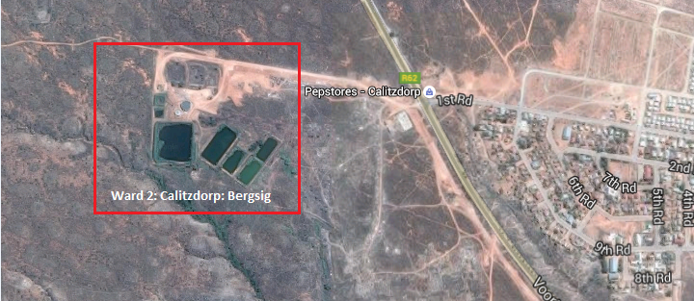
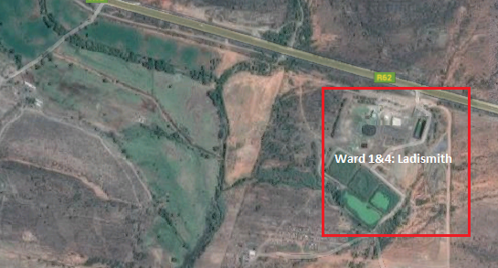
Table 25: Ladismith WWTW Table 26: Calitzdorp WWTW

The figure below depicts the waste water treatment plants in Kannaland area.
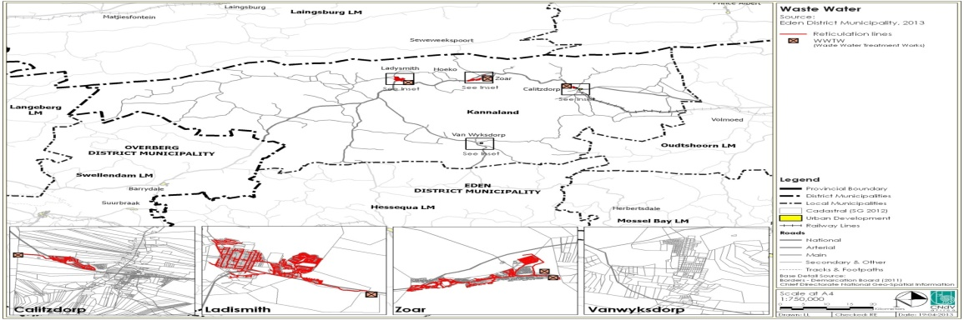
Table 27: Waste Water Treatment plant – as indicated in SDF figure 3.4.9.1
Water

All households have access to basic water services which means that water is available within 200 meters from their dwellings/houses. All the houses in the urban areas of Kannaland Municipality are provided with individual water connections. JOJO water tanks (especially to better deal with COVID-19 health requirements and standpipes are provided in the informal areas as a temporary emergency service. Tanker water services are provided to those JOJO tanks and to rural schools and rural communities on request. Water is the sustaining source of life and hence access to safe and potable water remains a priority service.

The figure below indicates the water infrastructure in Kannaland.
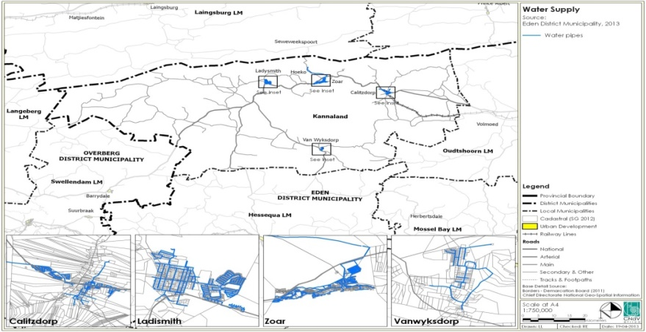

Ladismith water infrastructure: 12 boreholes are currently operational and fully equipped.which is drilled as part of the Ladismith Water Feasibility Study and drought relieve intervention.

As an interim measure a Deep borehole is envisaged (500m-600m deep) and as a first phase some 3 exploratory boreholes were drilled to assist in the final positioning of the Deep borehole. The exploratory boreholes may also produce usable water and could then also be connected into the Bulk water production network. The challenge at this stage is to source some additional R6 m to finish off all drilling exercise and also provide safety protection and a monitoring system that would via telemetry provide valuable information like depth of water in boreholes and reservoirs, status of all pumps whether in operation or not and flow rates.

For future planning the building of the proposed Swartberg Dam is essential for water storage security.

In order to achieve economic growth, the Municipality needs to ensure availability of sufficient water infrastructure capacity to meet the existing and future needs of Ladismith. The Municipality must provide sufficient infrastructure (raw water storage capacity) that is sustainable and reliable in meeting existing and future social economic growth for Ladismith. Only a proper Storage Dam like the planned Swartberg Dam would guarantee water security and attract more economic spin-offs for Ladismith. This project was however placed on the back burner for some 2-3 years 2017 – currently but the intervention of the Technical services department in the period September – December 2019 via Special Water Forum meetings with many stakeholders got interest going towards this project again. This Dam would cost in the order of approx. R180m and the planning and preliminary design is underway and to be continued with during 2020/21 financial year.

Vanwyksdorp Water Reticulation Project

This project is aimed at upgrading water infrastructure which is cost effective and sustainable to supply the Vanwyksdorp community with potable water. It aims to supply pipelines that are accessible for maintenance and repairs.

Calitzdorp: Water Availability study Project

This project is aimed at the identification of water sources and to make proposals for providing water security in the Municipality. This study will be completed in the 2020/21 financial year and will, in conjunction with the Water Services Audit Report, be utilized to prioritize future developments.

Ladismith Water Reticulation Project

This project is aimed at upgrading water infrastructure which is cost effective and sustainable to provide the Ladismith community with potable water. It aims to supply pipelines that are accessible for maintenance and repairs.

Swartberg Water Storage Dam Project

Economic Development in the Ladismith area (which is the biggest economic node in the Kannaland municipal area) has been restricted by the lack of water storage capacity. The Municipality is initiating the process for the establishment of a bulk water storage facility (dam) for the municipal area in partnership with the other two spheres of government. Engagements in this regards form part of the back-to-basics meetings and Water Forums.

The availability of raw water storage can unlock current and future housing developments and will ensure the availability of housing for medium to low income groups. Kannaland Municipality has approved a Human Settlement Plan, which will manage overall the housing projects in the municipal areas. The provision of human settlements is a high priority for the Municipality. The Municipality engages with the relevant sector departments in this regard, as this is an urgent matter for Kannaland.

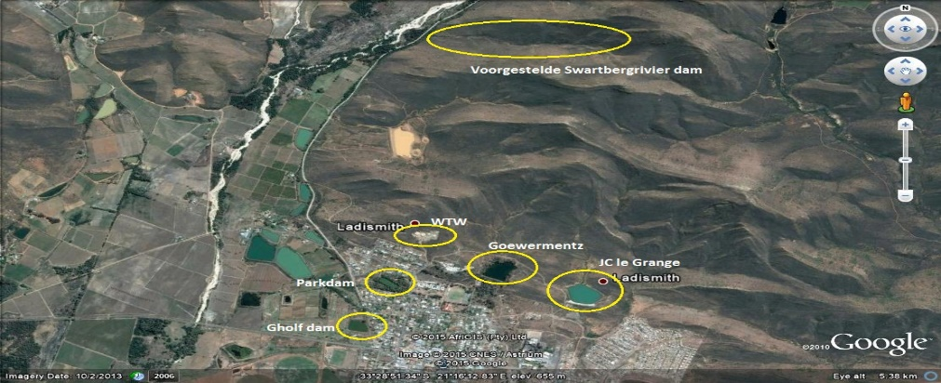
The construction of a new raw water storage dam for the town of Ladismith will be a major catalyst for future sustainable economic growth. As stated previously, the dam will unlock various economic projects. This project has been prioritized and the Municipality has submitted various business plans to be pursued in order to identify and source the resources required to build the dam in partnership with the Garden Route District Municipality, Provincial and National Government.

Water security Project
Ladismith

A new 3 mega-litre reservoir, in addition to the Deep Borehole and proposed Swartberg Dam, in Ladismith will be required to secure water supply for the next ten years. Refurbishment of old piped networks requires ongoing attention. Also water conservation and demand management will receive further attention.
- Upgrading of the WTW – implemented during the 2019/20 and 2020/21 FY, first phase completed next phase planned for the 2021/22 FY

Vanwyksdorp

Potable water is extracted for Vanwyksdorp from three boreholes and a fountain (Die Oog), stored in a reservoir and distributed to three reservoirs. All water enters the network system via the reservoirs and is distributed to consumers.

Future developments planned for Vanwyksdorp with regards to water is the following:
- Vanwyksdorp upgrading of raw water reservoir project;
- Vanwyksdorp upgrading of water reticulation networks;
- Vanwyksdorp additional boreholes drilling and equipping; and
- Vanwyksdorp upgrading of the WTW.

Calitzdorp

Bulk raw water to Calitzdorp is supplied via the Calitzdorp Nels Dam and a gravity bulk pipeline and booster pumpstation to the water purification plant and reservoirs. All water is entered into the network system via the reservoirs and is distributed to consumers. Currently the Nels Dam is owned and managed by the Calitzdorp Irrigation Water Board.

Calitzdorp Water Project

The projects below are in construction phase and some was already successfully compelted:
- Construct a high-pressure pump station and reservoir in Bergsig. – No funding yet
- Upgrading of the Water Treatment Works – Drought funding was received during the 2019/20 FY.
- Bulk water supply pipeline from Nels dam to the WTW – project completed during the 2020/21 FY
- New 1.5Ml reservoir for Bloekomlaan – project completed during the 2019/20 FY
- Drilling of Deep Borehole – implemented during 2020/21 FY
Future developments planned for Calitzdorp with regards to water include drilling and equipping of boreholes.

Zoar

Zoar receives its water directly from the Tierkloof dam which is located in the Seweweeks Poort. The dam is used for domestic supply to the Zoar community. The Tierkloof Dam belongs to the Department of Water and Sanitation, but the water supply is managed by the Municipality. A bulk raw water pipeline conveys the water to the Zoar Water Treatment Works which is situated opposite the township of Zoar, next to the R62 district road.

Future developments planned for Zoar with regards to water is the following:
- Upgrade and refurbishment of raw water supply pipeline; and
- Drilling and equipping of additional boreholes.
- New Dam proposed on Long Term for irrigation & additional drinking water
- 1Ml reservoir at WTW – implemented during the 2019/20 FY
- Upgrade of the WTW – implemented during the 2020/21 FY
Kannaland has also applied for further top-up funding from the National Disaster Drought Funds to supplement existing funding to few urgent on-going projects as follows: This is ongoing
Ladismith Deep Borehole – additional R6m

The Municipality has emphasised the improvement for water security and quality and therefore business plans has been submitted to the Department of Water and Sanitation for the building of the New Proposed Swartberg Dam and Waste water treatment works in Ladismith and Zoar. The aim is to unlock business development potential, attract investment to the area and facilitate the implementation of residential development.
The Municipality is in need of new fleet to ensure the services are properly delivered to the constituents in Kannaland.

Electricity
Electricity is the main energy source of households. Kannaland Municipality is responsible for the provision of electricity to Ladismith and Calitzdorp, whilst Zoar and Vanwyksdorp are supplied by ESKOM.

There are 11 Schools and 5 Clinics that have access to basic electricity Services.

Throughout the entire municipal area, a needs analysis was done to identify infrastructure /assets that need to be upgraded. It was established that 95% consist of aging infrastructure and should be urgently upgraded as it holds various risks for the Municipality. Business plans have been drafted and submitted for the necessary funding in order to address the identified challenges.

The Municipality has applied for Integrated National Energy Programme (INEP) funding with the Department for electricity infrastructure upgrades.
2020/21 | 3mil (applied for)
2021/22 | 2.7mil (applied for maintenance on infrastructure)
Table 28: Proposed funding for electricity upgrades

The current substation in Calitzdorp has an electricity usage capacity of 1.6 MVA and the availability of electricity is 1.6 MVA.

The vision is also to maintain a green and healthy environment, and therefore it is a prime consideration to upgrade the low-tension networks by placing the cable networks underground.
The following was identified as needs and will be prioritised for the outer financial years:
- Upgrading of new transformers and refurbishment of old transformers;
- Underground network cabling,
- Bulk supply to Ladismith and Calitzdorp – Upgrading of substations;
- Meter replacement of conventional to prepaid meters;
- Replacement of three phased prepaid meters;
- Electricity connections to farm houses and or informal settlements
- Upgrading of overhead networks
- Upgrading and refurbishment of infrastructure will result in a secure revenue stream as well as quality services delivered to the residents of Kannaland. The Municipality’s aim is to budget for the maintenance of all electrical upgrades.
The electrification of houses in Calitzdorp for the housing project will start in the 2021/22 financial year depending on the human settlement project progress.

The electricity maintenance plan needs to be reviewed and updated to guide the Municipality in terms of revenue streams and the cut of losses. The Municipality is also in process to conduct an electricity meter audit through the entire Kannaland to ensure we have the correct data to act on.

It should be noted although the Municipality applied for funding for the 2021/22 and outer years, no funds were gazetted or acknowledged yet.

ROADS AND STORMWATER
The main road system in Kannaland Municipality consists of National and Provincial roads maintained by the Provincial Government. The R62 national road passes through Calitzdorp, Zoar and Ladismith and alongside Vanwyksdorp on the corridor linking the Breede Valley with Oudtshoorn and beyond.

Divisional and sub-divisional roads: The divisional roads such as the R327, and R323, are maintained by the Garden Route District Municipality which has offices in Ladismith and working camps in Calitzdorp and Vanwyksdorp. Roads are critical to the economy of the region because residents, farmers and entrepreneurs are reliant on accessible roads for their livelihood. Vanwyksdorp, which is a small town, remains a very isolated area and is linked to the R62 by the R365 which is a gravel road also maintained by the Garden Route District Municipality.

The Municipality is responsible for the maintenance of municipal roads within the four towns (Ladismith, Calitzdorp, Zoar and Vanwyksdorp).

Roads and Stormwater

Paving projects are more labour intensive, create jobs, more cost effective, require less maintenance and has a longer life span. It is evident that the majority of the paved roads in the four towns are falling into the category of poor to very poor. The majority of unpaved roads in the four towns require blading (not necessarily re-gravelling) mainly due to poor drainage as well as poor maintenance over the years. Funding is required to implement the identified and prioritised projects in the Roads and Storm Water Master Plan.

Ladismith Roads Project
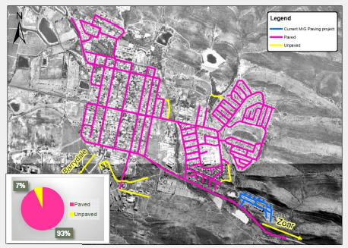
A plan for the extensive upgrade and maintenance of the north-western side of Ladismith’s roads will be developed during the 2019/20– 2021/22 financial years. The Municipality will engage with the relevant sector departments to assist as the MIG funding mainly aims to eradicate municipal infrastructure backlogs in poor communities to ensure the provision of quality basic services.

The road network in Ladismith comprises of 22.07 km of paved roads (93%) and only 1.61 km of unpaved roads (7%).

Zoar Roads Project

Through the IDP public participation it was identified that there is a need to pave the internal roads of Zoar and the project is registered with MIG. The following roads are prioritized future:
- Bruintjieshoogte
- Karoolande – circle route
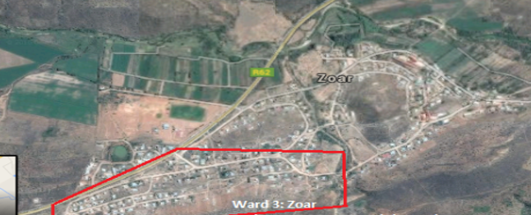
Table 29: Zoar Internal Road upgrade
Priority is currently being given to water and sanitation projects due to drought-related risks.

Calitzdorp Roads Project

The Municipality is planning to upgrade all roads and pavements in Calitzdorp and have applied to the Department of Rural Development and Land Reform for grant funding to address identified upgrades. Unfortunately, no feedback has been received from the Department.

Calitzdorp Road Maintenance Project

General road maintenance will be undertaken on an on-going basis. Operational maintenance will be continued and potholes will be filled.
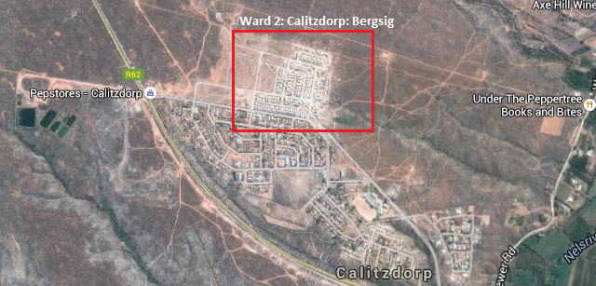
Table 30: Calitzdorp Bergsig Internal Roads
Calitzdorp 3 way stop project

During the public participation sessions and at the IDP Indaba it was raised that a three-way stop is urgently required at the entrance of Calitzdorp (on the Route 62 way). It will minimise road accidents and promote road safety to all motorists and residents. The Municipality needs to ensure that the correct processes are followed to be assisted.

Vanwyksdorp Roads Project

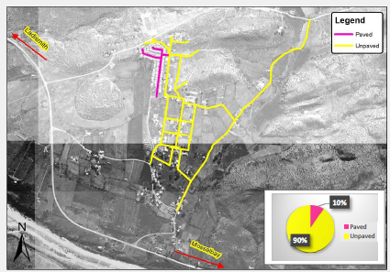
General road maintenance will be undertaken on an on-going basis. The Municipality aims to upgrade all gravel roads and funding needs to be sourced.

The road network in Vanwyksdorp comprises of 0.58 km of paved roads (10%) and 5.50 km of unpaved roads (90%).
The Municipality has developed an integrated transport plan with the assistance of the District Municipality and Provincial Government however support will be required to fulfill the projects listed below. The Rural Transport Programme must be developed and needs to be aligned with the integrated transport plan.

As previously mentioned, the tree planting linked to paving and/or upgrading of roads and pathways will be prioritized thus support from sectors or donations of trees from the Department of Agriculture, Forestry and Fishery (DAFF) will be required to execute this initiative. The implementation of the integrated transport plan aligned with the rural transport programme, will also ensure economic growth for the Kannaland area.

All four towns of Kannaland urgently needs road upgrades (main roads and internal roads).
O - 1.1.A - Infrastructure Planning programme

Below is the MIG, RBIG, WSIG and Drought Relief budget outlined as per the Municipality’s prioritization:
No | WARD NO. | Project name | DEPARTMENT | EPWP | Current  or  Planned | Duration |  | Budget Available | Funding Source
 |  |  |  |  |  | Estimated Start Date | Estimated End Date | Budget Available | Funding Source
 | 1, 4 | Ladismith: Water Treatment Works | Technical Services | Y | Planned | 05/07/2021 | 30/06/2022 | 2 259 884 | MIG
 | 1, 4 | Ladismith: Waste Water Treatment Works | Technical Services | Y | Planned | 05/07/2021 | 30/06/2022 | 4 169 049 | MIG
 | 3 | Zoar: New Sport Field lighting | Technical Services | Y | Planned | 05/07/2021 | 30/06/2022 | 1 308 720 | MIG
 | 3 | Zoar: New Cemetery | Technical Services | Y | Planned | 05/07/2021 | 30/06/2022 | 1 856 696 | MIG
 | 2 | Calitzdorp: Deep Borehole | Technical Services | Y | Planned | 05/07/2021 | 30/06/2022 | 10 000 000 | WSIG
 | All | Kannaland: Installation of Water Meters | Technical Services | Y | Planned | 05/07/2021 | 30/06/2022 | 469 951 | MIG
 | 4 | Van Wyksdorp Borehole | Technical Services | N | Planned | 05/07/2021 | 15/12/2021 | 315 148 | Drought Relief
 | 1,4 | Ladismith Boreholes | Technical Services | N | Planned | 05/07/2021 | 15/12/2021 | 3 376 017 | Drought Relief
Table 31: infrastructure budget
The 2021/22 BUDGET for MIG is R10 594 000 and incorporated the above projects as indicated for MIG
In some instances where the priority dictates, multiyear projects have been proposed. The discipline is maintained by prioritising the housing pipeline to enable housing delivery. The budget of MIG is dynamic because it reflects the requirements of the communities. Therefore, some projects may be prioritised differently where necessary.
Solid Waste Infrastructure Programme

Ladismith Landfill Site:
The Ladismith landfill site is a licensed facility owned and operated by the KLLM which only accepts general domestic, garden and construction and demolition (C&DW) waste. In September 2018 the KLLM received a Waste Management Permit for the operation and further development of the Ladismith landfill site in terms of the Waste Act, 2008.

Below is a satalite image of where the Ladismith landfill:
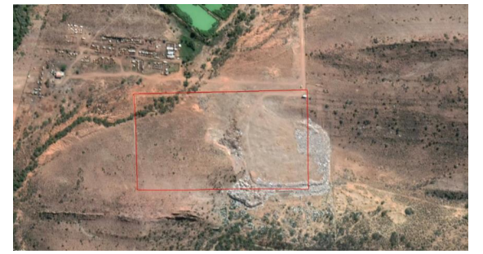
Table 32: SATELLITE IMAGE OF LADISMITH LANDFILL SITE SHOWING PERMITTED BOUNDARY OF THE SITE IN RED (source, google earth satellite imagery, accessed on 15 May 2019 image date 10 April 2019)
Calitzdorp Landfill Site:
The Calitzdorp landfill site is a licensed facility owned and operated by the KLLM which accepts garden and construction and demolition waste (C&DW). The site has been issued with a variation license for the operation and closure of the landfill for the period September 2018 to July 2020. Closure activities must commence by 20 July 2020.

Below is a satalite image of where the Calitzdorp landfill:
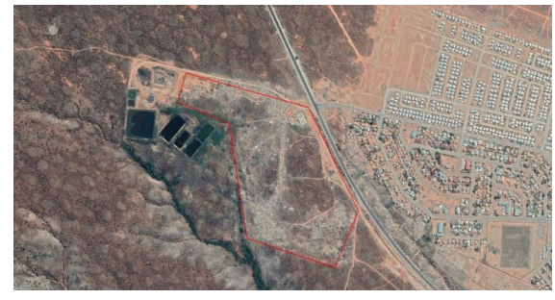
Table 33: Satellite image of Calitzdorp landfill site showing permitted boundary of the site in red (source, google earth satellite imagery, accessed on 15 May 2019 image date 28 April 2018)
Zoar Landfill site:
The Zoar landfill site is a licensed facility owned and operated by the KLLM which accepts general domestic, garden and construction and demolition (C&DW) waste. In September 2018 the KLLM received a Waste Management Permit for the operation and further development of the Zoar landfill site in terms of the Waste Act, 2008. The KLLM can continue to use the Zoar landfill site until the airspace capacity is reached.

Below is a satalite image of where the Zoar landfill site:
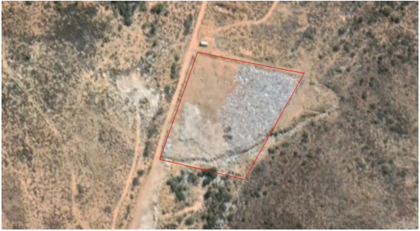
Table 34: Satellite image of Zoar landfill site showing permitted boundary of the site in red (source, google earth satellite imagery, accessed on 15 May 2019 image date 10 April 2019)
Van Wyksdorp Landfill site:
The Van Wyksdorp landfill site is a licensed facility owned and operated by the KLLM. The site has been issued with a variation license for decommissioning and closure for the period July 2018 to December 2019. Closure activities must commence by 10 December 2019.

Below is a satalite image of where the Zoar landfill site:
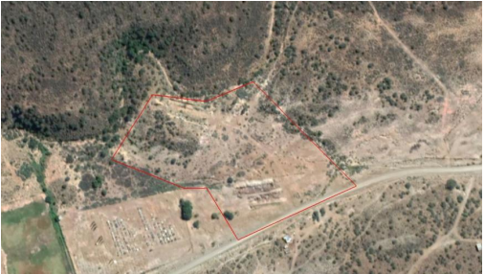
Table 35: Satellite image of Van Wyksdorp landfill site showing permitted boundary of the site in RED (source, google earth satellite imagery, accessed on 15 May 2019 image date 10 April 2019)

Integrated Waste Management Plan Project

According the waste management act, the Municipality has appointed a dedicated waste management officer which is responsible for coordinating waste management in the municipal area.
Despite the challenge of aging infrastructure and fleet, the Municipality ensure its utmost best to maintain the sites as well utilize the fleet to deliver services. However funding support to purchase new reliable fleet is still on the priority list. Business propasals will be developed and submitted to the Department of Local Government in order to assist the Municipality.

Most of the outlined projects within the IWMP has been addressed e.g awareness programmes in the community and schools have been conducted successfully. However, due to our financial position, the IWMP will be presented for further funding support from relevant sector departments to ensure the Municipality can roll out some projects over a phased period. (More detail can be found in the IWDP)

Waste Management Project

Below is what the Municipality will do or plan in terms of waste management during the next 2 years:
- Addressing the issue of storm water diversion, as indicated in the permits, at the landfill sites;
- Looking into the possibilities of recycling/waste diversion;
- Recycling projects/opportunities (in progress and is continuous)
- Further cleaning of illegal dumping sites in Kannaland Municipal Area (in progress and is continuous);
- Environmental awareness and clean-up campaigns (in progress and is continuous);
- Awareness campaigns on illegal dumping and waste minimization (in progress and is continuous);
- Purchasing of new collection equipment and proper maintenance on vehicles;
- Waste removal services to informal settlements as well as farm areas.
- Calitzdorp: Solid Waste Transfer Station Project
In order for the Municipality to obtain a license for the transfer station, it has to be upgraded to the required standards.

Project Management
Pipeline Projects
Projects that have been identified and funding applications being prepared or in the process of application
PROJECT
Zoar – Establishment of pedestrian walk ways
Zoar – Installation of high mast lights
Zoar – Upgrade and Refurbish of raw water supply pipeline
Zoar – Upgrade Waste Water Treatment Works
Zoar – Upgrade of Identified Internal Roads
Zoar – Drill and equip new boreholes
Zoar – Installation of bulk and zone water meters
Calitzdorp – High pressure pump station and reservoir
Calitzdorp – upgrade various sections on water reticulation
Calitzdorp – Refurbish Sewer Pump Stations and Waste Water Treatment Works
Calitzdorp –: Upgrade Roads
Calitzdorp – upgrade and refurbish KKRWS
Calitzdorp - refurbishment of sport facilities
Calitzdorp – installation of bulk and zone water meters
Ladismith – Establishment of a K53 facility
Ladismith – Rehabilitation and upgrade of roads
Ladismith – refurbishment of sport facilities
Ladismith – Installation of bulk and zone water meters
Ladismith – New Reservoir
Van Wyksdorp – upgrade water reticulation
Van Wyksdorp – upgrade raw water reservoir
Van Wyksdorp – Installation of bulk and zone water meters
Table 36: Planned Projects not yet registered
The table below outline the PMU budget for the three financial outer years:
SOURCE FUNDING | 2020/21 | 2021/22 | 2022/23
MIG Capital | 9 595 350 | 10 064 300 | 10 528 850.00
MIG (INCL PMU) | 10 107 000 | 10 594 000 | 11 083 000.00
RBIG – DAM RELOCATION | - | - | -
RBIG - WWTW | 0 | 4750 000.00 | -
WSIG | 10 000 000 | 10 000 000 | 20 690 000.00
INEP |  | 2 000 000.00 | 2000 000.00
DROUGHT RELIEVE | 2600 000.00 | - | -
Table 37: Infrastructure Budget
Projects approved by WSIG for the 2021/22 financial year
Project | Project Value | Project Allocation
Calitzdorp: Deep Borehole Development | 17mil | 10mil

Human Settlements Plan Project.
The Municipality has initiated the process with the Department Human Settlements where the development of a HSP was completed. The plan should be reviewed annually as data tend to change.
The Municipality undertakes to conduct the planning for the following housing projects which have been developed as part of a ten year plan for housing for the Kannaland municipal area:
LOCATION | HOUSING UNITS | FUNDING SOURCE
Calitzdorp: Bergsig | 692 | DoHS  MIG
Ladismith: Parmalat | 422 | DoHS  MIG
Van Wyksdorp | TBD | DoHS  MIG
Table 38: Proposed Housing Projects - Source: ASLA
Proposed Calitzdorp Bergsig Housing Project
Table 39: Calitzdorp Bergsig Housing Project
The first phase of 250 houses has been completed. The second phase will result in a final 692 (inclusive of the 250) houses being completed. A planning and implementation plan will be developed as part of the Integrated Human Settlements Plan.

Proposed Ladismith Housing Project: Parmalat
Table 40: Ladismith Housing Project: Parmalat
The Ladismith, Parmalat project is currently in the planning phase and entails 530 housing opportunities. The bulk services need to be upgraded before implementation of the project can commence.
Proposed Ladismith Housing Project: Schoongezicht Project
Table 41: Ladismith Housing Project: Schoongezicht Project
The Schoongezicht project is currently in the planning phase (2018-19) and entails 195 housing opportunities. The bulk services need to be upgraded before the project can commence. Given the creative management application in devising and launching the Nissenville GAP Project the successful reification of this Schoongezicht vision is a realistic prospect.
Proposed housing Project: Van Wyksdorp
Table 42: Housing Project: Van Wyksdorp
The Van Wyksdorp project is currently in the planning phase. The housing plan provides for 200 houses for the Van Wyksdorp area. The bulk services for the project stills need to be upgraded and the preferred site acquired from the Provincial Government. A sewage processing plant has been established in Van Wyksdorp.

Key Performance Area 2: Service Delivery
(National KPA – 1: Basic Service Delivery and Infrastructure Development)

PDO 2: Provide basic services and improve public relations
The delivery of municipal services in electricity, water, sanitation, refuse, roads and storm water is a key function of the Kannaland Municipality. As mentioned earlier, funding remains the biggest challenge. If the water security can be availed to Kannaland, enourmous outcomes can evolve such as business expansions, investmenst, food security, job creation ect.

Some of the challenges are to ensure adequate maintenance of assets, controlling the rising unit costs of service delivery, addressing future bulk supply shortages and ensuring adequate investment in economic infrastructure. These challenges are made more difficult by high expectations from communities, decaying infrastructure, limited organisational capacity and resources.

Water Services
Kannaland Municipality is the designated Water Services Authority in its demarcated municipal area. There are four water treatment works (plants) located at Ladismith, Zoar, Calitzdorp and Van Wyksdorp.

Van Wyksdorp Water Treatment Works is supplied from Buffelsfontein River and three boreholes as well as irrigation water supply from Buffelsfontein River every second week for seven hours.
Zoar Water Treatment Works is supplied from the Tierkloof Dam belonging to the Department of Water and Sanitation. Calitzdorp Water Treatment Works is supplied form Nels Dam belonging to the Irrigation Board.

Water sources are limited in the Kannaland area. It is imperative that proper planning and management of water resources is ensured at all times. We strive to comply with the water services Act 108 of 1997.

Greendrop and Bluedrop Status

Other concerns of the DWS are the apparent overload of the wastewater works as indicated in the high operational capacity percentages. This progress reporting decision is made due to either lack of flow measuring or in the case of Ladismith, the actual overloading of the works as evident in the high flows to the works. Other information received indicated that the works is being upgraded, and this is applauded. The Municipality also has no supervisory and process controller competencies available at any of their systems.

This is also appreciated although it would be important for staff to get the necessary accredited training to improve their qualification. Maintenance staff is available at all systems, and the Municipality should retain these competencies. The Municipality is encouraged not to allow the situation at their wastewater works to deteriorate.

The Municipality requested that the department provides the Municipality in future with detailed and more updated reports.

Master Plan Review Project

Draft master plans in respect of all infrastructure related activities and update where current plans are found to be out-dated. This project is in planning phase, where support will be sourced to assist the Municipality in developing master plans as well how stakeholders can assist in the implementation phase.
Maintenance Plan Project

The Municipality will continue to apply for funding to appoint a service provider to review existing maintenance and replacement practices aimed at reducing unit costs and to ensure longer term returns on existing infrastructure.

Key Performance Area 3: Safe Communities:

PDO 3: To strive towards a safe community in Kannaland through the proactive management of traffic, environmental health, fire and disaster risks.
Safety Programme
Traffic Services Project

The function of the traffic service is critical to ensure overall law enforcement and road safety within the Kannaland municipal area. The function is also critical for revenue enhancement of the Municipality given the various income streams it secures. The following key functions are being managed by the traffic section:
- motor vehicle registration services;
- learners licensing;
- renewals of drivers licence;
- vehicle testing services;
- issuing of traffic fines;
- visible law enforcement (road-blocks); and
- visible law enforcement (illegal water use, illegal dumping, control of hawkers etc.)
- Road markings/sings
- Managing E-natis system

Internal funding as well business plans for securing the projects below will be submitted to Provincial sector departments in the outer financial year for the projects that have not been funded as yet.
- Procurement of extra cameras;
- Assistance to develop a traffic by law – IGRS
- Speed hump for identified areas throughout Kannaland
- Traffic / Road signs
- Speeding Strips
Disaster Management Strategy/Plan Project

The Municipality will review the status of preparedness and contingency plans associated with the prevailing risks identified in the area and to also reflect possible risk reduction projects during next two outer financial years.

The Kannaland Disaster plan has been developed in terms of the Disaster Management Act (Act 7 of 2002) that requires Local Authorities (B Municipalities) to develop and maintain a Disaster Management Plan for their area of control/jurisdiction.

Department of Local Government is in partnership with municipalities will annually review the disaster plan. Public participation workshops have been held to gain input from relevant stakeholders and hazard experts.

The primary goal is to ensure developmental risk reduction, by having planned development linked with risk reduction initiatives and risk information, i.e. taking into account the prevailing risks (risk assessment) for sustainable development (resilient municipal assets and communities).
It is also to ensure that operational risk reduction objectives are developed and/or updated. Project plans and contingency plans for identified risks should be in the Disaster Management Plan.

The Municipality has developed a draft community safty plan to outline the risks and actions to be taken by several sector departments. This was done in collaboration with the district and provincial government.
Sustainability of the environment
Environmental Programme
Alien Invasive Control Management Plan Project

Alien invasive species remain a challenge in terms of the water at the Swartberg River. The department of Environmental affairs and the Municipality will identify possible programs and projects to eradicate those challenges.

Health Programme
Quality of health strategy project:

The Municipality will identify plans aimed at enhancing the quality of health for the Kannaland communities.

Air quality management project:

A budget allocation for Air Quality Management needs to be secured. Budget should ideally cover the following: air quality monitoring (passive or continuous monitoring of air pollutants), staff training and implementing air quality intervention strategies.

Key Performance Area 4: Socio-Economic Development
(National KPA -2 Economic Development)

PDO 4: To facilitate economic growth and social and community development
Tourism Programme

Tourism Development Strategy Project:
Kannaland’s local economy is built on the opportunities created by tourists visiting the area. It is essential that the tourism industry be further developed and investment into this industry be promoted to ensure continuous growth. The Municipality should consider making allocations for tourism development, Art and Culture promotion and SMME development as stated in the IDP. The funding to appoint a service provider to develop an LED (Local Economic Development) strategy which will include the tourism strategy during the outer financial year. During consultaion sessions, a tourism indaba be held.

Joint planning Programme

The Joint Planning Initiative is based on mega or long-term projects and initiatives whilst IDP the Indaba focuses on immediate or short-term projects which require integrated planning and support from other lead departments in provincial and national government. The Joint Planning Initiatives (JPI’s) are more of a longer-term nature.

These JPI’s consist of catalytic projects commonly referred to as game changers which would require collaborative planning and pooling of resources between the relevant government departments and municipalities in order to maximise the impact on the socio-economic and infrastructure challenges faced by local communities.
The Municipality has identified a number of catalytic projects/programmes namely under the following categories:
- Housing;
- Social services and Youth activities and development;
- Infrastructure: water, drainage and sanitation;
- Infrastructure: roads and transport
- Safety and security;
- Economic development and local business development;
- Agriculture.
These projects/programmes would have a significant impact in the Municipality, region and even the province and it is therefore crucial that strategic partnerships be formed to facilitate joint planning for the successful implementation of these projects/programmes. The current status of previous commitments will not be included in this document as mentioned at the IGR platforms, Council is in process to review the long term projects to be tabled at the next JPI. However, the Departments which played a significant role in assisting the Municipality are commended for their continuous commitment.

Agri Processing Project:

The Klein-Karoo has vast developmental potential, especially in terms of agriculture and agro-processing. The dairy, fruit and livestock economic sectors need to be analysed in order to determine the output and benefit that can be gained from these sectors. Value-adding processing of these sectors should be analysed in terms of developing these sectors from the base of Kannaland. The appointment of a service provider to do this analysis and to development of an Agro-Processing implementation plan is an important mechanism to prepare strategies to optimise the regions development potential.

SDF Review Project:

The SDF isin the process of review inconjunction with the Western Cape Government and its associated implementation plan aligned with the SPLUMA principles and incorporate the SDF as a core component of the IDP.

EPWP Project:

This programme is used to relieve unemployment in the municipal area.

Library Project:
Business plans have been submitted for the upgrading of the library in Calitzdorp Bergsig.

A mobile library project is to be established in the near future which will help these in designated areas (who cannot reach the central town libraries). As reading is fundamental to functioning in today’s society and enables oneself to educate in any area of life which you are interested in and to do research and critical thinking. Awareness campaigns on the importance of utilizing the library is already done amongst our youth, schollars and the elderly groups.

Key Performance Area 5: Effective and Efficient Governance
(National KPA 3 Institutional Development and Municipal Transformation)
(National KPA 5 Good Governance and community participation)

PDO 5: To promote efficient and effective governance with high levels of stakeholder participation
Institutional Stabilisation Programme

The political and administrative leadership of Kannaland Municipality need to be positioned to manage competing demands for limited resources in a fair equitable and efficient manner.

Policy Review Project:
The Municipality is in process of updating all municipal policies, strategies and operational plans over the next three years. This will be done to ensure that municipal activities, rules and procedures are consistent with all relevant policies, legislations and by-laws.

Transparency and Participation
Participation Programme Communication Project:

Improve communication of the vision, strategy and plans both internally and externally, to keep staff informed, capacitated and to manage the expectations of the community.

Community participation in Agriculture Project

In the Agricultural sector, improved processes will be introduced to support inclusive participation in agricultural value-chains and fostering an environment conducive to local and regional private sector investment. Community participation in the structures of local government will be strengthened in all the areas in the Municipality. Kannaland Municipality will work towards ward committees that are better resourced, more powerful and taken seriously. The Municipality will actively promote the participation of the community in the working of the Municipality.

Key Performance Area 6: Efficient Workforce

PDO 6: To provide an efficient workforce by aligning our institutional arrangements to our overall strategy
Human Resources
The Municipality consists of 238 employees. The staff component is the biggest single budget item and hence the development, motivation and utilization of staff are a high priority.

Institutional Transformation Programme

The key deliverable of this programme is to bring stability in the council administration, to fill management vacancies, conduct organizational redesign and to compile all job descriptions and job evaluations for all posts.

Policies and Procedures Project

It is paramount that all organizational policies, processes and procedures are reviewed in order to ensure that it is valid, relevant, legally compliant and viable. The Municipality will ensure that most of the critical policies be reviewed and redeveloped where necessary during the 2020/2021 financial year.

Staff Development Project

The following interventions have been identified to maximize employee development:
- Create development opportunities for the Municipality’s employees and maximizing existing developmental opportunities;
- Implementation of the Individual Performance Management programme for all managers/supervisors up to the third level of reporting;
- Implementation of the employment equity plan;
- Maximising the SAMRAS leave module, in particular employee self-service that related to leave entitlements and leave requests.
- Development of supervisors to improve the skills needed to supervise and lead employees; A number of critical areas that management needs to address to ensure optimal service delivery have been identified and these areas must be strongly attend to in future:
- Low staff morale
- Inadequate skills levels
- Inadequate qualifications
- Lack of clarity regarding roles and responsibilities (middle management and supervisors)
- Lack of discipline

Workplace Skills Development Project (WSP)

The Municipality has developed a Work Place Skills Plan (WSP) of which the main objective is to ensure that there is staff development through training interventions for all levels of staff. The Municipality is committed to ensure that all staff is skilled and trained in their respective fields, even though there are financial constraints. The Municipality will continue to source funding and form cooperative partnerships where the opportunity presents itself to ensure a well-qualified workforce. As part of the workplace skills development project, the skills requirements of staff will be identified, personal development plans developed and training programmes developed in order to ensure that staff is appropriately skilled and equipped to conduct their duties with excellence. This process will be rolled out over the first three years of the next term of office.

Key Performance Area 7: Financial Sustainability
(National KPA 4 Financial viability and management)

PDO 7: To strive towards a financially sustainable Municipality

The challenges need to be taken into account that many of the projects identified in the IDP during
consultation, are not financial supported with adequate revenue provisions. Hence, external funding sources will be identified and consulted to fund most of the critical projects.

Budgeting and Expenditure Management Project

The Municipality will review the budget and expenditure management systems to ensure that efficient and effective service delivery is in line with Municipal priorities. This will require the development of a Long-Term Financial Plan (10 - 15 years) split into three phases being 1 – 5 years, 6 – 10 years and 11 – 15 years. The plan will include the following:
- Predicting future municipal revenue;
- Estimating future operational expenditure;
- Determining future capital demand:
- Asset replacement expenditure;
- New capital investment;
- Determining a funding model for future capital investment;
- Perform financial modelling inclusive of:
- Liquidity and ratio management;
- Recommendations to attain financial results;
The Municipality will implement the creditors’ payment policy and perform creditor classification and institutionalize pre-determined creditors payment dates and implement expenditure and creditors management.

Revenue Management Project
The revenue management systems will be reviewed in order to maximise revenue generation possibilities and improve revenue performance. The Municipality will source funding for the appointment of a service provider to draft a revenue enhancement strategy and plan to improve revenue value chain by:
- Performing a complete meter audit of metered services;
- Performing a physical verification of all services and service connection points.
- Performing debtor data analysis and cleansing.
- Performing a complete indigent verification process.
- Conducting on-site water demand management and loss control.
- Analysing electricity losses and draft a loss control program.
- Engage in meter replacement program.
- Apply cost-reflective tariff modelling.
- Reviewing, analysing and performing benchmarking of user tariffs to the industry norm.
Customer Care Project:

The Municipality will introduce measures to enhance levels of customer care, increase responsiveness to consumer billing and other queries. The Municipality will improve community access points, source funding to conduct a customer satisfaction survey, implement a customer service call centre, set benchmarks for activities relating to complaints and set service level standards for customer responses.

Cash and Liability Management Project

The Municipality will review cash and debt management strategies and practices. All liabilities (current and non-current) will be reviewed and a strategy developed in order to meet obligations in a timely manner in accordance with legislative requirements. In order to achieve the deliverables of this project, the Chief Financial Officer will implement cash flow monitoring, design and implement an effective grant management and monitoring system to ensure that conditional grants are only used for their intended purposes and introduce the daily management of cash-flow with weekly reporting. Monthly bank reconciliations will be performed and long-term debt reviewed and restructured where economic benefits can be attained.

Cash flow targets will be set as part of the MTREF and short-term liabilities reviewed and calculated. Long term liabilities will be reviewed and calculated and all contingent liabilities disclosed. Creditors will be engaged to discuss/agree repayment plans/arrangements for liabilities in order to enter into arrangements with creditors and to monitor that the payments are made according to the agreed repayment plans.

Financial Controls Project
COGTA has assign a dedicated specialist to assist with the MFMIP programme to assist the municpality with controls and processes.

The Municipality will review internal controls and delegations regarding financial management. Some of the initiatives that will be conducted include the following:
- Draft an Audit action plan to address audit findings.
- Correct prior year errors and compile audit evidence file.
- Review monthly progress on corrected errors.
- Implement safeguards to mitigate errors going forward.
- Perform Risk analysis of Municipality and implement risk management system.
- Revise and implement internal systems of control to mitigate financial risks identified.
- Review all policies, budget and non-budget related, and amend where necessary.
- Workshop all policies with related staff.
- Review and amend all job descriptions.
- Review archiving and record keeping.
- Capacitating and skills development of finance department staff.
- Implement internal controls to mitigate financial risks
Asset Management Project:

The Municipality will source funding during the outer financial year in order to develop and integrated infrastructure and asset management plan. This will entail the review and updating of the Asset Register. This plan should include the assessment of the useful lives of all infrastructure assets by performing a conditional assessment and ensure that a GIS reference exists for all infrastructure assets.

An Asset Procedure Manual will be drafted and asset maintenance plans will be included for all major asset categories. The Municipality will perform a municipal strategic asset assessment and master plans review for all Infrastructure assets will be updated and founds sourced in order to perform a land audit to identify all municipal assets and to determine a performance assessment of all municipal properties. This will be followed by the drafting of a municipal asset management strategy which also includes a performance and disposal framework.

Supply Chain Management Project

The Municipality will review governance practices in the Supply Chain practices and implement proper controls and risk management practices. In this process SCM Delegations will be reviewed and electronic Contract Management system implemented.

Capital Budget Implementation Project:

The Municipality needs to be pro-active with regards to planning and implementation of the capital budget. Potential risks need to be addressed as soon as they are identified. This will require the improvement of planning processes in order to institute the monitoring of action plans to ensure that capital budget is implemented effectively to avoid under spending as experienced in the previous years and the current financial year. Attention will be given to projects business plans, risk identification and turnaround times on supply chain management processes to ensure the full implementation of the capital budget for a financial year.
ICT Project:

The Municipality will initiate a process towards the review of IT infrastructure and implement accounting in order to ensure that financial systems are in line with the Municipal Budget and Reporting Reforms (mSCOA etc.). For better and efficient workflow, the Municipality is in need of a server upgrade and business plans have been submitted for funding in order to implement the project.

Liability Management Project

All liabilities current and non-current will be reviewed and a strategy developed to meet obligations in a timely manner in accordance with legislative requirements.
- Review and calculate short term liabilities
- Review and calculate long term liabilities
- Review and disclose all contingent liabilities
- Engage with creditors to discuss/agree repayment plans/arrangements
- Draft repayment plans for liabilities and enter into arrangements with creditors

CHAPTER 5:
In-Year Municipal Performance Scorecard

CHAPTER 5: Proposed Organisational Performance

Five Year Performance Scorecard
Please note that this scorecard is subject to change as per the key performance indicators and targets can be amended as per need per department.

This is part of a draft scorecard, the final sdbip. After the approval of the budget the final scorecard will be developed which will be aligned directly with the IDP and budget – will be included in the final IDP
KPA | Strategic Objective | Performance Indicator | Performance Measure | Target  2018/19 | Target  2019/20 | Target  2020/21 | Target  2021/22
KPA1: Reliable Infrastructure | To provide access to reliable infrastructure that will contribute to a higher quality of life for Kannaland citizens | Capital budget spent in terms of the infrastructure projects listed in the IDP | 1A.  % of capital budget spent | 85% | 86% | 87% | 92%
KPA 2: Service Delivery: | To provide basic services and improve our public relations) | Households with access to basic level of water | Number of residential properties which are billed for water | TBC | TBC | TBC | TBC
KPA 2: Service Delivery: | To provide basic services and improve our public relations) | Households with access to basic level of electricity | Number of residential properties which are billed for electricity or have pre-paid meters | TBC | TBC | TBC | TBC
KPA 2: Service Delivery: | To provide basic services and improve our public relations) | Households with access to basic level of sanitation (NKPI – 10a) | Number of residential properties which are billed for sewerage | TBC | TBC | TBC | TBC
KPA 2: Service Delivery: | To provide basic services and improve our public relations) | Households with access to basic level of refuse removal (NKPI – 10a) | Number of residential properties which are billed for refuse removal | TBC | TBC | TBC | TBC
 | Provide for the needs of indigent households through improved services. | Indigent households receiving free basic water | Number of indigent households receiving free basic water | TBC | TBC | TBC | TBC
 |  | Indigent households receiving free basic electricity | Number of indigent households receiving free basic electricity | TBC | TBC | TBC | TBC
 |  | Indigent households receiving free basic sanitation | Number of indigent households receiving free basic sanitation | TBC | TBC | TBC | TBC
 |  | Indigent households receiving free basic refuse removal | Number of indigent households receiving free basic refuse removal | TBC | TBC | TBC | TBC
KPA 3: Safe Communities: | To strive towards a safe community in Kannaland through the proactive management of traffic, environmental health, fire and disaster risks) | Compliance with drinking water quality standards | Percentage compliance with drinking water quality standards | 90% | 90% | 87% | 90%
 |  | Draft an alien invasive plan | Number of plans drafted | 0 | 0 | 1 | TBC
KPA 4: Socio-Economic Development: | To facilitate economic growth and social and community development | Develop a led strategy | Number of strategy | TBC | TBC | 1 | TBC
KPA 4: Socio-Economic Development: |  | 4B  EPWP jobs created  (NKPI – 10d) | 4B  Number of EPWP jobs created | 70 | 80 | 90 | 100
KPA 5: Effective and Efficient Governance | Objective 5.1 To promote efficient and effective governance with high levels of stakeholder participation | 5A  Unqualified audits by the Auditor General | 5A  Auditor General opinion | Unqualified Audit | Unqualified Audit | Unqualified Audit | Clean Audit
 | Transparency and participation | Council meetings open to the public | Number of Council meetings open to the public | 4 | 4 | 4 | 4
KPA 6: Efficient Workforce | To provide an efficient workforce by aligning our institutional arrangements to our overall strategy | People from employment equity target groups employed in the three highest levels of management | Percentage of people from employment equity target groups employed in the three highest levels of management in compliance with the approved employment equity plan | TBC | TBC | TBC | TBC
 | To enable education and skills development to equip people with economic skills | Completion of the WSP | Number of report completed | 1 | 1 | 1 | 1
KPA 7: Financial Sustainability | To strive towards a financially sustainable Municipality) | Cost coverage | Ratio of cost coverage maintained | TBC | TBC | TBC | TBC
KPA 7: Financial Sustainability | To strive towards a financially sustainable Municipality) | Debtors to Annual Income | Performance Indicator: Net Debtors to Annual Income Revenue expressed as a percentage | TBC | TBC | TBC | TBC
KPA 7: Financial Sustainability | To strive towards a financially sustainable Municipality) | Debt coverage by own billed revenue | Ration of debt coverage by own billed revenue | TBC | TBC | TBC | TBC
KPA 7: Financial Sustainability | To strive towards a financially sustainable Municipality) | Bank Account Reconciliation | Reconciliation of bank account within 30 days after month end | 12 | 12 | 12 | 12
Table 43: Performance Scorecard

Performance Scorecard Definitions – will be included in the final IDP
Priority | Strategic Objective | Performance Indicator | Performance Measure | Definition
KPA 1: Reliable Infrastructure | –To provide access to reliable infrastructure that will contribute to a higher quality of life for Kannaland citizens | Capital budget spent  (NKPI – 10c) | % of capital budget spent | Percentage reflecting year-to-date spend of the municipal capital budget  Formula: Actual capital budget spend/capital budget x 100/1
KPA 2:  Service Delivery: | Provide for the needs of indigent households through improved services. | Indigent households receiving free basic water (NKPI – 10a) | Number of indigent households receiving free basic water | Number of residential properties which are billed for water or have pre-paid meters as at 30 June of each financial year. Calculated as the actual number of monthly bills that have been issued
KPA 2:  Service Delivery: |  | Indigent households receiving free basic electricity (NKPI – 10a) | Number of indigent households receiving free basic electricity | Number of residential properties which are billed for electricity or have pre-paid meters (Excluding Eskom areas) as at 30 June of each financial year. Calculated as the actual number of monthly bills that have been issued
KPA 2:  Service Delivery: |  | Indigent households receiving free basic sanitation  (NKPI – 10a) | Number of indigent households receiving free basic sanitation | Number of residential properties which are billed for sewerage as at 30 June of each financial year. Calculated as the actual number of monthly bills that have been issued
KPA 2:  Service Delivery: |  | Indigent households receiving free basic refuse removal  (NKPI – 10a) | Number of indigent households receiving free basic refuse removal | Number of residential properties which are billed for refuse removal as 30 June of each financial year. Calculated as the actual number of monthly bills that have been issued
 | - Provide for the needs of indigent households through improved services. | Indigent households receiving free basic water (NKPI – 10b) | Number of indigent households receiving free basic water | Provide free basic water to indigent households as defined in paragraph 9(1) of the Municipality's Credit Control and Debt Collection Policy as at 30 June
 |  | Indigent households receiving free basic electricity (NKPI – 10b) | Number of indigent households receiving free basic electricity | Number of formal residential properties connected to the municipal electrical infrastructure network (credit and prepaid electrical metering)(Excluding Eskom areas) and which are billed for electricity or have pre-paid meters (Excluding Eskom areas) as at 30 June of the financial year
 |  | Indigent households receiving free basic sanitation (NKPI – 10b) | Number of indigent households receiving free basic sanitation | Number of formal residential properties connected to the municipal waste water sanitation/sewerage network for sewerage service, irrespective of the number of water closets (toilets) which are billed for sewerage as at 30 June of the financial year
 |  | Indigent households receiving free basic refuse removal (NKPI – 10b) | Number of indigent households receiving free basic refuse removal | Number of formal residential properties for which refuse is removed once per week and which are billed for refuse removal as at 30 June of the financial year
KPA 3:  Safe Communities: | To strive towards a safe community in Kannaland through the proactive management of traffic, environmental health, fire and disaster risks | Compliance with drinking water quality standards | Percentage compliance with drinking water quality standards | % of water samples in the Kannaland jurisdiction area to comply with SANS241 micro biological indicators. Calculated by calculating:  Number of water samples in compliance with SANS241 micro biological indicators/Number of water samples x 100/1
 |  | EPWP jobs created  (NKPI – 10d) | Number of EPWP jobs created | This indicator measures the number of work opportunities created through the Expanded Public Works Programme (EPWP). An EPWP work opportunity is defined as paid work created for an individual on an EPWP project for any period of time, within the employment conditions of the Code of Good Practice for Special Public Works Programmes.
Key Performance Area 5: Effective and Efficient Governance | To promote efficient and effective governance with high levels of stakeholder participation) | Unqualified audits by the Auditor General | Auditor General opinion | This indicator measures good governance and accounting practices and will be evaluated and considered by the Auditor-General in determining his opinion. An unqualified audit opinion refers to the position where the auditor, having completed his audit, has no reservation as to the fairness of presentation of financial statements and their conformity with Generally Recognised Accounting Practice. This is referred to as ‘clean opinion’. Alternatively, in relation to a qualified audit opinion, the auditor would issue this opinion in whole, or in part, over the financial statements if these are not prepared in accordance with Generally Recognised Accounting Practice, or could not audit one or more areas of the financial statements. The audit opinion covers the audit of predetermined objectives.
Key Performance Area 5: Effective and Efficient Governance |  | Council meetings open to the public | Number of Council meetings open to the public | The indicator measures the number of municipal council meetings open to the public to maintain transparency in the day-to-day governance of the Municipality.
Key Performance Area 6: Efficient Workforce | To provide an efficient workforce by aligning our institutional arrangements to our overall strategy | People from employment equity target groups employed in the three highest levels of management | Percentage of people from employment equity target groups employed in the three highest levels of management in compliance with the approved employment equity plan | The indicator measures the percentage of people from employment equity target groups employed in the three highest levels of management in compliance with the approved employment equity plan. Each department contributes to the corporate achievement of targets and goals by implementing its own objectives of quantitative and qualitative goal setting.  Calculated as follows:  Number of EE targeted employees (top3 levels)/Number of positions (Minus vacant positions) x (100/1)
Key Performance Area 6: Efficient Workforce |  | 6C  Limit vacancy rate to 30% of budgeted post | 6C  % vacancy rate | Calculated as follows:  Number of funded posts vacant divided by number of budgeted funded posts expressed as percentage
Key Performance Area 6: Efficient Workforce | - To enable education and skills development to equip people with economic skills | Budget spend on implementation of WSP | Percentage budget spent on implementation of WSP | A workplace skills plan is a document that outlines the planned education, training and development interventions for the organisation. Its purpose is to formally plan and allocate budget for appropriate training interventions, which will address the needs arising out of local government’s skills sector plan, the Municipality’s strategic requirements as contained in the IDP and the individual departmental staffing strategies and individual employees’ PDPs. The WSP will also take into account the employment equity plan, ensuring incorporation of relevant developmental equity interventions into the plan.  Formula: Actual training budget spend/Training budget x 100/1
KPA 7: Financial Sustainability | To strive towards a financially sustainable Municipality) | Cost coverage  (NKPI – 10g(i)) | Ratio of cost coverage maintained | Total cash and investments (short-term), less restricted cash for monthly operating expenditure. Financial viability measured in terms of the available cash to cover fixed operating expenditure as at 30 June ((Cash and Cash Equivalents - Unspent Conditional Grants - Overdraft) + Short Term Investment) / Monthly Fixed Operational Expenditure excluding (Depreciation, Amortisation, and Provision for Bad Debts, Impairment and Loss on Disposal of Assets))
KPA 7: Financial Sustainability | To strive towards a financially sustainable Municipality) | Debtors to Annual Income  (NKPI – 10g(ii)) | Performance Indicator: Net Debtors to Annual Income Revenue expressed as a percentage | This is a calculation where we take the net current debtors divided by the total operating revenue. Financial viability measured in terms of the outstanding service debtors as at 30 June (Total outstanding service debtors/ revenue received for services)
KPA 7: Financial Sustainability | To strive towards a financially sustainable Municipality) | Debt coverage by own billed revenue (NKPI – 10g(iii)) | Ration of debt coverage by own billed revenue | This is a calculation where we take the total own billed revenue divided by the total debt. Financial viability measured in terms of the Municipality's ability to meet its service debt obligations as at 30 June (Short Term Borrowing + Bank Overdraft + Short Term Lease + Long Term Borrowing + Long Term Lease) / Total Operating Revenue - Operating Conditional Grant)
KPA 7: Financial Sustainability | To strive towards a financially sustainable Municipality) | Bank Account Reconciliation | Reconciliation of bank account within 30 days after month end | Reconciliation of bank account within 30 days after month end is the norm. This must be achieved 12 times per annum (each month)  To be calculated as the number of months per annum that the Municipality has reconciled the bank account within 30 days of month end and submitted to Council.

Chapter 6:
Financial planning

CHAPTER 6: FINANCIAL PLAN
Section 26 of chapter 5 of the Local Government Municipal Systems Act, No 32 of 2000 prescribes the core components of the Integrated Development Plan (IDP). Section 26(h) requires the inclusion of a financial plan, which should include a budget projection for at least the next three years. This financial plan aims to determine the financial affordability and sustainability levels of the Municipality over the medium term.

A Municipality’s financial plan integrates the financial relationships of various revenue and expenditure streams to give effect to the IDP. It provides guidance for the development of current budgets and assesses financial impacts on outer years’ budgets by incorporating capital expenditure outcomes, operating expenditure trends, optimal asset management plans and the consequential impact on rates, tariffs and other service charges.

The Municipality has to do long term financial planning in order to determine the appropriate mix of financial parameters and assumptions within which the Municipality should operate to facilitate budgets that are affordable and sustainable at least ten years into the future. This helps to identify the consequential financial impact of planned capital projects on the Municipality’s operating budget.
The planning is reviewed annually to determine the most affordable level at which the Municipality can operate optimally, taking into account the fiscal overview, economic climate, national and provincial influences, IDP and other legislative imperatives, internal governance and community consultation.

Financial strategy
This section provides an overview of the Kannaland Municipality’s 2021/22 MTREF. It includes an assessment of how the budget links with the national and provincial government contexts along with a review of the fiscal position of the Municipality.

The Municipality’s budget must be seen within the context of the policies and financial priorities of national, provincial and local governments. In essence, the spheres of government are partners in meeting the service delivery challenges faced in Kannaland. Kannaland alone cannot meet these challenges. It requires support from the other spheres of government through the direct allocation of resources, as well as the achievement of their own policies.

The process encompassed the following:
- Framework for and strategic direction of the budget;
- Forecast taking above direction into account.
- Departmental budget presentations to execute the Municipality’s strategies, business improvement measures and implementation readiness of capital programmes.
- Utility Services presentations on their proposed budgets and tariff increases.
- Key Financial Drivers
Ensuring congruence between the Municipality’s strategy and budget included alignment with the:
- IDP;
- Development Strategies;
- Core economic, financial and technical data obtained at local and national level; and
- Other issues, policies and strategies stemming deemed important in this regard.

Management and governance frameworks
The outcome of the modelling incorporated the above as well as the assumptions outlined below. The principles applied to the MTREF in determining and maintaining an affordability envelope included:
- higher-than-inflation repairs and maintenance provision to ensure and enhance the preservation of municipal infrastructure;
- higher increases to selected cost elements subjected to higher-than-average inflationary pressure, such as staff costs;
- the assumption of a 100% capital expenditure implementation rate;
- credible collection rates based on collection achievements to date, and also incorporating anticipated improvements in selected revenue items; and
- national and provincial allocations as per the Division of Revenue Act (DORA)

Revenue Framework
According to MFMA Circular No. 99, the following headline inflation forecasts underpin the 2021/22 national budget:
Fiscal year | 2019/20 | 2021/22 | 2022/23 | 2023/24
 | Estimate | FORECAST
CPI Inflation | 4.1% | 3.9% | 4.2% | 4.4%

The growth parameters apply to tariff increases for property rates, user and other charges raised by municipalities and municipal entities, to ensure that all spheres of government support the national macroeconomic policies, unless it can be shown that external factors impact otherwise
The increase in revenue is mainly due to an increase in tariffs that have been in line and capped by the headline (CPI) inflation forecast. It should be noted that even though Kannaland Municipality had tariff increases that exceeded inflation the progress made to achieving a self-sustainable Municipality has been offset by the increased inability to collect revenue. The cost of compliance, low productivity, the high cost of rural procurement and the inability to attract scares skills at an affordable cost all contribute to an expense account that cannot be funded by our current revenue base and strategies need to be developed to expand the current revenue base with taking into account the limited water storage capacity at the same time. The drought is having an adverse effect on not only the ability to collect revenue, as a result of the downturn in the economy, but also on the selling of economic services (water and electricity) that are the main contributors to the profit margin of the Municipality.
The increase in revenue is mainly due to:
- an increase in tariffs
- an increase in grant funding
- an increase in equitable share allocation
- the prevention of water losses due to by-passed and faulty water meters

Rates charges, tariffs and timing of revenue collections:
The Budget Committee made use of tariff modelling to calculate realistic tariff increases.
TRADING SERVICES:
- Electricity 17.90% (Nersa / Eskom award to be considered)
- Water 4.4%
- Refuse 4.4%
- Sanitation 4.4%
- Sundries Tariffs 4.4% on average (except town planning 8%)
NON-TRANDING SERVICES
- Property Rates 0% (The impact of the final valuation roll will be considered to ensure that a balance will be found between affordability and the increase in property value)
Financial Performance

Operating expenditure framework
The operarting revenue and expenditure items:
Revenue
- We still await the approval of NERSA on Electricity Tariffs.
- Electricity Revenue is the biggest revenue generating item for the Municipality. This means we have to safeguard the electricity infrastructure to ensure that they keep generating revenue.
Expenditure
- We have a deficit of R 9.4 million in the 2021/22 however the cash items are cash funded. We have a Budget Funding Plan to ensure that the municipality will be cash funded during the 2021/22 MTREF.
- Employee Related Costs remain the biggest expenditure item which needs to be further scrutinized to curtail this budget.
- Employee Related Costs is the only remaining item where further possible savings can be achieved. However, this needs to be carefully done as some of these vacancies are critical and are contributing into the poor level of service delivery. We have amended the employee related costs policy in order to ensure that unnecessary spending is avoided. E.g. Working in shifts to reduce the overtime expenditure.
- Own funding Capital Projects to the value of R 1 million have been included in the final budget.

Below is the spatial distribution of allocations to the Municipality:

Financial schedules

CASHFLOW
- Table 44: Cashflow

Capital Budget
The Capital budget is funded wholly from external grant funding and is aligned with Key Performance Area 1 – Reliable infrastructure.
Table 45: Budgeted capital expenditure by vote, functional classification and funding

Budgeted Financial Performance – A2

Chapter 7

Sector Planning

Chapter 7: Sector Planning
The below table indicates a list of critical Master, Operations and Maintenance plans that urgently need to be developed or reviewed. The management has highlighted the need for these critical plans at various IGR forums such as LGMTEC, TIME and “Back to Basics” meetings. A formal request has been directed to the department of COGTA in specific Municipal Infrastructure Support Agency (MISA).

Status Quo Master Plans, Operational, Maintenance and other plans
Plan | Status | Adopted by Council | KPA Alignment
Water Master Plan | Complete and will be reviewed in the 2015/16 financial year. | February 2012. | KPA 1
Sewage Master Plan | Complete and will be reviewed in the 2015/16 financial year | October 2009. | KPA 1
Roads and Storm water Management Plan | Not completed. The Municipality plans to develop this plan during the 2015/16 financial year | Complete 2017 | KPA 1
Spatial Development Framework | In process to be reviewed | November 2013. The SDF will be updated / review in the 2020/21 -2022/2023 financial year | KPA 1,2,3,4,7
Integrated Transport Plan | Completed | May 2014 | KPA 3
Disaster Management Plan | Completed | The plan was be reviewed May 2019 | KPA 3
Waste Management Strategy | In process but not finalised as yet | Completed in May 2015 | KPA 1 and 3
Human Settlement Plan | Complete | The HSP was be completed by end May 2016 | KPA 1 and 4
Bulk Infrastructure Master Plan: Sanitation | Complete | February 2012 | KPA 1
Local Economic Development Strategy | In process to be complete | May 2013 | KPA 4
Air quality management Plan | Completed. A draft air quality management was developed with assistance of Provincial Government and adopted 2013/14 financial year. The document will be reviewed in the 2018/19 financial period | May 2019 | KPA 3
Integrated Water Management Strategy for Ladismith (Storage, boreholes, water rights, runoff) | In process and plan to be completed in the 2018/19 financial year. | Will be developed in the 2020/2021 financial year | KPA 1
Integrated Municipal Infrastructure Plan | Not developed as yet – plan to commence with the process in 2016/17 | Will be developed in the 2020/2021 financial year | KPA 1
Electricity Master Plan | Completed | January 2017 | KPA 1 and 2
Water Services Development Plan | Completed | - | KPA 1 and 2
Water Revenue Management | Plan needs to be developed | This will form part of the revenue enhancement plan | KPA 7
Water Safety Plan | Plan needs to be developed | This will form part of the revenue enhancement plan | KPA 1,2,3
Alien invasive Management Plan | Plan needs to be developed | - | KPA 1,2,3
Integrated Waste Management Plan | Complete | October 2019 | KPA 1,2,3
Table 49: Status Quo Master Plans, Operational, Maintenance and other plans
NOTE: all of abovementioned sector plans need to be updated and workshop with council for future implementation.

Relationship between sectoral plans:
 | Spatial Development Framework (KPA 1,2,3,4 and 5) | Zoning Scheme  (KPA 4) | Housing Plan  (KPA 4) | Integrated Transport Plan  (KPA 3) | Infrastructure Master Plans  (KPA 1)
Spatial Development Framework  (KPA 1,2,3,4 and 5) |  |  | Identifies municipal growth direction  Identifies areas to be protected (e.g. agriculture and nature) Identifies areas for economic development  Identifies housing priority areas | Identifies municipal growth direction  Identifies areas to be protected (e.g. agriculture and nature) Identifies areas for economic development  Identifies housing priority areas | Identifies municipal growth direction  Identifies areas to be protected (e.g. agriculture and nature)  Identifies housing priority areas  Identifies areas for economic development  Identifies Infrastructure priority areas
Zoning Scheme  (KPA 4) | Translates nature and form of urban development needed into supportive regulations |  | Provides for overlay zones meeting the specific requirements of different human settlements | Provides for land use regulations that supports public transport  Indicates extent of land use right requiring services | Provides for land use regulations that supports efficient infrastructure provision  Indicates extent of land use right requiring services
Housing Plan  (KPA 4) | Identifies current settlements and interventions which should be accommodated in future planning | Identifies nature and form of human settlement development which is affordable |  | Identifies current settlements and interventions which should be accommodated in future planning | Identifies current settlements and interventions which should be accommodated in future planning
Integrated Transport Plan  (KPA3) | Identifies transport and roads priority areas | Identifies ideal route classification | Identifies transport and roads priority areas |  | Identifies transport and roads priority areas
Infrastructure Master Plan  (KPA 1) | Identifies existing infrastructure capacity/constraints  Identifies interventions required to support growth/infill | Identifies existing infrastructure capacity/constraints | Identifies existing infrastructure capacity/constraints  Identifies interventions required to support growth/infill | Identifies existing infrastructure capacity/constraints  Identifies interventions required to support growth/infill
Table 50: Relationship between sector plans

List of Statutory, Strategic and Operational Plans
STATUTORY PLANS
- IDP and Process Plan (Budget Time Schedule of Events for the Approval of the Budget and IDP)
- Spatial Development Framework – In progress
- Municipal Disaster Risk Management Plan
- Integrated Human Settlements Plan
- Comprehensive Integrated Transport Plan (inclusive in document)
- Circulars to be implemented

STRATEGIC AND OPERATIONAL PLANS (can be obtained on request)
- Economic Development Strategy
- 2018/19 Annual Report and oversight report
- Air Quality Management Plan (AQMP)
- Comprehensive Integrated Transport Plan
- Community safety plan
- Updates on disaster management
- Audit action plan
- LG Socio economic Profile of Kannaland Municipality

